|  |
| --- |
| **Maths Home Learning**  **Counting** |
| **Year 2 Learning Booklet** |

**I can count in steps of 2, 3, and 5 from 0, and in tens from any number, forwards and backwards**

**Spot the mistake and correct it.**

**Identify the missing numbers.**

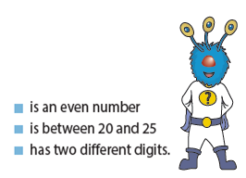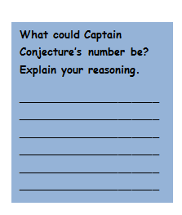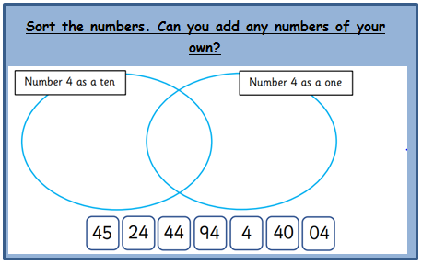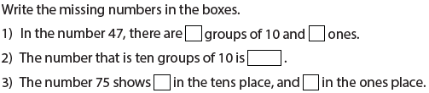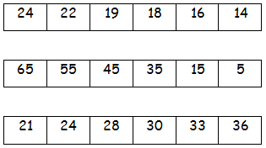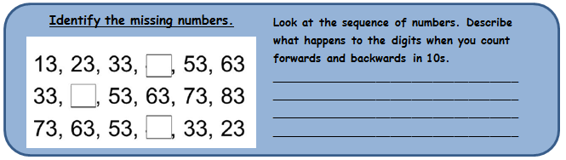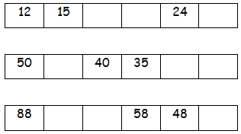

**I can recognise the place value of each digit in a two-digit number (tens, ones)**

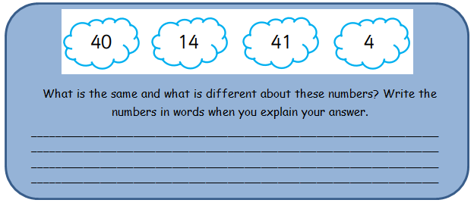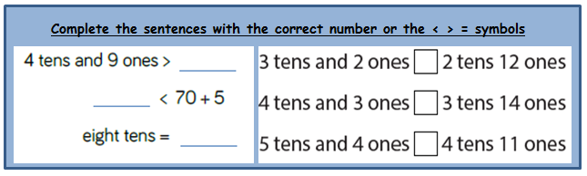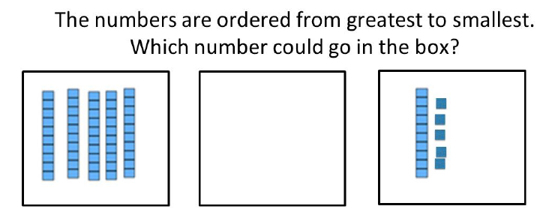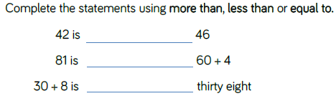

**I can read and write numerals to 100**

__________________________________________________________________________________________________________________________________________________________________________________________________________________________________________________________________________________________________________________________________________________________________________________

Eli is struggling to order numbers from smallest to greatest. Can you write an explanation of how to order numbers in a logical way? Show him using 14, 44, 54, 48, 9, 100.

**I can use language more than, less than, fewer than, greater than**

**I can compare and order numbers from 0 up to 100; use and = signs**