|  |
| --- |
| **Maths Home Learning**  **Measurement** |
| **Year 2 Learning Booklet** |

**I can choose and use appropriate standard units to estimate and measure length/height in any direction (m/cm); mass (kg/g); temperature (°C); capacity (litres/ml) to the nearest appropriate unit, using rulers, scales, thermometers and measuring vessel**

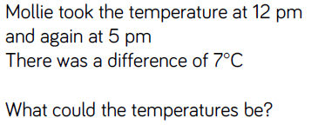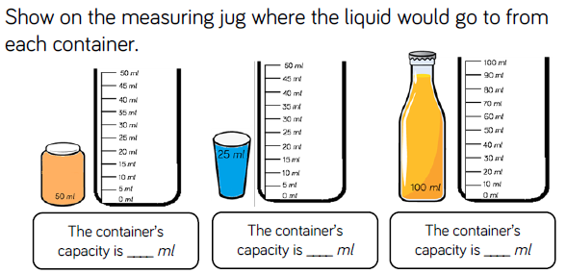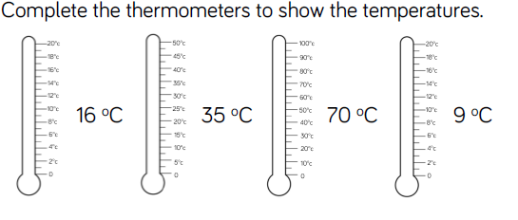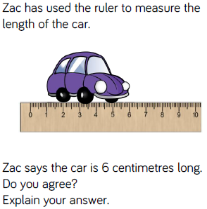

__________________________________________________________________________________________________________________

__________________________________________________________________________________________________________________

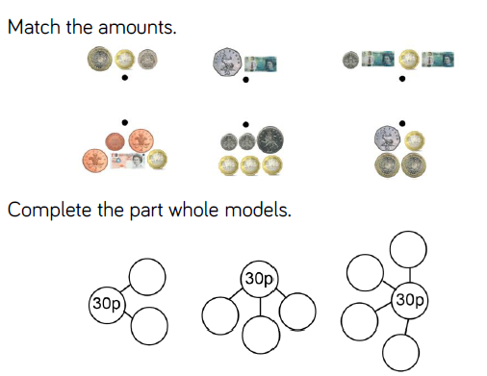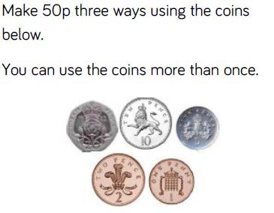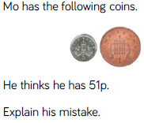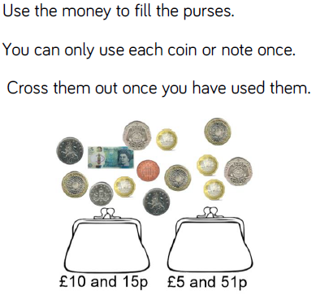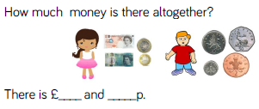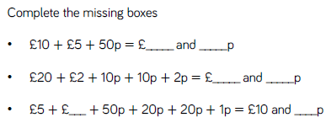

_________________________________________________________________________________________________________________________________________________________________________________________________________________________________________________________________________________________________________________________________________________________________________________________________________

**I can find different combinations of coins that equal the same amounts of money**

______________________________________________________________________________________________________________________________________________________________________________________________________________________________________________________

**I can recognise and use symbols for pounds (£) and pence (p); combine amounts to make a particular value**