|  |
| --- |
| **Maths Home Learning**  **Shape** |
| **Year 2 Learning Booklet** |

**I can identify and describe the properties of 2-D shapes, including the number of sides and line symmetry in a vertical line**

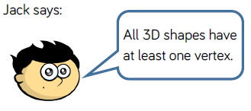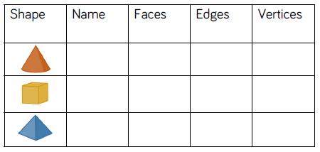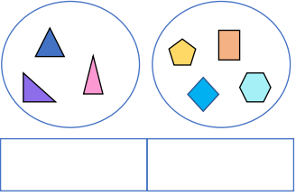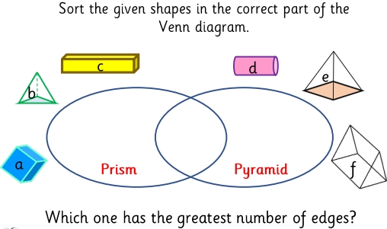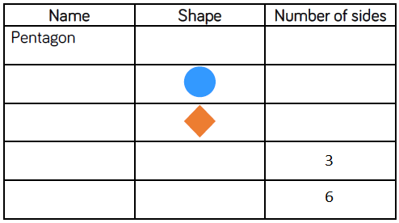

True or false? Explain! _________________________________________________________________________________________________________________________________________________________________________________________________________

How have these shapes been sorted? Is there more than once answer?

**I can compare and sort common 2-D and 3-D shapes and everyday objects**

**I can identify and describe the properties of 3-D shapes, including the number of edges, vertices and faces**

Does the number of vertices always equal the number of sides? Do any of these shapes have a line of symmetry? Draw it on.

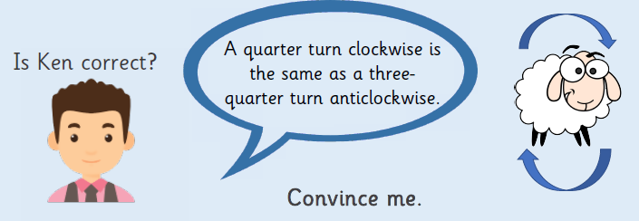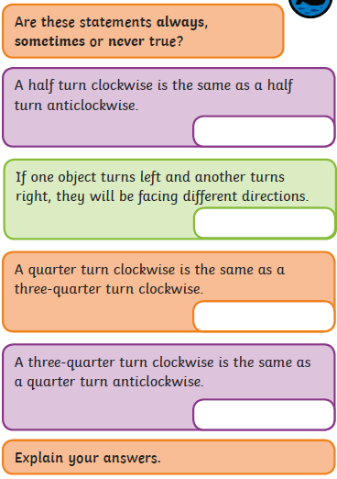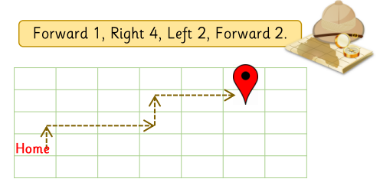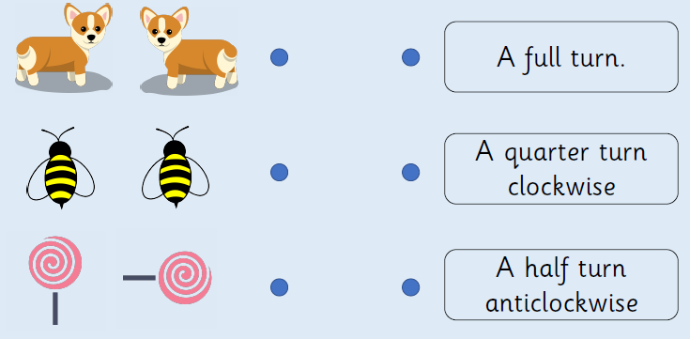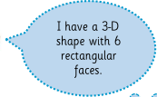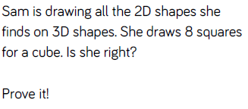

**Spot the mistake!**

**Can you correct the directions?**

_________________________________________________________________________________________________________________________________________________________________________________________________________

**Match the image to the correct description.**

**I can describe position, direction and movement including whole, half, quarter or three quarters**

What shape could Mo have? Explain! ____________________________________________________________________________________________________________________________________________

_____________________________________________________________________________________________________________________________________________

**I can identify 2-D shapes on the surface of 3-D shapes**