|  |
| --- |
| **Maths Home Learning**  **Time** |
| **Year 2 Learning Booklet** |

**I can tell and write the time to five minutes, including quarter past/to the hour**

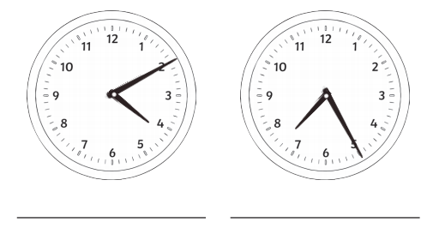

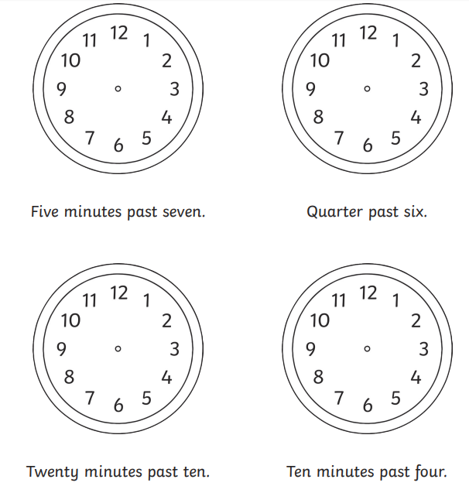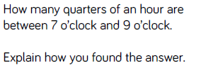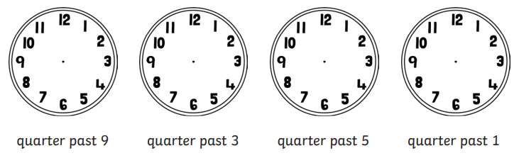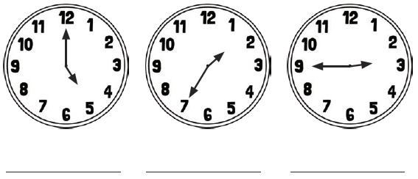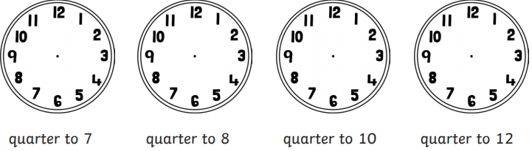

_________________________________________________________________________________________________________________________________________________________________________________________________________________________________________________________________________________________________________

**I can draw the hands on a clock face to show the time to the nearest 5 minutes, including quarter past/to the hour**

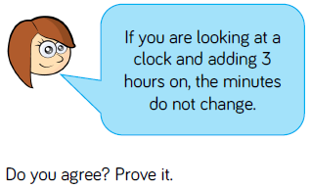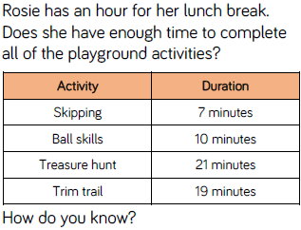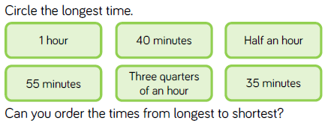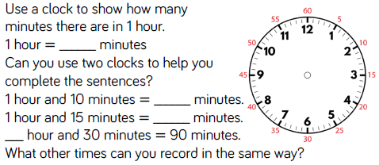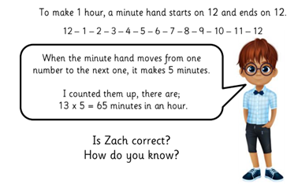

___________________________________________________________________________________________________________________________________________________________________________________________________________________________________________________________________________________________________________________________________

_____________________________________________________________________________________________________________________________________________________________________________________________________________________________________________________

_______________________________________________________________________________________________________________________________________________________________________________________________________________________________________________________________

**I know the number of minutes in an hour and the number of hours in a day**