|  |
| --- |
| **Maths Home Learning**  **Addition and Subtraction** |
| **Year 4 Learning Booklet** |

**I can add and subtract numbers with up to 4 digits using the formal written methods of columnar addition and subtraction where appropriate**

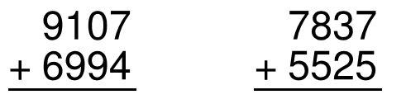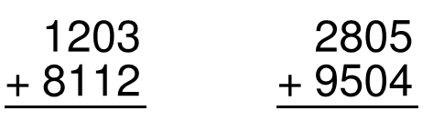

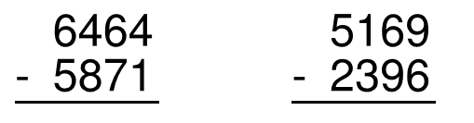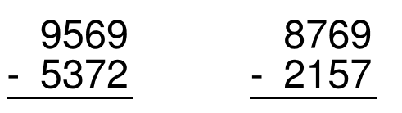

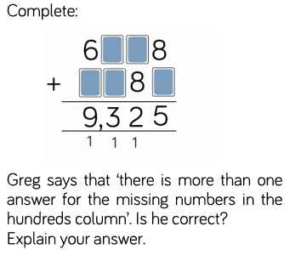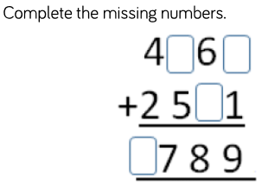

**I can estimate and use inverse operations to check answers to a calculation**

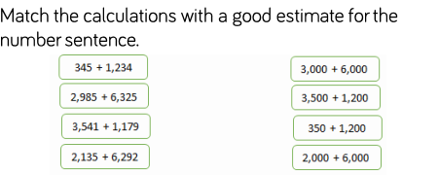

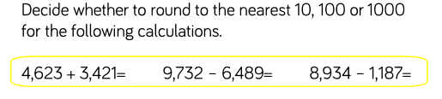

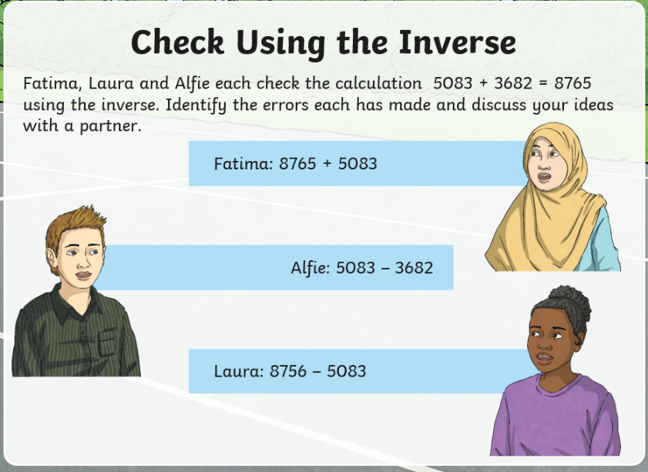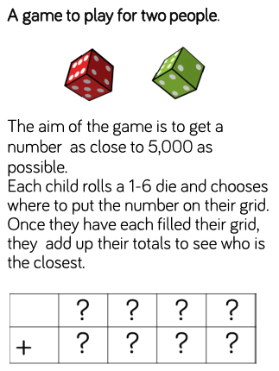

**I can recall multiplication and division facts for multiplication tables up to 12 × 12**

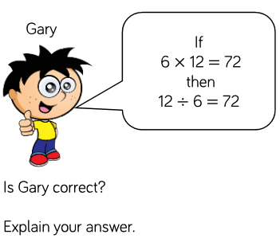

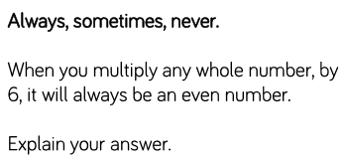

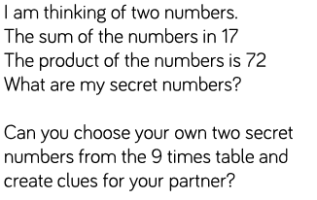

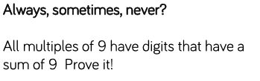

**I can multiply two-digit and three-digit numbers by a one-digit number using formal written layout**

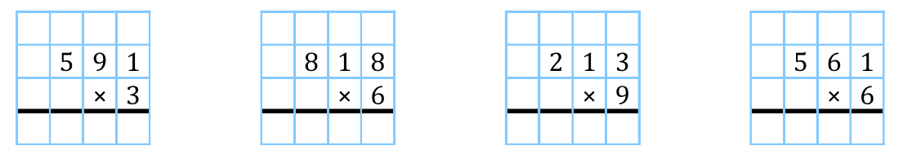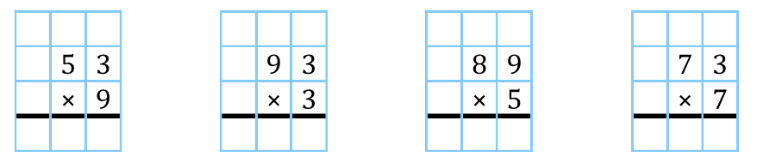



1. Beyonce went on a shopping spree in London, and bought 4 pairs of shoes. Each pair cost £496. How much did she spend in total?
2. It’s a busy Saturday in McDonalds! 185 children each want 6 chicken nuggets. How many nuggets need to be cooked?