|  |
| --- |
| **Maths Home Learning**  **Fractions and Decimals** |
| **Year 4 Learning Booklet** |

**I can recognise and show, using diagrams, families of common equivalent fractions**

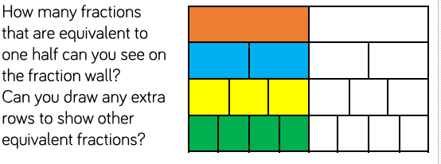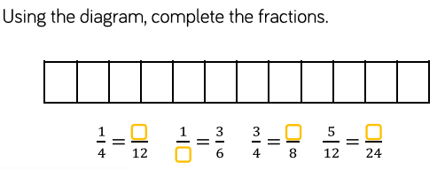

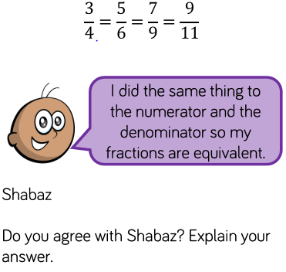

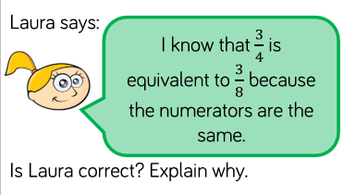

**I can count up and down in hundredths; recognise that hundredths arise when dividing an**

**object by one hundred and dividing tenths by ten.**

**I can**

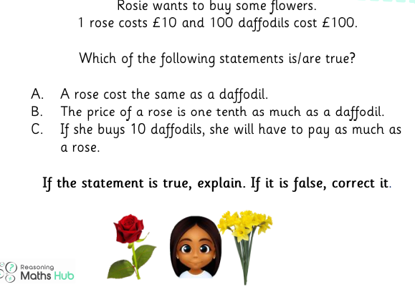

What are the next numbers in these sequences ?

0.23 0.24 0.25 0.26 __

0.14 0.15 0.16 0.17 __

0.33 0.34 0.35 0.36 __

1.45 1.46 1.47 1.48 __

What are the next fractions in these sequences ?

___



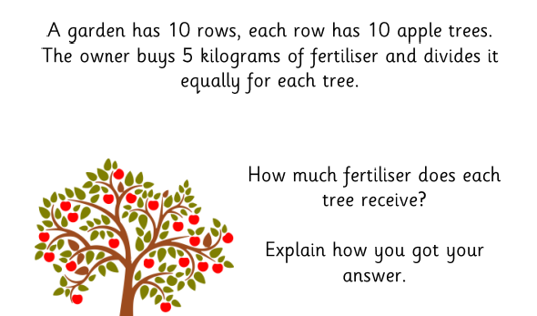

___



___



**I can add and subtract fractions with the same denominator**

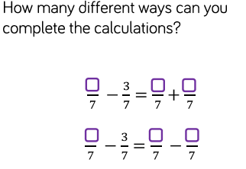

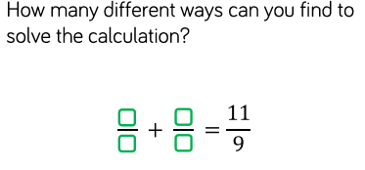

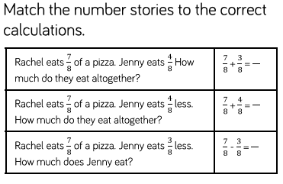

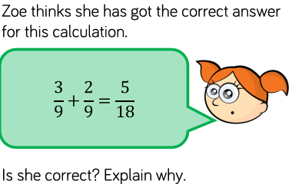

**I can recognise and write decimal equivalents of any number of tenths or hundredths eg 6/10 = 0.6**



