|  |
| --- |
| **Maths Home Learning**  **Measure** |
| **Year 4 Learning Booklet** |

**I can convert between different units of measure eg kilometre to metre; hour to minute**

1. 45cm = ____ mm
2. 87m = ____ cm
3. 1.1km = ____ m
4. 102cm = ____ mm
5. 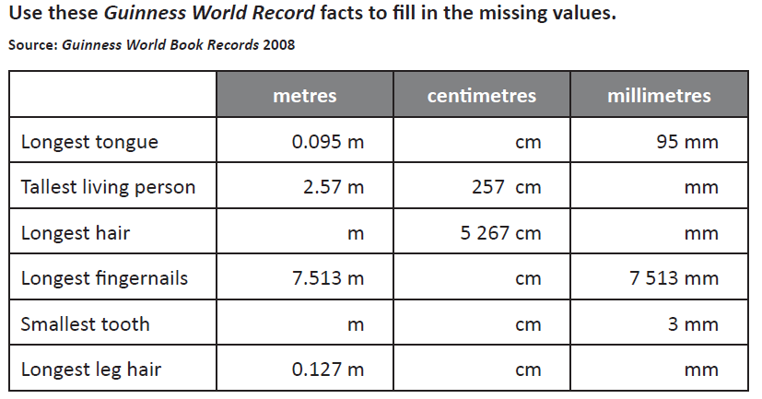43.26m = _____ cm

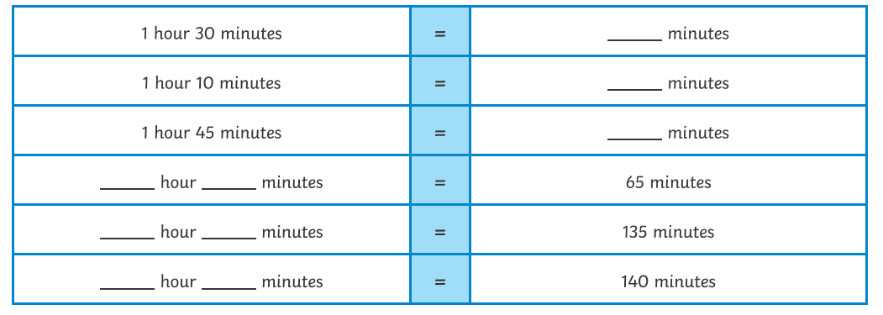

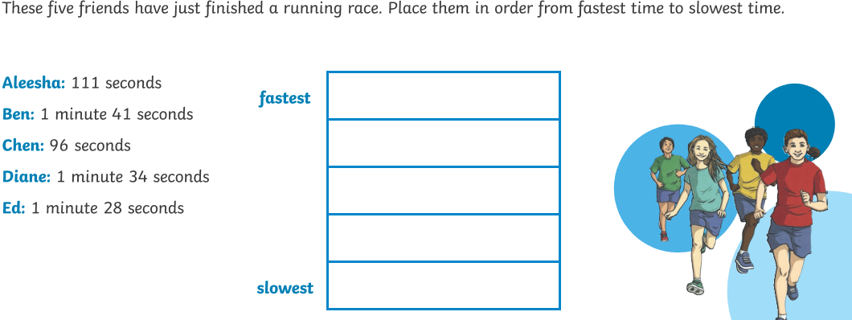

**I can estimate, compare and calculate different measures, including money in pounds and pence**

