|  |
| --- |
| **Maths Home Learning**  **Time** |
| **Year 4 Learning Booklet** |

**I can tell and write the time from an analogue clock, including using Roman numerals from I to XII, and 12-hour and 24-hour clocks**

**I can**

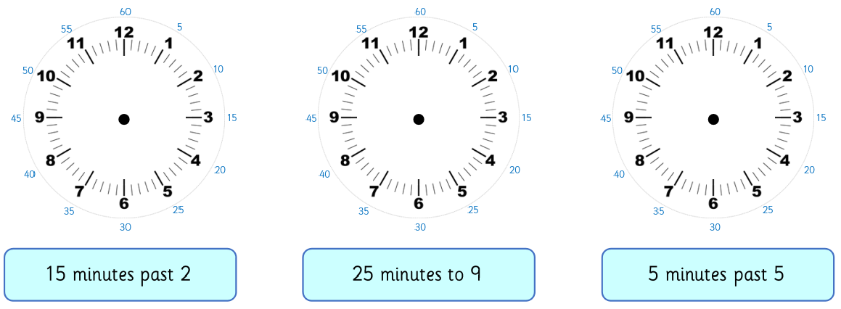

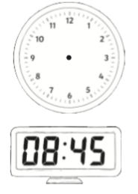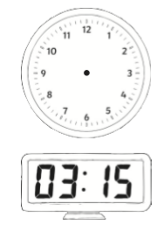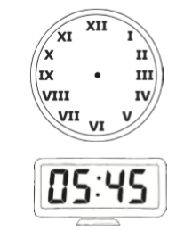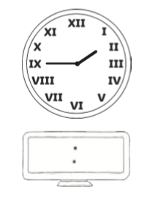

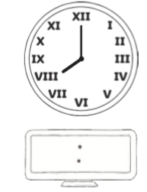

**I can estimate and read time with increasing accuracy to the nearest minute; record and compare time in terms of seconds, minutes and hours**

**I can**

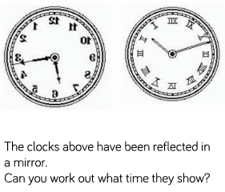

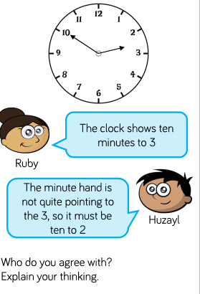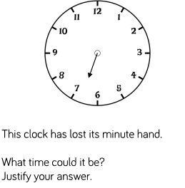

**I can use vocabulary such as o’clock, a.m./p.m., morning, afternoon, noon and midnight**

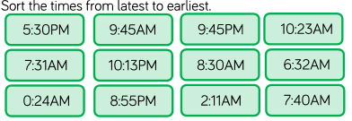

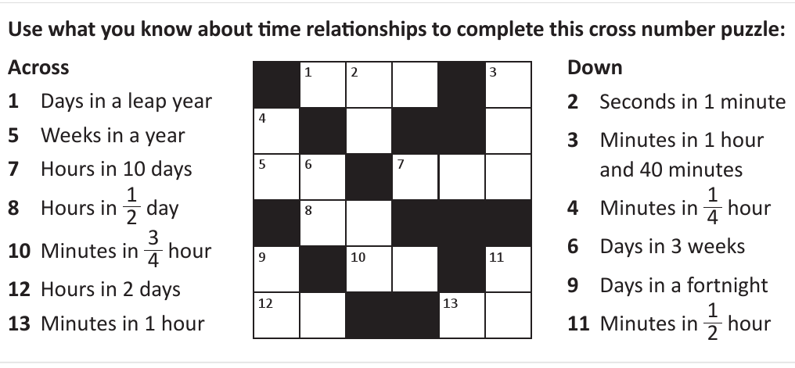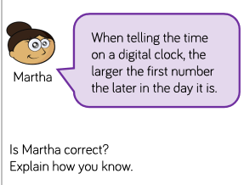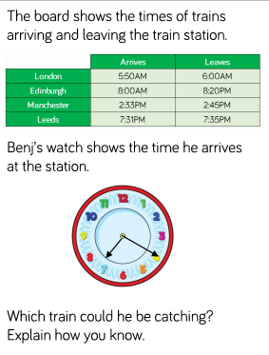

**I know the number of seconds in a minute and the number of days in each month, year and leap year**