|  |
| --- |
| **Maths Home Learning**  **Calculation** |
| **Year 5 Learning Booklet** |

**Identify multiples and factors, including finding all factor pairs of a number, and common factors of two numbers**

**Add and subtract whole numbers with more than 4 digits, including using formal written methods (columnar addition and subtraction)**

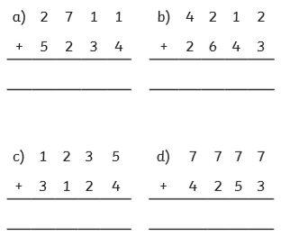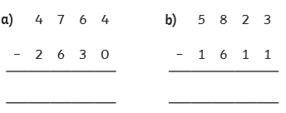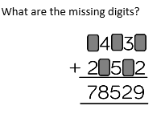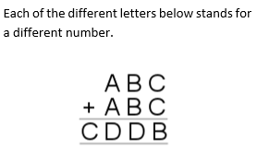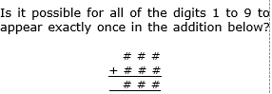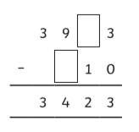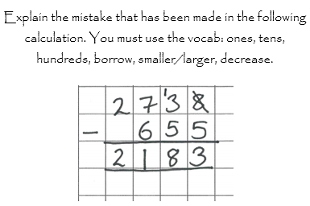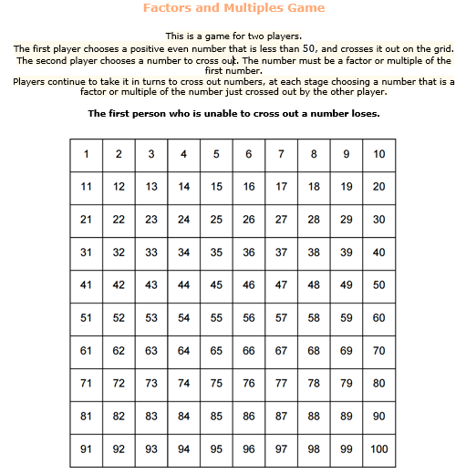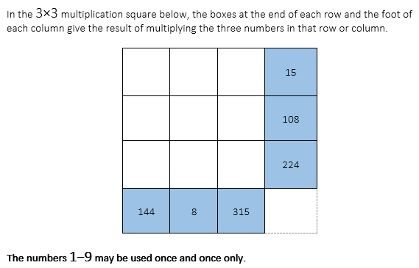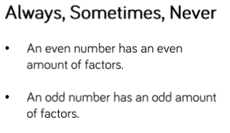

**Round any number up to**

**1 000 000 to the nearest 10, 100, 1000, 10 000 and 100 000**

**Divide numbers up to 4 digits by a one-digit number using the formal written method of short division and interpret remainders appropriately for the context**

**Multiply numbers up to 4 digits by a one- or two-digit number using a formal written method, including long multiplication for two-digit numbers**

**Know and use the vocabulary of prime numbers, prime factors and composite (nonprime) numbers**

