|  |
| --- |
| **Maths Home Learning**  **Measure** |
| **Year 5 Learning Booklet** |

**Convert between different units of metric measure (for example, kilometre and metre; centimetre and metre; centimetre and millimetre; gram and kilogram; litre and millilitre)**

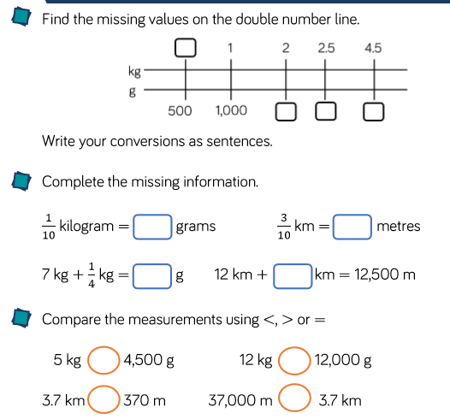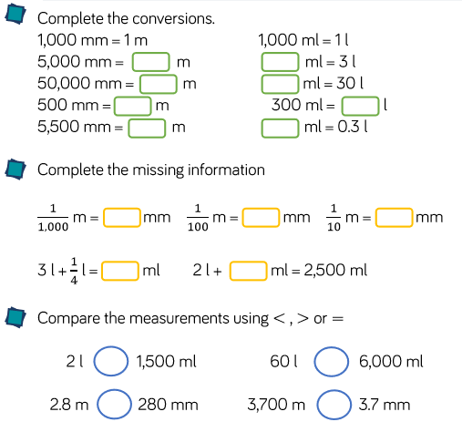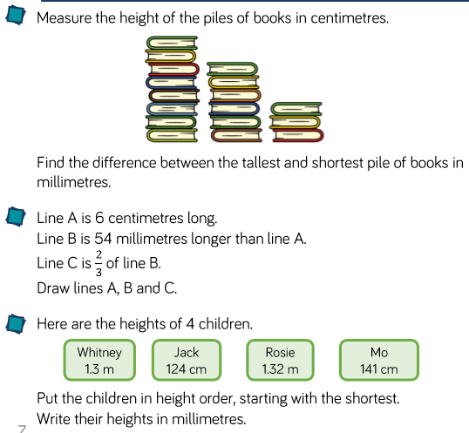

**Use all four operations to solve problems involving measure [for example, length, mass, volume, money]**

**Solve problems involving converting between units of time**

