|  |
| --- |
| **Maths Home Learning**  **Place Value and Number** |
| **Year 5 Learning Booklet** |

**Read, write, order and compare numbers to at least 1 000 000 and determine the value of each digit**

**Count forwards or backwards in steps of powers of 10 for any given number up to 1 000 000**

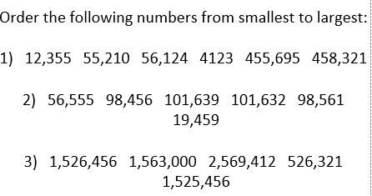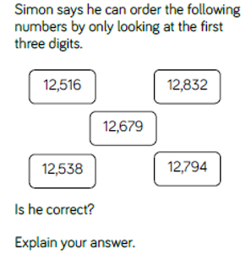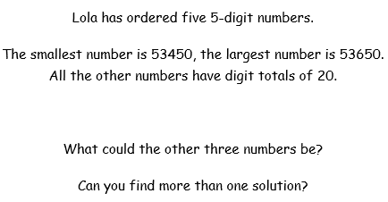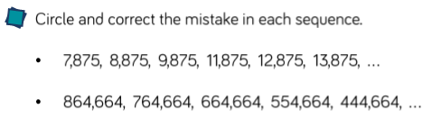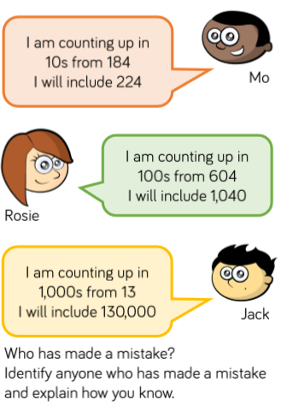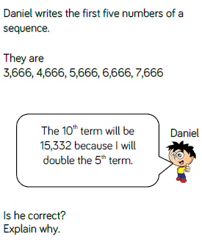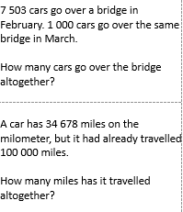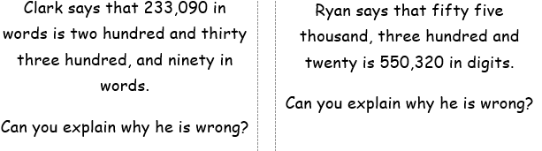

**Round any number up to**

**1 000 000 to the nearest 10, 100, 1000, 10 000 and 100 000**

**-Interpret negative numbers in context, count forwards and backwards with positive and negative whole numbers, including through zero**

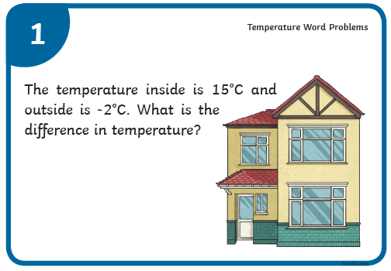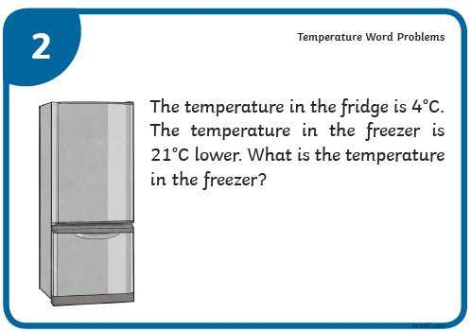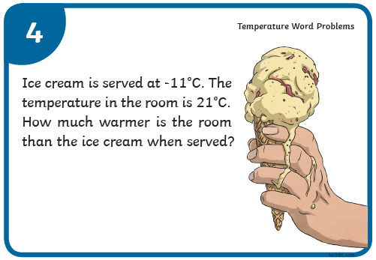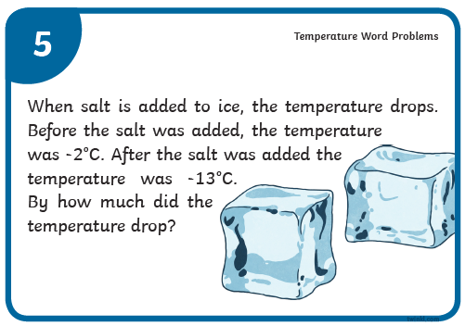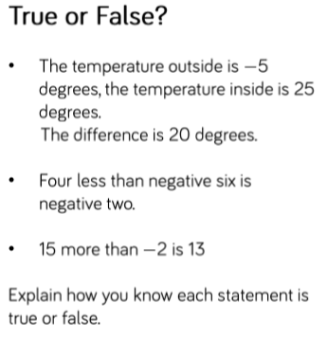

**Round any number up to**

**1 000 000 to the nearest 10, 100, 1000, 10 000 and 100 000**



