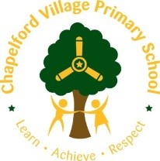  Residential Fieldtrip Learning Opportunities/Ideas  Burwardsley  Year 4  Learn, Practice, Repeat …  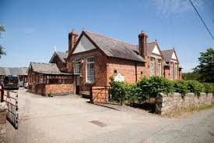 | History  Burwardsley is a village and civil parish the unitary authority of Cheshire West and Chester and the ceremonial county of Cheshire.  St John's Church is in School Lane, Burwardsley, Cheshire. It is recorded in the National Heritage List for England as a designated Grade II listed building. It is an active Anglican parish church in the diocese of Chester.  The church originates from the 17th century. It has a buttress dated 1730, and the church was restored in 1795. In 1871 a further restoration was carried out by the Chester architect John Douglas, which included the addition of a bell turret. Another restoration, with the addition of a chancel which has been attributed to Douglas, was carried out in about 1878.  During the visit the Rector of the church is always happy to share this with the children – please contact prior to the visit.  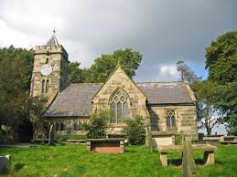  History Activities /Skills/ Learning  A trip to Beeston Castle-Linked to the Normans topic. Look at the castle remains. What is left? What would it have looked like? What was it used for? Discuss the position of the castle-why would this have been useful? Why is it important that we visit the castle?  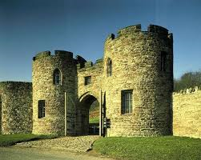  The history of St Johns church. How long has the church been there? What evidence is left on the headstones? Has the church had any restoration work? Why?  Discover the history of Burwardsley residential centre. How long ago was the building used as a school? What were the rooms used for? Can you tell it used to be a school? How?  Recap learning from year 3-Learn in the life size, Iron Age Celtic roundhouse. Discover the local History of Burwardsley. Take part in the archaeological dig experience to excavate and identify the artefacts discovered in the ground. | Geography Activities/Skills/  Learning  Locate on a map. What does the map tell us about the landscape of Burwardsley? Look at historical maps and photographs. Has Cheshire/Burwardsley changed? Could it change in the future? Why? Is all of Cheshire landscape similar? Why?  What are the similarities and differences between Burwardsley and Warrington?  During walk up Willow Hill, track using an ordnance survey map and compasses. Link 4 figure compass points to degrees on a compass. Create own maps and keys, using grid references.  At the top of Beeston Castle, create map using compass directions (folded paper: see KB)  Investigate ordnance survey map of the village. Find the symbols in the village. Add any others. Compare to the village on google maps. What are the advantages and disadvantages of each?  Revisit the use of the River Dee. Where is this in relation to Burwardsley? Look at a map of Burwardsley in Roman times. How has it changed? Why? | PHSCE  Friendships and co-operation (working as a team)  Keeping safe (rules in particular environments)  Risks and hazards (keeping safe in new environment)  Setting personal goals (goals for the trip and achievements – set at beginning and end)  New situations (new environments and working with new people)  Charter Education  Bear Grylls – Survival Unit  MFL  Spring 2/Summer 1 unit  Vocabulary - Feeling well/ unwell  Jungle animals and fantastical  animals  Suggested Activities -Starting the morning with how you feel  Group names/dorms using jungle animals  Game like corners with French vocab  Conversational Opportunities - Conversations in partners about how you feel  Introducing ourselves with age and names  Music  Performing traditional campfire songs with different parts and harmonies, e.g. Gin Gan Gooly, Coca Cola, Princess Pat. Perform with different starting points and an increasing number of groups.  Perform in assembly | Art  Intent  *Children will develop their knowledge of great architects by focussing on Antoni Gaudi.  *Children will use local nature to inspire their work as Gaudi did with his architecture. They will explore how he embellished his designs with mosaics and stained glass.  *Children will overlearn their painting skills applying it to a new type of media.  Expected Outcomes/Art Skills  *Use a variety of tools and  techniques including different  brush sizes and types.  *Suggest how an Artist has used  colour, pattern and shape.  *Create a piece of Art in  response to the work of  another Artist.  Expected Outcome Art Knowledge  * Gustav Klimt was an Austrian painter.  *1862-1918  *He rose to success from a life of poverty.  *His work included lots of symbolism.  *His paintings are very intricate and took many hours to complete.  *Klimt lived a simple life. When at home he wore a long robe and sandals. He painted all day, every day.  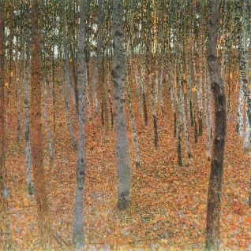  Collage and mixed media of surrounding forest using natural materials: bark, sand…  Local Crafts artist – Sarah Gallagher Hayes Twigtwisters Willow Weaver can be pre-arranged but this will add to the cost of the residential visit – Contact - 07889507348

Y4 – Science at Burwardsley | The centre offer pond dipping which enables them to classify plants and animals.  Afterwards, the staff then go through a food chain and web with the children. | Animals including humans  explore and use classification keys to help group, identify and name a variety of living things in their local and wider environment  construct and interpret a variety of food chains, identifying producers, predators and prey
 | Nature walk | Animals including humans  explore to identify and name a variety of living things in their local and wider environment
 | Children could create musical instruments out of natural things found in the environment of Burwardsley. | Sound  find patterns between the pitch of a sound and features of the object that produced it

Year 4 – PE - Skills Objectives  Invasion Games:  - I can receive the ball from one direction and pass to another  - I can pass the ball to beat a defender and score as many goals as possible.  - I can make up my own game using equipment and rules.  - I am aware of the importance of moving into a space in order to receive a pass from a team member.  - I can compare tactically how my team stopped someone scoring in the game and how the opposition defended their goal.  Striking and fielding:  - I can hit a ball well so that I have a good length of time to score a point.  - I can pass and receive the ball accurately to a team mate.  - I am aware of the importance of move into a space in order to receive a pass from a team mate and discuss the best throw to use to field the ball.  - I can compare tactically how I have stopped someone scoring in the game and teach others.  - I can discuss how I need to change the type of throw/hit to aim at different targets | Year 4 - Ideas linked to the curriculum  - Invasion - Play games involving moving the ball in different ways. Can they roll the ball to their partner on the opposite side; using dominant and non-dominant body parts e.g. hand or foot? Complete timed challenges how many times can you send the ball in your team in a minute?  Can they bounce it down to their partner? Kick it? Strike it? Throw it etc. Set up targets worth different points and compete in houses. Have to stop it with their foot to gain a point. Why would we need to stop a ball with our foot?  - Striking and fielding – Diamond or Kwik Cricket  Stop the children at different points and discuss how to field to support your team? Which is the best throw to get the ball back to the baller or your fielding team? Think tactics.  Play top dog – teams of 5 in a line and they need to catch the ball to stay top dog. Space ball using the balls and cones.

Year 3 + 4 OAA objectives

Objectives:
- I can orientate a simple map by matching shapes or obstacles on the ground to shapes on a map.
- I can use a map to visit a checkpoint.
- I can use my map reading skills to visit a number of checkpoints.
- I can begin to discuss different ways of planning my route.
- I can work in pairs, taking it in turns to plan the next leg of the trail.

 | Area of Computing | Learning Opportunity | Objectives Covered
Year 4 | Creativity | Take photographs of artwork created to share with parents.  Create a presentation of the photographs taken. | Presentation (Powerpoint)  Create a title slide and choose a style. Change the layout of a slide.  Insert a picture/text/graph from the Internet or personal files.  Decide upon and use effective transitions.

