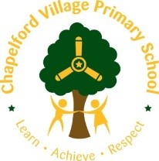  Residential Fieldtrip Learning Opportunities/Ideas  Crosby Hall Educational Trust (CHET)  Year 2  Learn, Practice, Repeat …  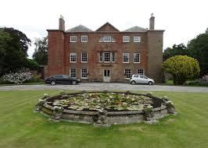 | Modern Foreign Language  Spring 1  Getting to know you:  Numbers and colours  Group names/dorm names could be colours  Using numbers to get into groups, count children, count objects,  A basic conversation with someone you don’t normally work with (in a different year group)  Hello, how are you? Good thanks, you?  Start the day with a French greeting/register.  Music  Create sentences about activities 'pottery is lots of fun' and sing and clap in a rhythm. Teachers use call and response with the children where the children sing this back. Repeat several times to create a group of sentences which can turn into a call and response song.  • Perform this at assembly.  • Talent show | Art  Intent  *Children will develop their knowledge of great artists by focussing on Antony Gormley using his sculpture as an opportunity to create a piece of art using drawing and painting skills.  *This is an opportunity for children to consolidate sketching and painting skills from the Autumn term.  Expected Outcome: Art Skills  *Create textured paint by adding sand, plaster.  *Observe and draw shapes from observations.  *Record and explore ideas from first hand observations  Expected Outcome:  Art Knowledge  *Antony Gormley is a British artist known for his exploration of the human body.  *His most famous works include “Another Place” and “Angel of the North”  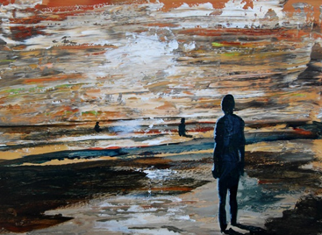 Painting- water colour of Another Place (10 mins from Crosby Hall) | History At Crosby Hall  CHET is a small independent centre situated in a rural setting on a 120 acre estate.  It was created out of the 17th century stables and farm buildings at Crosby Hall, which has been the home of the Blundell family for many centuries.  The Blundell family founded CHET more than 25 years ago.  History Activities/Skills/Learning  Which King or Queen was on the throne in the 17th century? (King George 111) How was their role/way of life similar or different to Queen Elizabeth 11? (Linked to history topic, Summer term)  Estate walk- Walk around the woods of Crosby Hall Estate to learn about times gone by. What was the estate used for? How has the landscaped changed from the 17th century until now? Are there any remains or evidence from the 17th century you can see or touch?  Geography  Crosby-Year 2  Crosby is a coastal town in the Metropolitan Borough of Sefton, in Merseyside, England. Historically in Lancashire, it is situated north of Bootle, south of Southport and Formby and west of Netherton.  Geography Activities/Skills  Learning  Estate walk- Walk around the woods of Crosby Hall Estate to learn about times gone by. What was the estate used for? How has the landscaped changed from the 17th century until now? Look at old maps. Locate Crosby on a map. Which main cities are nearby? What is the place like? Has it changed?  What do the children like and dislike about the area? Justify preferences.  Orienteering activity.  Night walk – is the walk the same or different in daylight and night time? What are the similarities and differences? | PHSCE  Personal Values (setting own goals and understanding own values)  Making Choices (correct choices and consequences of choices – being safe)  Responsibility (being away from home)  Friendships (working co-operatively)  Achievements and Goals (Children set goals for the trip)

Y2 – Science at Crosby Hall | Create a photograph using x rays and solutions. | Working scientifically:  observing closely, using simple equipment  using their observations and ideas to suggest answers to questions
 | Walk in the environment – Measure the temperature and light conditions of the environment. Could use light monitors and thermometers and compare their results with which plants and animals they have found in the environment. | Revision of Y1:  observe and describe weather associated with the seasons and how day length varies  Plants/ Living things and their habitats:  identify that most living things live in habitats to which they are suited and describe how different habitats provide for the basic needs of different kinds of animals and plants, and how they depend on each other  observe and describe how seeds and bulbs grow into mature plants  find out and describe how plants need water, light and a suitable temperature to grow and stay healthy
 | Build dens so they have to consider a lot about the materials they use for different parts. They also covered their den with waterproof materials. | Revision of Y1  distinguish between an object and the material from which it is made  identify and name a variety of everyday materials, including wood, plastic, glass, metal, water, and rock  describe the simple physical properties of a variety of everyday materials

Physical Education At Crosby

 | Year 2 – Skills objectives  Invasion games:  - I can send a ball accurately using a variety of styles to a partner or target and receive with control.  - I can pass a ball to a point and then kick/strike/throw to a target.  - I can show how I keep the ball away from my opponents and send it to the best places to score a point.  - I can discuss the importance of stopping the ball prior to kicking/striking in order to score.  Dance:  - I can create a short sequence of movements which can be repeated or taught to a partner, e.g. stretch, roll, turn, make shapes or actions with their body to show feeling.  - I can put together a sequence which moves from the floor to a tall stretch making movements strong and sudden.  - I can create shapes and discuss how my muscle feels after holding a shape. |  |  |  | Year 2 – Ideas linked to the curriculum  - Invasion - Play games involving moving the ball in different ways. Can they roll the ball to their partner on the opposite side – like in a relay race? Can they bounce it down to their partner? Kick it? Strike it etc. Set up targets worth different points and compete in houses. Have to stop it with their foot to gain a point. Why would we need to stop a ball with our foot?  - Dance - Create a dance linked to the dragon machine – how might a dragon at different parts of the text. What about when the machine crashes? What shapes might they use to make their machine – can the hold them and link them into a sequence? Can they create the sequence in unison or cannon? Discuss it – is it effective? How could they improve their performances? Record them on an ipad and evaluate performances.
 |  | Area of Computing | Learning Opportunity | Objectives Covered
Year 2  Crosby Hall |  | Creativity | Take short video clips of activities.  Capture audio recordings of children talking about an activity they have completed. | Sound recording  Record sound at and away from a computer.  Use software to record sounds.  Change sounds recorded.  Video  Capture video.  Discuss which videos to keep and which to delete.  Arrange clips to create a short film.  Add a title and credits.

