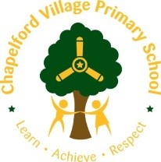  Residential Fieldtrip Learning Opportunities/Ideas  Fox Howl  Year 3  Learn, Practice, Repeat …  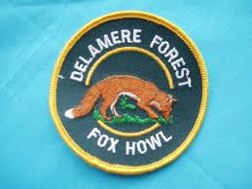  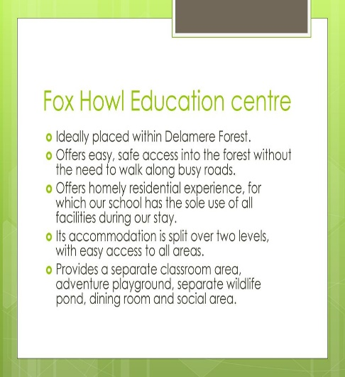 |  | History  Fox Howl-Year 3  Key Knowledge  The forest is all that remains of the great Norman hunting forest of Mara and Mondrum, which once covered much of Cheshire. The name 'foresta de la mara' i.e. forest of the mere or lake, first appears in 1153-60, usually referred to in conjunction with the adjoining Forest of Mondrum. Once one of the hunting forests of the Norman Earls of Chester, it may have previously been an Anglo-Saxon hunting forest. In the early middle ages the forest covered over 60 square miles (160 km2). Game once included wild boar, and red, fallow and roe deer. The more northern Forest of Mara remained wooded in the fourteenth century and still had a population of wild boar, deer and wolves. By that date, however, large areas of the southern Forest of Mondrem had been cleared. The last deer in the forest were killed during the Civil War, as clearance for agriculture progressively diminished the wooded area. A small percentage of the original area of the Forest of Mara, remained a hunting forest until 1812, when an Enclosure Act was passed. The Forestry Commission, established in 1919, took over the management of Delamere Forest in 1924, after which the land was managed for timber production  History Activities/Skills/Learning  How would the animals in the forest have been useful to people in the past?  Why don’t we see them here now?  Is there any evidence that these animals were here?  Why do you think the enclosure act was brought into action?  Pre learning linked to Iron Age to Stone Age (Summer 1)  Geography  Fox Howl-Year 3  Delamere Forest or Delamere Forest Park is a large wood near the village of Delamere in Cheshire, England. The woodland, which is managed by the Forestry Commission, covers an area of 972 hectares (2,400 acres) making it the largest area of woodland in the county.  Geography Activities/Skills/  Learning  Locate on a map. What is nearby? Using 8 figure compass points. Gather opinions about the forest and Chapelford, explaining their reasons.  Compare old and new maps of Delamere. Has it changed? Look at ordnance survey map, plot a route and follow it during the trip. Recreate maps, creating simple keys. Create own orienteering trail in teams around a section of the forest, using compass points.  Look at environmental issues affecting the forest. Look at redevelopment project. Discuss advantages and disadvantages.  https://www.forestryengland.uk/article/delamere-redevelopment-project |  | Modern Foreign Languages - FRENCH  Autumn 1 unit  Getting to know you:  Numbers and colours  Group names/dorm names could be colours  Using numbers to get into groups, count children, count objects,  A basic conversation with someone you don’t normally work with (in a different year group)  Hello, how are you? Good thanks, you?  Start the day with a French greeting/register.  Music  • Create campfire songs about Fox Howl activities e.g. 'Year 3 are dipping in the stream, boys and girls aren't looking very clean!'  • Use call and response as in Year 2 but one group of children call, the others respond, rather than being teacher led.  • Perform at assembly  I've got a great recording of this and lyrics from when we went as an example. |  | PHSCE  Community boundaries and rules (rules/being safe in different environments and communities)  Friendships (working co-operatively e.g den building/orienteering)  Safety (fire safety, safety in the forest etc)  Character Education:  Ed Stafford – Walking in the Amazon | Art  Intent  *Children will create a piece of Art in response to paintings by Gustav Klimt whilst developing their knowledge of great artists.  *Children will explore sketching techniques to support current learning in school.  Expected Outcome: Art Skills  *Use sketchbooks to collect and record visual information from different sources.  *Experiment with different grades of pencil and other implements to create lines and marks  *Add collage to a painted, printed or drawn background.  *Use a range of media to create collages.  *Use different techniques, colours and textures etc when designing and making pieces of work.  *Use collage as a means of extending work from initial ideas  Expected Outcome:  Art Knowledge  * Gustav Klimt was an Austrian painter.  *1862-1918  *He rose to success from a life of poverty.  *His work included lots of symbolism.  *His paintings are very intricate and took many hours to complete.  *Klimt lived a simple life. When at home he wore a long robe and sandals. He painted all day, every day.  Collage and mixed media of surrounding forest using natural materials: bark, sand…  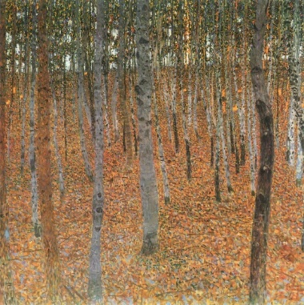
Y3 –Science at Fox Howl | Night walk -  Children could explore the knowledge behind why we have darkness at night and the importance of light when walking. They could take torches to create shadows and the importance of protecting your eyes.  During their walk, they could collect rocks and analyse/ classify them the next day or back at the centre based on their properties. Or they could do this prior to the trip and then try to find examples of rocks whilst on the walk.  Children could search for a flowering plants and revise the different parts of them, labelling, sketching or taking photographs.  Children could identify different plants and explain how each one is adapted to its location. |  | Light  recognise that they need light in order to see things and that dark is the absence of light.  Revision of Y1 – describe weather with seasons and how day length varies.  Rocks  compare and group together different kinds of rocks on the basis of their appearance and simple physical properties  Plants  identify and describe the functions of different parts of flowering plants: roots, stem/trunk, leaves and flowers  explore the requirements of plants for life and growth (air, light, water, nutrients from soil, and room to grow) and how they vary from plant to plant  Revision of Y2  The importance of exercise. Identify and compare things that are living, dead and never alive. Study the habitat, identifying plants and animals within it.
 | Pond dipping and stream fishing so touch on habitats for different creatures, particularly in the water. They also have to read clarification keys to study the features and characteristics of the creatures they find and they use the keys to name the creatures they have caught, justifying why. |  | Revision of Y2  The importance of exercise. Identify and compare things that are living, dead and never alive. Study the habitat, identifying plants and animals within it.
 | Build dens so they have to consider a lot about the materials they use for different parts- sturdy logs for the structure, piles on pine needles for roots. They also hang their own hammocks and consider how they are held up when someone sits in them through the knots. |  | Revision of Y2  Uses of everyday materials  identify and compare the suitability of a variety of everyday materials, including wood, metal, plastic, glass, brick, rock, paper and cardboard for particular uses  find out how the shapes of solid objects made from some materials can be changed by squashing, bending, twisting and stretching
Year 3 - Skills objectives  Dance:  - I can create three movements showing change in speed and level, direction and expression.  - I can develop a phrase of movement by repeating an action and adding linking movements.  - I can create a performance that has a beginning, middle and end.  - I can watch my own dance on video and observe how fidgeting can affect the quality of my performance.  - I can use this understanding to improve my own performance. |  |  |  |  | Year 3 - Ideas linked to the curriculum  - Dance - Create a dance linked to Seal Surfer – how might the characters move at different parts of the text? What movements and shapes might the waves make? Can the hold them and link them into a sequence? Can they create the sequence in unison or cannon? Movements completed at a range of levels, do they flow. Are some of them repeated? Why might they be repeated? Is it effective? Does the dance tell a story? Discuss the performance. How could they improve their performances? Record them on an ipad and evaluate performances.

Year 3 + 4 OAA objectives

Objectives:
- I can orientate a simple map by matching shapes or obstacles on the ground to shapes on a map.
- I can use a map to visit a checkpoint.
- I can use my map reading skills to visit a number of checkpoints.
- I can begin to discuss different ways of planning my route.
- I can work in pairs, taking it in turns to plan the next leg of the trail.

 | Area of Computing | Learning Opportunity | Objectives Covered
Year 3  Fox Howl | Creativity | Take photographs of artwork created to share with parents. | Graphics  Acquire, store and combine images from cameras or the internet for a purpose.

