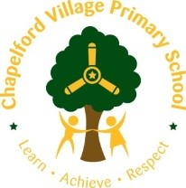  Residential Fieldtrip Learning Opportunities/Ideas  Llandudno  History. The town of Llandudno developed from Stone Age, Bronze Age and Iron Age settlements over many hundreds of years on the slopes of the limestone headland, known to seafarers as the Great Orme and to landsmen as the Creuddyn Peninsula.  Principal area: Conwy  Welsh Assembly: Aberconwy  Ambulance: Welsh  Population: 20,701 (2011)  Year 4  Learn, Practice, Repeat …  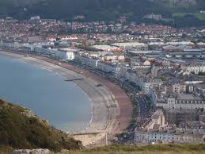 | History Activities/Skills/Learning  How was Llandudno affected by WW2 – can the children find any evidence of WW2 in the town – what can this evidence tell us?  What is the history of the Llandudno tram up the Great Orme – why was built and what was the purpose?  What is the history of Llandudno – what is the evidence that can be seen that may suggest that this was a Victorian Holiday Destination – Victorian Pier/Hotels/Lido ? How are the street names relevant to people who lived there in the past?  The Great Orme Mines – links to the Stone and Bronze Age which is a summer 2 topic! What pre learning can be undertaken?  Geography  Llandudno is a seaside resort, town and community in Conwy County Borough, Wales, located on the Creuddyn peninsula, which protrudes into the Irish Sea.  Llandudno is a city/town with a small population in the state/region of Conwy, Wales which is located in the continent/region of Europe.  Cities, towns and places near Llandudno include Deganwy-Llandudno Junction, Conwy, Llansantffraid Glan Conway and Colwyn Bay.  The closest major cities include Liverpool, Manchester, Stoke-on-Trent and Wolverhampton.  Geography Activities/Skills/  Learning  Where is Llandudno on the map? Locate and describe by linking 8 compass points to degrees on a compass.  Compare a historical map of Llandudno. Has it changed? Suggest reasons for this.  Look at the landscape of the Great Orme on an ordnance survey map.  Before visit, plan the route they will take up to Orme. Follow this during the trip.  During trip up the Orme, create own map, taking photographs as reference points. Draw the contour of the hill, show where the highest point is.  How does the landscape of Llandudno compare to Warrington? How has the landscape of Llandudno changed? What made it change? How might it change in the future?  Conduct community survey on specific topic and present findings. What conclusions can you draw from your evidence?  PHSCE  Being involved in the community (surveys in the public)  Personal safety (rules, talking to strangers etc…) | Modern Foreign Languages - French  Y4/5 SoW  Spring 2/Summer 1 unit  Feeling well/ unwell  Jungle animals and fantastical animals  Weather  Clothes  Starting the morning with how you feel  Group names/dorms using jungle animals  Game like corners with French vocab  Clothing kit list in French  Starting the morning with the weather forecast, talking about clothes based on this  Conversations in partners about how you feel  Introducing ourselves with age and names  What are you wearing today, what you need to go and put on… | Art  Intent  *Children will develop their knowledge of great artists by focussing on Andy Goldsworthy. This is an opportunity to consolidate previous learning about his work in KS1 but use a different media for their sculpture.  *Children will secure their sculpture skills by revisiting unit from SPR 2.  Expected Outcome: Art Skills  *Use sketching to develop initial ideas by selecting and recording from first hand observation, experience and imagination, and explore ideas for different purposes.  *Shape, form, model and construct from observation or imagination.  *Use recycled, natural and man‐made materials to create sculptures.  *Plan a sculpture through drawing and other preparatory work  Expected Outcome:  Art Knowledge  *Andy Goldsworthy is a British sculptor, photographer and environmentalist who produces site-specific sculptures and land art situated in natural and urban settings who lives in Scotland.  *Born 1956.  * He uses found materials to make art. He tries to use exclusively natural elements.  *Because of the transient nature of his art, he always photographs a sculpture after it is complete.  *Name different media for sculpting and their properties.  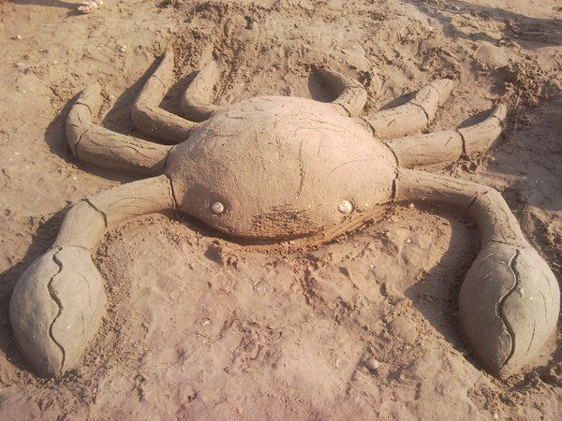  Use natural materials to create a sculpture combining relief and impression to add detail.  Use photography to record their art. | Religious Education  Religious Background for Prior Knowledge  Christianity is the largest religion in Wales. Until 1920 the established church was the Church of England, but from 1920 the disestablished Church in Wales, still Anglican, was self-governing. Wales also has a strong tradition of nonconformist, including Methodism.  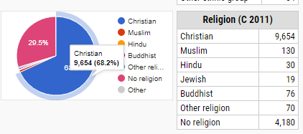  Most adherents to organised religion in Wales follow the Church in Wales or other Christian denominations such as the Presbyterian Church of Wales, Catholicism, Baptist and Methodist churches, and Eastern Orthodoxy. Other religions Welsh people may be affiliated with include Buddhism, Hinduism, Judaism, Islam, Sikhism and Druidism, with most non-Christian Welsh people found in the large cities of Cardiff and Swansea  Learning Opportunities and Skills  Prior to the trip, could the children study the percentage make up of religions in Llandudno? Look at how Christianity is the prominent religion- why do they think this is based on the background of Llandudno? (Beliefs and values skill).  When they are there could they complete surveys (Geography skill) to ask people about their religion? Reflection when home- did their surveys represent their prior knowledge? Look at why this might be? Are the results valid and reliable (science vocab).  Music  •Collect natural material from the beach and create their own percussion.  •Use ipads to record sound buttons of natural sounds- waves, footprints  •Perform percussions in assembly/ combine sound buttons to create a track

Y5 – Science at Llandudno | Children could collect pebbles and rocks and drop them from the pier into the water to revise the effect of gravity (+ air resistance). Link this to the barrel falling in English. They could also explore the forces of the water by observing and recording the wave count.  Study the sun in the morning and ask the children throughout the day where it is and has it moved?  Revisit this in the evening on the beach. What has happened now and why?  Filter and sieve water to purify it at the beach and look at the separation of mixtures with sand and rocks. Use filter paper and measuring cyclinders. | Forces  explain that unsupported objects fall towards the Earth because of the force of gravity acting between the Earth and the falling object  Earth and space  use the idea of the Earth’s rotation to explain day and night and the apparent movement of the sun across the sky  States of matter  use knowledge of solids, liquids and gases to decide how mixtures might be separated, including through filtering, sieving and evaporating

Year 5 - Skills objectives  Net and wall  - I can pass accurately at speed. I can score points by hitting into opponents court so it bounces x2.  - I can play short tennis doubles and singles using basic rules on full court.  - I can beat an opponent by feinting in one direction and passing in another.  - I can comment on success of performance.  - I can discuss how to restart a game after a point has been scored.  - I can explain how I get ready to play a game starting slowly and then getting more vigorous.  Invasion games  - I can pass accurately at speed.  - I can pass the ball into space for a team member to receive, in order to beat an opponent.  - I can beat an opponent by feinting in one direction and passing in another and marking players tightly.  - I can watch a successful team and comment on success of tactic, e.g. passing into a space for a team member to receive.  - I can show in my next attempt, awareness of team members and opponents position.  I can explain how I get ready to play a game starting slowly and then getting more vigorous.  Athletics  - I can sprint and change a baton; I have the ability to take off and include use of arms; I can use a greater range of equipment; I can throw; I can measure how far I can run in a given time, I can measure how high and how I can jump in different ways.  - I can make up a throwing game which involves throwing over a distance.  - I can develop an ability to run around a bend, demonstrating when and how to overtake.  - I can set my own targets to improve time over given straight line/distance e.g. leg action, stride strength.  - I can show how to use arms more vigorously to reach an outstretched arm towards the next runner in a relay exchange. | Year 5 - Ideas linked to the curriculum  - Net and wall – Beach volleyball. Set up a court on the beach using cones and then discuss how they can get points. Where should you hit it to try and get a point. Use some of the children to be umpires and act as the net (improvised net) to ensure that it would go over a net. Show the correct technique for serving, bump, spike etc…Which one would you use when? Record games on an ipad – chn to discuss how they scored the point. Could they create their own game and lead it with other children – working on leadership.  - Invasion - Play games involving moving the ball in different ways. Can they roll the ball to their partner on the opposite side; using dominant and non-dominant body parts e.g. hand or foot? Complete timed challenges how many times can you send the ball in your team in a minute?  Can they bounce it down to their partner? Kick it? Strike it? Throw it etc. Set up targets worth different points and compete in houses. Have to stop it with their foot to gain a point. Why would we need to stop a ball with our foot?  - Athletics - Relay races for sprinting technique, correct way to pass the baton. Throwing for distance – set up targets. Jumping games – correct technique. Take ipad and get them to record one another and discuss how they can jump further, run faster, throw further.

Year 5 OAA objectives

Objectives:
- I can orientate a map to the ground accurately.
- I can follow a course through a number of check points using a large scale map, e.g. of school site with accuracy and speed.
- I can, in a score of orienteering even, decide how many sites I can visit in the time available.
- I can compare with others the different planning that has been used to complete a course or challenge.
 | Area of Computing | Learning Opportunity | Objectives Covered
Year 5 | Productivity | Design a questionnaire – Why do people visit Llandudno?  Present results using excel. | Spreadsheets  Create data collection forms and enter data accurately from these.  Make graphs from the calculations on my spreadsheet.

