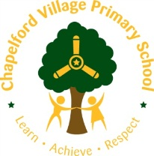

Year 1 Curriculum Overview 2019 / 2020

Year group:  One | Autumn 1  7 weeks 2 days |  | Autumn 2  7 weeks | Spring 1  6 weeks | Spring 2  6 weeks | Summer 1  5 weeks | Summer 2  7 weeks
Maths | - Number and Place Value  - Addition & Subtraction  - Geometry Shape 2D |  | - Place Value  - Number Addition and Subtraction | - Time  - Place Value  - Addition and Subtraction  - Length and Height | - Multiplication and Division  - Fractions  - 3D Shape | - Geometry/ Position  - Place Value  - Four Operations | - Money  - Weight and Volume
English | Poetry – 2 weeks  Lost and Found  Oliver Jeffers - 4 weeks  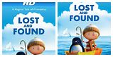  Salina Yoon’s Penguin stories  Be brave little penguin by Giles Andrea  The Emperor’s egg by Martin Jenkins  The penguin who wanted to find out by Jill Tomlinson |  | Poetry – 1 week  Nibbles  Emma Yarlette – 3 weeks  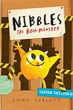  Goldilocks and the three bears by Emma  Chichester Clark  Little Red Riding Hood and Jack and the  Beanstalk texts  The Gruffalo by Julia Donaldson  Where the Wild Things Are  by Maurice Sendak | Poetry – 1 week  Lion Inside  Rachel Bright – 3 weeks  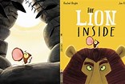  How to be a lion by Ed Vere  The tiger who came to tea by Judith Kerr  Mog the forgetful cat by Judith Kerr | Poetry – 1 week  Beegu  Alexis Deacon – 3 weeks  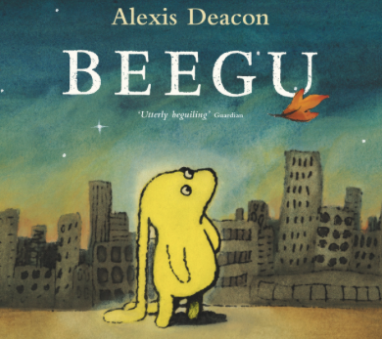  Refugee focus | Toys in Space  Mini Grey – 3 weeks  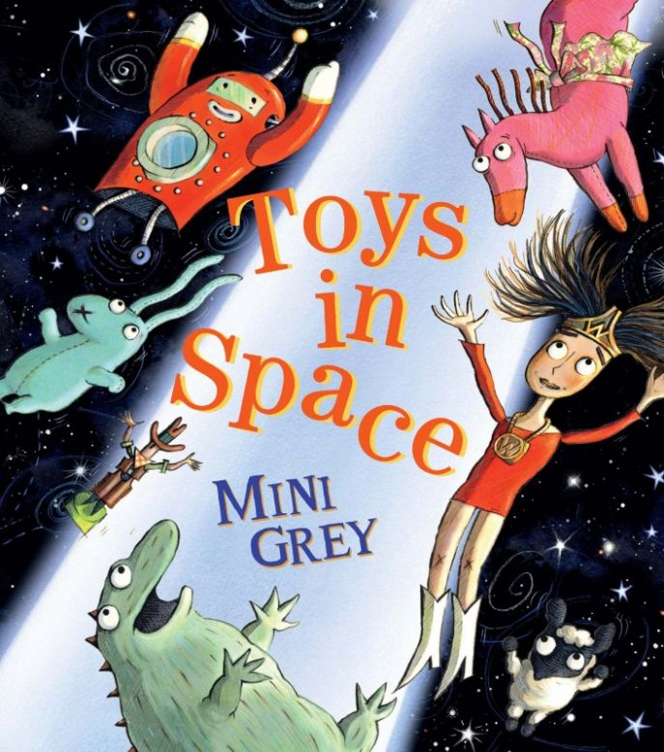  Space Dog by Mini Grey  It was a dark and stormy night by Janet and Allan Ahlberg  One true bear by Ted Dewan | Poetry – 1 week  Goldilocks and Just the One Bear  Leigh Hodgkinson – 3 weeks  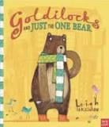  Old bear stories by Jane Hissey  Dogger by Shirley Hughes  Scaredy bear by Steve Smallman
Outcomes | Outcome  Fiction: story based on the structure of Lost and Found  Greater Depth  Change the setting of the story |  | Outcome  Recount: diary  Greater Depth  Add in further details about other characters’ feelings | Outcome  Fiction: story based on the structure of The Lion Inside.  Greater Depth  Change both animals in the story. | Outcome  Greater Depth | Outcome  Fiction: story based on the structure of Toys in Space.  Extension: Instructions  Greater Depth  Choose their own toy to write about and change the space creature. | Outcome  Fiction: story based on the structure of Goldilocks and just the one bear.  Extension: Non-chronological report  Greater Depth  Change the animal and the setting
Sentence | Combine words to make sentences  Write sentences |  | Join words using and | Join words and clauses using and  Sequence sentences to form short narratives | Join words and clauses using and  Sequence sentences to form short narratives | Join words and clauses using and | Join words and clauses using and
Text | Compose a sentence orally before writing it |  | Use plural noun suffixes -s and - es  Sequence sentences to form short narratives (link ideas or events by pronoun) | Add suffixes to verbs where no change is needed to the root | Add suffixes to verbs where no change is needed to the root | Add suffixes to verbs where no change is needed to the root  Change the meaning of verbs and adjectives by adding prefix un- | Use simple description  Sequence narrative accurately
Punctuation | Leave spaces between words  Punctuate sentences using a capital letter and a full stop  Use a capital letter for names of people and the personal pronoun ‘I’ |  | Punctuate sentences using a capital letter and a full top | Punctuate sentences using a capital letter and a full stop, question mark or exclamation mark | Punctuate sentences using a capital letter and a full stop, question mark or exclamation mark | Punctuate sentences using a capital letter and a full stop, question mark or exclamation mark | Use a capital letter for places and days of the week  Punctuate sentences using a capital letter, full stop, question
Word | Word Throughout each unit of Pathways to Write there will be opportunities to teach and apply word skills:  Spell words containing each of the 40+ phonemes already taught  Spell common exception words
 | 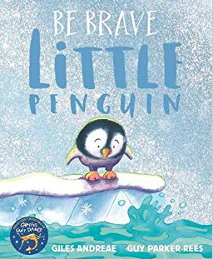  Agreed Additional Unit:  Be Brave little penguin – Jiles Andree – 2 weeks |  | 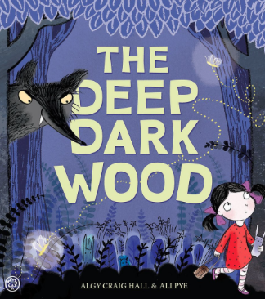  Agreed Additional Unit:  In the Deep Dark Wood  Algy Craig Hall – 2 weeks | 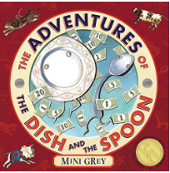  Agreed Additional Unit:  The adventures of the dish and the spoon  Mini Grey – 2 weeks | 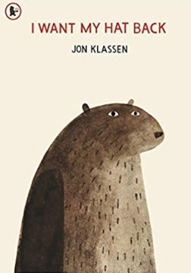  Agreed Additional Unit:  I want my hat back  Jon Klassen – 2 weeks | 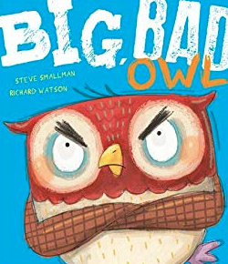  Agreed Additional Text:  The Big Bad owl  Steve Smallman – 2 weeks | 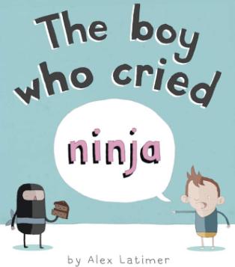  Agreed Additional Text:  The Boy Who Cried Ninja  Alex Latimer – 2 weeks
Non Fiction Focus | Information Texts about penguins (Fact file) Use introduction to Ruby Rat |  |  | Recount – Reggie (form of diary) |  | Instructions – How to make a happy hat – Iggy
Non Fiction Apply (Previous taught to apply across English or LC) |  |  | Information Texts (Fact file) |  | Recount (newspaper form) |  | Instructions – non-fiction topic based as Summer 1 is fiction
Class Author Study | Julia Donaldson |  | Oliver Jeffers | Nicola Davis – World Book Day Focus and Art Week | Benji Davis | Martin Waddell | Allan Ahlberg
Poetry Focus | Michael Rosen  A Great Big Cuddle |  |  | James Berry  Caribbean Playground Songs – CLPE Resource |  | AA Milne
Role Play  Small World | Role Play: Boat Design Workshop  In The Wild Collection  British Wildlife Collection |  | Fairytale Small World encouraging design and making of their own Fairytales | The Lion Inside – Small World  Leading onto African Safari Small World in Spring 2 |  | Small World –Space and Space Travel - link to fiction and non fiction texts | Traditional 3 Bears Small World – woodland scene, cottage, plates, bears etc – good maths opportunity – size, compare etc  To then move onto Goldilocks and Just the One Bear – City Small World.
Theme | Waterways |  | Light and Dark | Wild Thing! | All About Me! | The World Around Us and Beyond. | If you go down to the woods today …
Educational Visits  And Residentials | Visit to Anderton Boat Lift – trip on a boat, understanding of canals etc. |  | Christmas Theatre Visit  (Writing for a purpose opportunity!) |  |  | Visit to Jodrell Bank  EYFS and Key Stage 1 Design a Garden for Arley Hall | Visit to Walton Hall and Gardens  Tree walk  Plants and tree identification  Seasonal Weather  Picnic
Science  Ask simple questions and recognise that they can be answered in different ways;  Observe carefully, using simple equipment;  Identifying and classifying  Using their observations and ideas to suggest answers to their questions;  Gathering and recording data to help in answering questions. | Which Materials would best make a boat?  (Everyday Materials)  Distinguish between an object and the materials from which it is made;  Identify and name a variety of everyday materials, including wood, plastic, glass, metal, water and rock;  Describe the simple physical properties of a variety of everyday materials;  Compare and group together a variety of everyday materials on the basis of their simple physical properties. |  | Why does it get darker earlier in winter?  (Seasonal Change)  Observe changes across the four seasons;  Observe and describe weather associated with the seasons and how day length varies.  Nocturnal animals | Why Are humans not like Lions and other animals?  (Humans and Animals)  Identify and name a variety of common animals, including fish, amphibians, reptiles, birds and mammals;  Identify and name a variety of common animals that are carnivores, herbivores and omnivores;  Describe and compare the structure of a variety of common animals (fish, amphibians, reptiles, birds and mammals, including pets);  Identify, name, draw and label the basic parts of the human body and say which part of the human body is associated with each sense. | Animals Including Humans  The Senses  Name part of the human body  Identify, name, draw and label the basic parts of the human body and say which part of the human body is associated with each sense. | Which plants and trees do we find on planet earth?  Do we find plant and trees in Space?  (Plants and Animals)  Identify and name a variety of common, wild and green plants, including deciduous and evergreen trees;  Identify and describe the basic structure of a variety of common flowering plants, including trees.  To include working scientifically - ask simple questions and recognise that they can be answered in different ways  Observe carefully using different equipment  Identify and classify  Using observations suggest ideas to answer their questions  Gather and record data
Ongoing Science all Year | How do the seasons impact on what we do?  Observe changes across the four seasons  Observe and describe weather associated with the seasons and changes to length of the days.
History | Investigation into the life of:  Captain Edward J Smith (Captain of Titanic)  (Significant people from History)  (The lives of significant individual’s in Britain’s past who have contributed to the nations achievements)  Chronological Understanding:  Historical Knowledge:  Historical Interpretation:  Historical Enquiry: |  |  |  | What has changed since my Grandparents were young?  (Changes within living memory)  Looking at the local area, schools and education, toys, recreational activities and technology – what was it like in the past compered to now?  Interviews with Grandparents - first-hand knowledge and secondary resources – photographs etc.  Chronological Understanding:  Historical Knowledge:  Historical Interpretation:  Historical Enquiry: |  | What Was Here before Our School?  Local Area Study – Maps  Focus on why Warrington pack shared.  (Changes within living memory)  Link with Burtonwood Museum and investigate the life of the school grounds during WW2 – links with RAF and American Army.  Chronological Understanding:  Historical Knowledge:  Historical Interpretation:  Historical Enquiry  What Was Walton Gardens Like in The Past? How has it changes – historical enquiry.
 |  |  | Where Do, and Did the Boats on the Manchester Ship Canal Go?  (To develop knowledge of our own locality – use geographical skills including first hand observation)  To develop an awareness of th  e past and the ways it is similar and different to the present)  I understand places are linked with boats and transport etc.  Locational Knowledge:  Name, locate and identify characteristics of the four countries, capital cities of the United Kingdom and surrounding seas – Liverpool, Manchester, England, North Sea  Place knowledge:  Human and Physical Geography:  Use basics geographical vocabulary to refer to:  Physical Features:  Sea, ocean, river, canal, coast  Human Features: city, town, farm, port  Geographical skills and fieldwork:  Use world maps, atlases and globes to identify the UK and its countries, continent and oceans – England.  Use simple compass directions N, S, E and W)  Use aerial photographs and plan perspectives to recognise landmarks – devise a simple map – use and construct a basic key  Key Vocabulary:  Recap from EYFS: beach, sea, lake, river, mountain, dessert, countryside, forest, building, town, farm, road, park, path, people, land, world, map, local, place, globe | Why Can’t a Lion Live in the North Pole?  (Identify seasonal weather patterns in the UK and the location of hot and cold areas of the world in relation to the Equator and North and South Poles)  I can ask simple geographical questions  I can use simple maps of the local area  I can use positional language  I can understand how some places are linked to others  I can compare places I know  Locational Knowledge  Place knowledge:  Human and physical geography  Weather charts, seasons, clothing.  Geographical Fieldwork:  Map and Atlas Work:  Key Vocabulary:  weather, season, compass, compass points, North, South, East, West, equator, hot, cold, direction, country, right, left |  |  | The UK  The United Kingdom  Capitals cities  Locate the four countries on a map of the UK  Locate waterways on a map  Key Vocabulary:  Capital city, country, England, Scotland, Wales, N. Ireland, Belfast, Cardiff, Edinburgh, London,
Art | 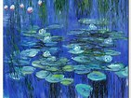  Painting  To explore the painting techniques of Monet - colour mixing, shade, perspective and texture (preliminary studies) using a range of paints – acrylic, watercolour  To use a variety of tools and different techniques – brush sizes and tools.  Mix colours  Colour – identify primary colours by name  Create texture within paint by adding sources – sand etc. |  | 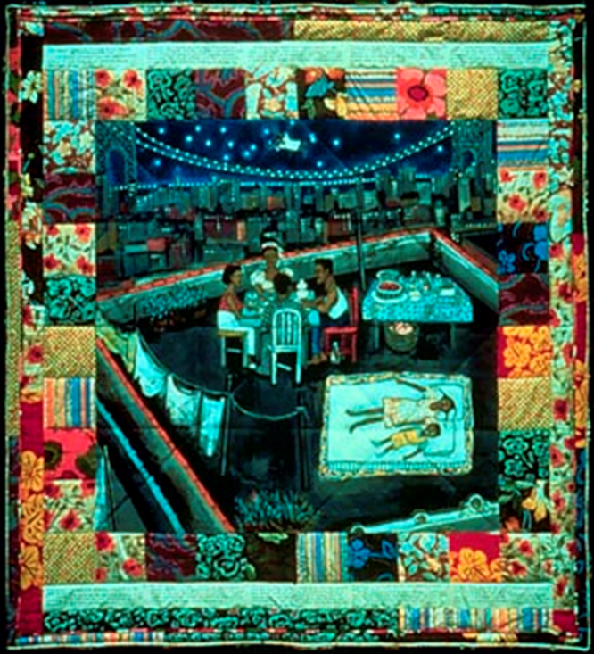  Collage  Create images from s variety of media – photocopies, material, art works, books  Arrange and glue to a variety of backgrounds  Sort and group for purpose  Fold, crumple, tear – overlap images,  Work on different scales  Linked to fairytales to make a collaborative class story quilt collage  Colour – Collect, sort, name, match – appropriate for an image.  Shape – Create and arrange shapes appropriately  Create texture by weaving materials – paper and natural resources through recycled materials | Drawing  Experiment with a variety of media; pencils, rubbers, crayons, felt tips,  Name, match and draw lines/marks from observations.  Invent new lines. Draw on different surfaces with a range of media.  Observe and draw shapes from observations. Draw shapes in between objects. Invent new shapes.  Investigate textures by describing, naming, rubbing, copying. | Sculpture  Experiment with constructing and joining recycled, natural and manmade materials | Printing  Print with a range of hard and soft materials e.g. corks, pen barrels, sponge.  Build repeating patterns and recognise pattern in the environment.  Roll printing ink over found objects to create patterns e.g. plastic mesh, stencils  Make rubbings to collect textures and patterns | Textile  Indian Block Printing  Apply colour with printing, dipping, fabric crayons  Create and use dyes i.e. onion skins, tea, coffee
Artist Study | 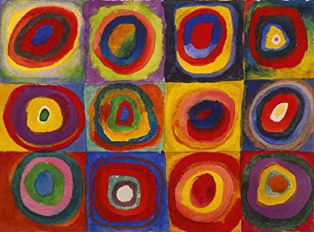  Kandinsky |  | Faith Ringgold  Story Quilts  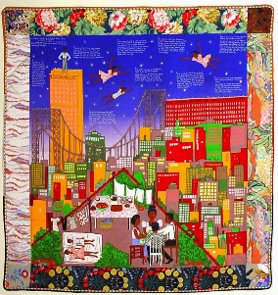 | Henri Rousseau  Jungles 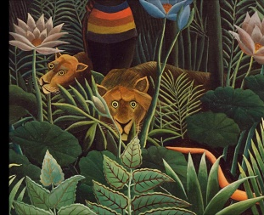 | Andy Goldsworthy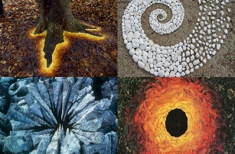  Suggested materials – Naturak Materials | Artist Study  Van Doesburg  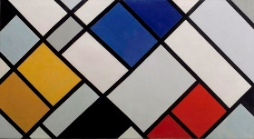 | Molly Mahon  Indian Block Printing - 20th century block printer – fabric and paper
Design Technology |  | Design Technology  Make a Cage to Keep Nibbles In  Free Standing Structures  Deconstruct, design and make a cage  DESIGN – Design purposeful, functional and appealing products for themselves and other based upon a design criterion  MAKE – select from and use a range of tools and equipment to perform practical tasks – cutting, shaping, joining and finishing  EVALUATE – explore and evaluate a range of existing products  TECHNICAL KNOWLEDGE –Build Structures exploring how they can be made stronger, stiffer and more stable. |  |  |  | Healthy Living week.  Can they design their own healthy fruit picnic?  Preparing fruit and vegetables  Design – purposeful, functional and appealing products for themselves and others based upon a design criterion.  Make – select from and use a range of tools and equipment to perform practical tasks.  Evaluate - Which fruit/vegetables might be the best for our product to match the occasion/purpose? – Healthy.  Technical - Children examine a range of fruit/vegetables. Use questions to develop children’s understanding.  Design Technology  Deconstruct, design and make a class bus – wheels and axils  DESIGN – Design purposeful, functional and appealing products for themselves and other based upon a design criterion  MAKE – select from and use a range of tools and equipment to perform practical tasks – cutting, shaping, joining and finishing  EVALUATE – explore and evaluate a range of existing products  TECHNICAL KNOWLEDGE –explore how to use mechanisms wheel and axis in their products
Cooking  Opportunities |  |  |  | Christmas Cooking  Sweets |  | Easter Biscuits /Cakes
Music  (charanga) | Hey You! |  | Little Angel Gets Her Wings | In the Groove | Rhythm in the Way We Walk and Banana Rap | Round and Round | Reflect, Rewind and Replay
Computing  (scheme)  Digital Literacy | Computer Networks  Keep It Private  Going Places Safely |  | Creativity  ABC Searching | Productivity | Creativity  My Creative Work | Programming | Communication  Sending E Mail
PE  (Real PE/Games) | Real PE  Gymnastics |  | Real PE  Dance | Real PE  Games - Football Focus | Real PE  Athletics | Real PE  Gymnastics and Dance linked to topic | Real PE  Games
Religious Education  What do people say about God? (God) | Hindu Dharma  What is God like?  Diwali |  | God – Christianity  How do some people behave because they believe in God. | Christianity – Baptism  What do dome people do because they believe in God? | Christianity –Easter  What stories are told about God and why are they told? | Islam – Why do some people think God made the World? | Judaism – Pesach  How do some people behave because they believe in God.
PHSCE | The School Community  Classroom Rules  Making a classroom  a caring environment.  Thinking about self  and others  Respect  ** NSPCC Pants ** |  | Friendships & Relationships  Recognising emotions through facial expression and body language  Behaviour  Anti-Bullying Week  Value of having friends  Caring for others | My Family  Family groups – diversity of family (Stonewall)  Respect for others  Part of community or groups  Jobs | Keeping Safe – Self Awareness  Road safety  Safety at home  Safe places/people  Internet safety | Health and Wellbeing  Personal hygiene  Medicines  Germs  ** Kidsafe ** | What have I Achieved?  Personal goals  Emotions and feelings  Value achievements and talents  ** Kidsfe**
Charcater Education | A Walk on the Wild Side  Steve Backshall |  |  | Simba And Me – Circle fo Life  Walk Disney |  | Traditional Tales  Once Upon A Time …

