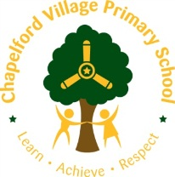

Year 2 Curriculum Overview 2019 / 2020

Year group:  Two | Autumn 1  7 weeks 2 days | Autumn 2  7 weeks | Spring 1  6 weeks | Spring 2  6 weeks |  |  | Summer 1  5 weeks |  | Summer 2  7 weeks
Maths | - Number & Place Value  - Addition & Subtraction | - Multiplication  - Division | - Number & Place Value  - Mass/Weight  - Counting & Money | - Length/Mass & weight  - Shape 2D and 3 D  Assess & Review |  |  | - Number/Place Value/Statistics  - Addition & Subtraction  - Capacity/Volume/Temperature  - Fractions  - Position/Direction/Time  - 2D and 3D shape  - Length and Mass  - Time |  | - Capacity, Volume, temperature  - Statistics  - Statistics ( including finding the difference)  Assess & Review
English | Poetry – 2 weeks  Troll Swap  Leigh Hodgkinson - 3 weeks  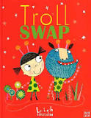  Novel:  Trolls Go Home  Alan McDonald | Poetry – 1 week  Norbert  Joanna Boyle (2018 – 2019) – 3 weeks  *Using the plan from The Owl Who Was Afraid of the Dark.  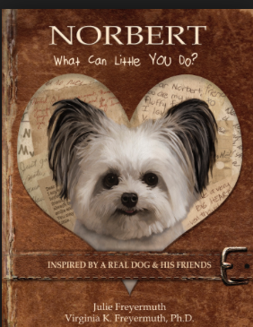  Novel: The legend of Spud Murphy  Eoin Colfer | Poetry – 1 week  My name is not refugee  Kate Milner – 3 weeks  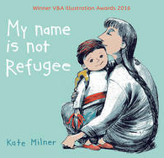  Novel: Paddington | Poetry – 1 week  The Last Wolf  Mini Grey – 2 weeks  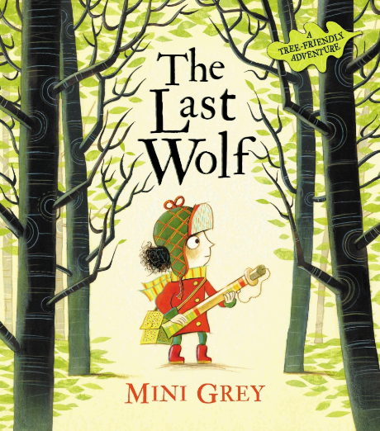  Novel  Fantastic Mr Fox  Roald Dahl |  |  | Revision unit:  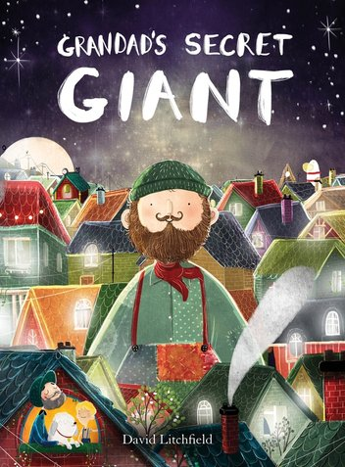  Grandad’s Secret Giant  David Litchfield – 3 weeks  Novel  The BFG  Roald Dahl |  | Poetry – 1 week  The Sea Monster  Chris Wormell – 3 weeks  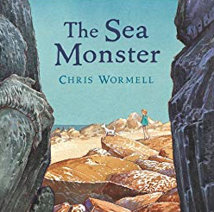  The Secret of Black Rock
Outcome | Outcome  Fiction: story with focus on characters  Greater Depth  Story about two independently invented contrasting characters who swap places | Outcome  Non-chronological report: report about owls  Greater Depth  Alter the layout to include own subheadings and extra features | Outcome  Fiction: story with adventure focus  Extension: Instructions  Greater Depth  Story written in 1st person | Outcome  Letter: letter in role as the character persuading to save the trees  Greater Depth  Real life letter to specific audience e.g. local MP |  |  | Outcome  Fiction: story with moral focus  Greater Depth  Story from the point of view of the giant |  | Outcome  Greater Depth
Sentence | Use subordination (because) and co-ordination (and)  Write expanded noun phrases to describe and specify | Use co-ordination (but, or)  Add -ly to turn adjectives into adverbs | Write sentences with different forms: statement, question, exclamation, command  Use subordination (apply because, introduce when)  Use present and past tenses correctly and consistently (some progressive) | Use present and past tenses correctly and consistently  Use the progressive form of verbs in the present and past tense  Use subordination (apply because, when; introduce that) |  |  | Use subordination (if, that)  Add -er and -est to adjectives  Use homophones and near homophones |  | Use present and past tenses correctly and consistently including the progressive form  Use subordination (using when, if, that, or because) and co-ordination (using or, and, or but)  Write expanded noun phrases to describe and specify  Add suffixes to spell longer  words e.g. -ment,- ful
Text | Plan or say out loud what is going to be written about | Write for different purposes | Read aloud with intonation | Write down ideas, key words, new vocabulary |  |  | Write down ideas, key words, new vocabulary |  | Make simple additions, revisions and corrections
Puncuation | Punctuation  Use punctuation correctly - full stops, capital letters | Punctuation  Use commas to separate items in a list | Punctuation  Use punctuation correctly - exclamation marks, question marks | Punctuation  Use punctuation correctly - apostrophes for the possessive (singular) |  |  | Punctuation  Use punctuation correctly – apostrophes for contracted forms |  | Punctuation  Proof-read to check for errors in spelling, grammar and punctuation
Word | Throughout each unit of Pathways to Write there will be opportunities to apply word skills:  - Spell many words correctly by segmenting spoken words into phonemes and representing these by graphemes  - Spell common exception words.
 | 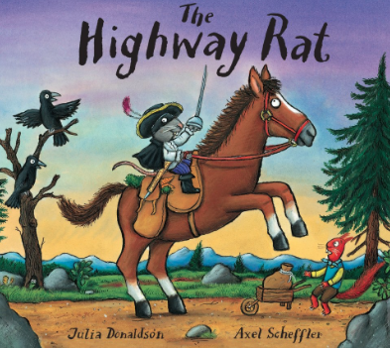  Agreed Additional Text:  The Highway Rat  Julia Donaldson – 2 weeks | 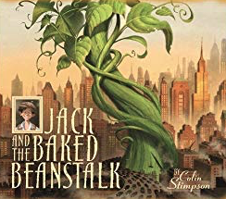  Agreed Additional Text:  Jack and the bakedbean stalk – 2 weeks | Agreed Additional Text:  The Man on the Moon  Simon Bartrom – 2 weeks  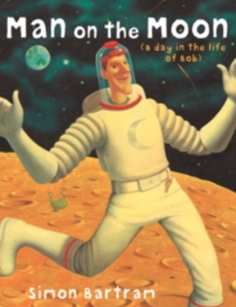 | 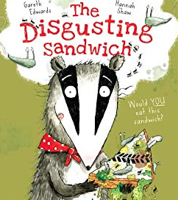  Agreed Additional Text:  The Disgusting Sandwich  Gareth Edwards – 3 weeks |  |  | 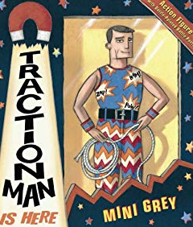  Agreed Additional Text:  Traction Man  Mini Gray – 2 weeks |  | 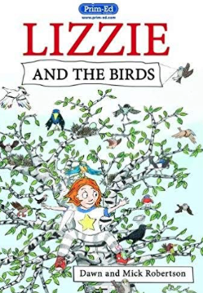  Agreed Additional Text:  Lizzie and the birds (text and the handbook) – 2 weeks
Non Fiction Focus | Instructions (How to be a good troll) | Non-chronological reports (Penquin – missing page from an information book) |  | Recount in the form of a diary for Traction Man
Non Fiction Apply (Previous taught to apply across LC or English) |  | Instructions (based on a real event/task) | Non-chronological reports (Leaflet links to Crosby) |  |  |  |  |  | Recount of trip to the beach (real life)
Class Author Study | Julia Donaldson | Raymond Briggs | Emily Gravett | Jeanne Wilis |  |  | Mini Grey |  | Roald Dahl
Poetry focus | Michael Rosen  A Great Big Cuddle |  | Julia Donaldson  “Question Time”  Poem to Perform  CLPE Resource  Focus: reading, learning to recite, developing vocabulary. |  |  |  | Aoife Mannix  Billy McCool  King of the Dinosaurs  CLPE Resource  Focus: reading, learning to recite, developing vocabulary.
Small World | Troll Den and Fairy Tales  Fairytale writing / retelling | Jack and The Baked Beanstalk  Small World Table
Theme | Houses and Homes | Kenya and Us | Significant British Individuals - Chrostopher Columbus |  | Super Humans |  |  | Great Fire of London  EYFS and Key Stage 1 Design a Garden for Arley Hall | The Seaside
Educational Visits and Residentials | Local walk in the community – Deakota Park, Local Area Study | Theatre Visit  (Opportunity for Writing) | Crosby Residntial Visit  Geographical study – difference between Crosby and Great Sankey | Eureka Museum |  |  | Visit to Formby Beach and Picnic  (Geographical Study)  Plan for end of Summer 1/early Summer 2
Science  Ask simple questions and recognise that they can be answered in different ways;  Observe carefully, using simple equipment;  Identifying and classifying  Using their observations and ideas to suggest answers to their questions;  Gathering and recording data to help in answering questions. | What are our homes made of?  (Materials)  Identify and compare the suitability of a variety of everyday materials, including wood, metal, plastic, glass, rock, brick, paper and cardboard for particular uses;  Find out how the shapes of solid objects made from some materials can be changed by squashing, bending, twisting and stretching | How can we grow our own Giant Beanstalks?  (Plants)  Observe and describe how seeds and bulbs grow into mature plants;  Find out and describe how plants need water, light and suitable temperature to grow and stay healthy.  . |  |  | How can you be the next sports star?  (Animals including Humans)  In Science children will deepen their knowledge about animas including humans. They will learn about basic needs of animals to survive and the importance of maintaining a healthy lifestyle Notice that animals, including humans, have offspring, which grow into adults;  Find out about and describe the basic needs of animals, including humans for survival (water, food and air);  Describe the importance for humans of exercise, eating the right amount of different types of food, and hygiene |  |  |  |  | Why would a giraffe not make a good pet?  (Living things and their Habitats)  Explore and compare differences between things that are living, dead and things that have never been alive;  Identify that most living things live in habitats to which they are suited and describe how different habitats provide for the basic needs of different kinds of animals and plants, and how they depend on each other;  Identify and name a variety of plants and animals in their habitats, including micro-habitats;  Describe how animals obtain their food from plants and other animals, using the idea of a simple food chain, and identify and name different sources of food.
History |  |  | Why were Christopher Columbus and Neil Armstrong Brave people?  The lives of significant individuals in Britain's past who have contributed to our nation's achievements. Can they recount the life of someone famous from outside Britain who lived in the past giving attention to what they did earlier and what they did later?  Can they recount some interesting facts from an historical event?  Can they answer questions by using a specific source, such as an information book? |  |  |  | The Great Fire of London  Samuel Pepys  Events beyond living memory that are significant nationally or globally.  Can they use words and phrases like: ‘before I was born’, ‘when I was younger’?  Can they use phrases and words like: ‘before’, ‘after’, ‘past’, ‘present’, ‘then’ and ‘now’; in their historical learning?  Can they use the words ‘past’ and ‘present’ correctly?  Can they sequence a set of events in chronological order and give reasons for their order?  Can they find out something about the past by talking to an older person?
Geography | What can we find out about Chapelford Village ?  Use the text - I am Here Where Are You by Anita Jones /Sarah Horne  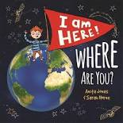  (Author will visit school)  Why Warrington? link  Use simple fieldwork and observational skills to study the geography of their school and its grounds and the key human and physical features of its surrounding environment.  Use aerial photographs and plan perspectives to recognise landmarks and human and physical features, devise simple maps, construct basic symbols and keys  I can label a diagram or photograph using some geographical words  I can say what they like and don’t like about their locality.  I can describe some places which are not near the school  Do I think that people ever spoil the area? How?  Key Vocabulary;  Village, factory, house, office, harbour, shop, cliff, forest, hill, mountain, soil, valley, vegetation, address | Where would you like to live England or Kenya?  Where would you like to live England or Kenya ?  Understand geographical similarities and differences through studying the human and physical geography of a small area of the United Kingdom, and of a small area in a contrasting non-European country. (Not the whole country)  Name and locate the world’s seven continents and five oceans.  I can find out about Africa (small area) by asking some relevant questions to someone else  I can describe a place outside Europe using geographical words  Use aerial photographs and plan perspectives to recognise landmarks and human and physical features, devise simple maps, construct basic symbols and keys  Key Vocabulary:  Asia, Africa, North America, South America, Antarctica, Australia, Oceania, Australasia, Europe, oceans: Arctic, Southern, Pacific, Atlantic, Indian, fieldwork, plan, aerial photograph, map key symbols, continent, globe, atlas |  |  |  |  |  |  | Oh We Do Like to be Beside The Seaside .  I can describe some human features of a town, such as the jobs people do  I can say what they like and don’t like about a locality and another locality like the seaside  I can describe the key features of a place, using words like, ‘forest’, ‘hill’, ‘mountain’, ‘valley’  I can describe some physical features of a town  I can find out about a town by asking some relevant questions to someone else  Key Vocabulary;  Village, factory, house, office, harbour, shop, cliff, forest, hill, mountain, soil, valley, vegetation, address
Art | 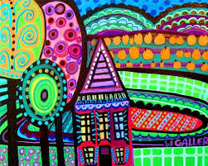  Painting  To explore tha painting techniques of Hundertwasser - colour mixing, shade , perspective and texture (preliminary studies) using a range of paints – acrylic based and translucent paint (Brusho)  To use a variety of tools and diferent techniques – brush sizes and tools.  Mix colours  Colour – identfy primary colours by name  Create texture within paint by adding sources – Beads  See collage pictures in school interview room. | 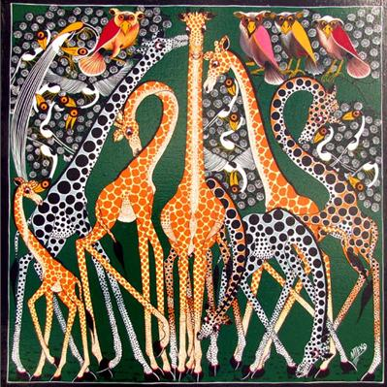  Collage  Create images from s variety of media of African Art – photocopies, maerial, art works, books  African pattern  Arrnage and glue to a varity of backgrounds  Sort and group for puspose  Fold, crumple, tear – overlap images,  Work on different scales  Linked to African geography study  Colour – Collect,sort, name, match – appropriate for an image.  Shape – Create and arrange shapes appropriately  Create texture by weaving materials – paper and natural resources through recycled materials | Drawing  Experiment with a variety of media; pastels, charcoal, ballpoints, chalk.  Use differently textured and sized media.  Observe and draw shapes from observations. Draw shapes in between objects. Invent new shapes.  Investigate tone by drawing light/dark lines, light/dark patterns, light dark shapes et | Sculpture  Manipulate malleable materials in a variety of ways including rolling and kneading.  Explore sculpture with a range of malleable media Manipulate malleable materials for a purpose, e.g. pot, tile.  Texture  Change the surface of a malleable material. e.g. build a textured tile. |  |  | Printing  Make simple marks on rollers and printing palettes.  Take simple prints i.e. mono ‐printing |  | Textile  Weaving  Match and sort fabrics and threads for colour, texture, length, size and shape.  Change and modify threads and fabrics, knotting, fraying, fringing, pulling threads, twisting, plaiting.  Create fabrics by weaving materials i.e. grass through twigs, carrier bags on a bike wheel.  Create cords and plaits for decoration.  Weaving and wrapping pebbles.
Artisit Study | Hundertwasser  Focus on homes and Buildings 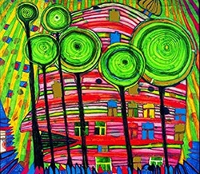 | Edward Saidi Tingatinga in 1968.  https://art-educ4kids.weebly.com/african-art.html  Tingatinga paintings originated in Tanzania .Edward began his work painting under a Baobob tree. His work consisted of bright, bold colours, simplistic designs, inspired by his surroundings in Africa . | Anthony Gormley  (Crosby)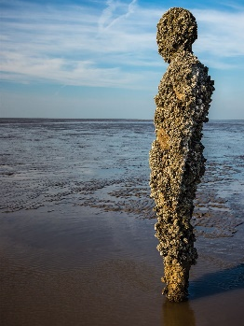 | Henry Moore  Suggested Material: Air Drying Clay  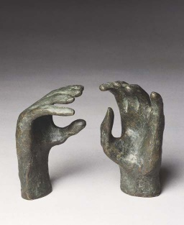 |  |  | Artist Study Arcimboldo, Giuseppe  (print with fruit/veg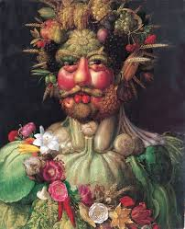 |  | Carolyn Saxby  Seaside Weaving using recycled materials  www.textileartist.org
Design Technology | Make a Troll House  Templates and joining techniques.  DESIGN – generate, develop,model ad communicate their ideas through drawing, templates, mock ups  MAKE – select and use a wide range of materias and componenents according to their characteristics (link with science)  EVALUATE – EVLAUATE A RANGE OF EXISTING PRODUCTS – MATERIALS THAT ARE USED TO MAKE a puppet?  TECHNICAL KNOWLEDGE – use materials and tools appropriate to the design. |  |  |  |  |  | Healthy Living week.  Focus  Can they design their own healthy plate?Preparing fruit and vegetables  DESIGN – generate, develop,model and communicate their ideas through drawing, templates, mock ups  MAKE – select and use a wide range of materias and componenents according to their characteristics.  Technical - Children examine a range of fruit/vegetables. Use questions to develop children’s understanding.  Evaluate - Which fruit/vegetables might be the best for our product to match the occasion/purpose? – Healthy. |  | Mechanisms  Focus  Sliders and Levers  Can they make a map of the physical features of a town they are studying? Map to have some sort of pop-up feature – eg, church or town hall.  DESIGN – generate, develop,model and communicate their ideas through drawing, templates, mock ups  MAKE – select and use a wide range of materias and componenents according to their characteristics.  EVALUATE – EVLAUATE A RANGE OF EXISTING PRODUCTS – MATERIALS THAT ARE USED TO MAKE pop-up features
Cooking  Opportunities | Cooking |  | African Cooking – Cakes and Christmas Treats | Space and exploreres food! |  |  |  |  | Design a perfect beach Picnic
Music | Hands, feet and heart | Ho, Ho, Ho! | I wanna play in a band! | Zootime |  |  | Friendship song |  | Reflect, rewind and replay!
Computing  Digital Literacy | Computer Networks  Staying Safe Online | Creativity  Sites I Like | Productivity  Screen Out The Mean | Creativity  Using Keywords |  |  | Programming |  | Communication  Follow the Digital Trail
PE | Real PE Unit 1  Dance Linked to Topic | Real PE Unit 2  Gymnastics | Real PE Unit 3  Games – Football | Real PE unit 4  Athletics |  |  | Real PE Unit 5  Games |  | Real PE Unit 6  Gymnastics 3 weeks  Dance 4 weeks
Religious Education  How do we respond to the things that really matter? (Worship) | Islam  Why do some people have religious rituals? | Christianity – Jesus  What makes us go ‘Wow’ or makes us think hard?  Christmas | Sikh Dharma  Does worship have to happen in a special place?  Chinese New Year | Christianity – Easter  How and why is celebrating and remembering important in religion and worship?  Easter |  |  | Hindu Dharma  What is really important? Why is this? How can we show this? Can worship help people remember what is important? |  | Christianity  What makes us go “WOW” and think hard?
PHSCE | Local Community  Shops, services and advertising  Community around them & who can help  Look after local community  What harms/helps the local environment?  **Kidsfe Revision Unit** | Celebrating and Recognising Difference  Anti-Bullying week  Similarities and differences between people  Feelings  What makes us unique?  Stereotypes  ** Pants – NSPCC** Revision | Changing Friendships & Relationships  Qualities of a good friend  How to deal with making and losing friends  Feelings associated with change  Manage feelings positively and effectively | Taking Charge  Personal values  Making choices  Recognise that their actions have concequences  Jobs  Money |  |  | Health and Wellbeing: My Body  Value bodies  Body Parts  Need for a healthy lifestyle  Disease  Medicines/drugs |  | Looking Forward  Responsibility  Trust  Reliability  Respect  Discussion  Achievements and goals
Chatacter Education – Missions | The Queen  The Longest Reign |  | Pochahontas  Trouble in the Tribe |  |  |  | Samuel Pepys  London’s Burning

