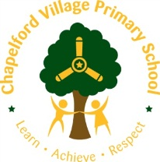

Year 3 Curriculum Overview 2019 / 2020

Year group:  Three | Autumn 1  7 weeks 2 days | Autumn 2  7 weeks | Spring 1  6 weeks | Spring 2  6 weeks | Summer 1  5 weeks | Summer 2  7 weeks
Maths | - Place Value  - Place Value and mental calculation  - 2D shape, length including perimeter  - Statistics/Mental Calculation  - Written addition  Written subtraction | - Counting/Multiplication tables ( 3x and 4x)  - Fractions  - Fractions/Division  - Volume/Capacity/Mass  - Multiplication including 8x table  Multiplication ( statistics, measures, money) | - Place Value, Mental addition and subtraction  - Fractions  - Fractions and Division  - Volume/capacity/mass  - Multiplication including 8x table  Multiplication ( statistics, measures money) | - 2D and 3D shape including sorting  - Addition and Subtraction ( statistics)  - Fractions  - Position and Direction  - Time  Assess and Review | - Multiplication facts ( statistics)  - Addition and subtraction ( measures)  - Multiplication and division ( measures)  - 2D shape including sorting  - Decimals – addition and subtraction ( money)  3D shape including sorting | - Place Value ( measures)  - Mental Calculation  - Fractions  - Measures  - Statistics  Assess and Review
English | Poetry – 2 weeks  Seal Surfer by Michael Foreman – 3 weeks  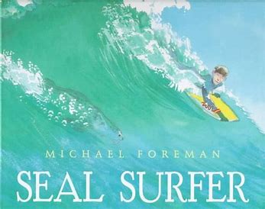  Climb novel:  Chimney Child – Laurie Sheehan | Poetry – 1 week  Winter’s Child  Graham Baker Smith – 4 weeks  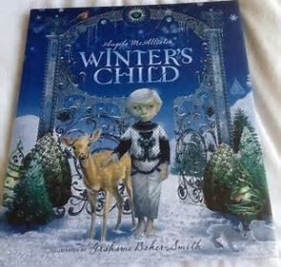  Climb novel: Ice Palace  Robert Swindells | Poetry – 1 week  Big blue Whale by Nicola Davies – 2 weeks  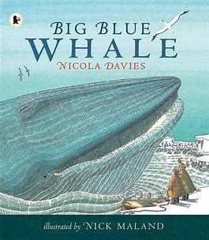  Climb novel: The Morning I Met A whale  Michael Morporgo | Poetry – 1 week  Escape from Pompeii by Christina Balit – 4 weeks  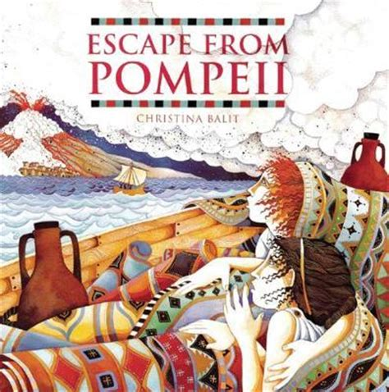  Climb novel: Christophe’s story | Stone Age Boy  Satoshi Kitamura – 2 weeks  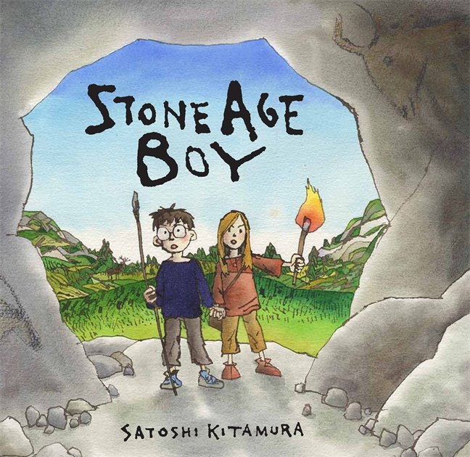  Climb novel: Billionaire Boy  David Walliams | Poetry – 1 week  Journey by Aaron Becker – 3 weeks  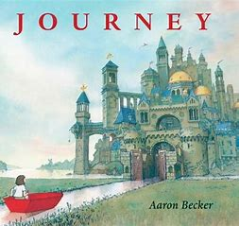  Quest by Aaron Becker  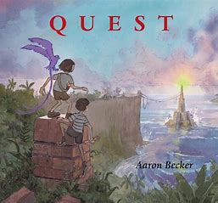  Tilly Mint Tales  Berlie Doherty  Climb novel: Percy Jackson and the Lightening Thief
Outcome | Outcome  Recount: letter in role  Greater Depth  Write a letter from Grandad in response to one of his grandson’s letters | Outcome  Fiction: fantasy story based on a fable  Greater Depth  Narrative from a different POV | Outcome  Persuasion: leaflet persuading for the protection of the blue whale  Greater Depth  Include a fact file about endangered sea creatures | Outcome  Fiction: historical narrative from character’s point of view  Greater Depth  Write from the POV of the captain | Outcome  Report: How to survive as a stoneage hunter.  Greater Depth: Include an explanation within their report | Outcome  Fiction: adventure story based on Journey using the language of Berlie Doherty  Greater Depth  Include a new setting route to lead from one place into another
Sentence | Use prepositions to express time, place and cause. | Form nouns with a range of prefixes | Use conjunctions to express, time, place and cause  Use adverbs to express time | Use the present perfect form of verbs in contrast to the past tense | Build an increasing range of sentence structures  Use adverbs to express time, place and cause | Use the present perfect form of verbs in contrast to the past tense  Use prepositions and adverbs to express time, place and cause (demonstrating some awareness of purpose through selection of relevant content)
Text | Group related ideas into paragraphs | Use paragraphs to organise information  Use headings and subheadings | Create characters, settings and plot in narrative  Propose changes to grammar and vocabulary to improve consistency | Asses the effectiveness of own and others’ writing (fiction)  Group related ideas into paragraphs (write an opening paragraph and further paragraphs for each stage) | Assess the effectiveness of own and others’ writing (non-fiction) | Group related ideas into paragraphs (write an opening paragraph and further paragraphs for each stage)
Punctuation | Use inverted commas to punctuate direct speech (introduction) |  | Proof-read for spelling and punctuation errors prior to publishing for a key audience | Use inverted commas to punctuate direct speech (and to show relationship between two characters) | Full range of punctuation taught at Y2 | Use inverted commas to punctuate direct speech
 | Agreed Additional Text :  Little Red  Bethan Woollvin  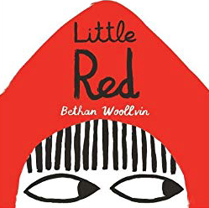  2 weeks | Agreed Additional Text: Queen Victoria’s Knickers  Jaquie French  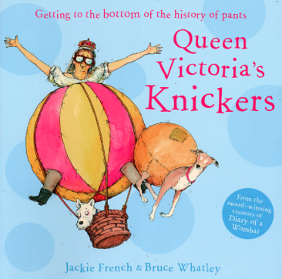  2 weeks | Agreed Additional Text:  The Rabbit problem  Emily Gravitt  3 weeks  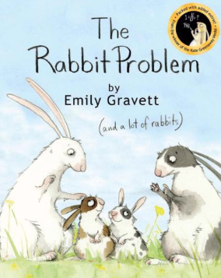 | Agreed Additional Text: Pretty Canizales – 1 week  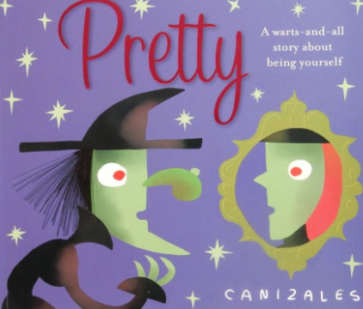 | Agreed Additional Text:  Billionaire Boy  David Walliams – 3 weeks  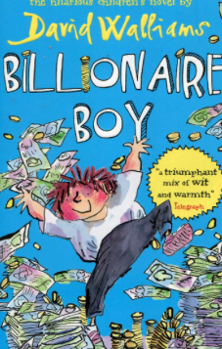 | Agreed Additional  Text:  Percy Jackson and the Lightening Thief – 3 weeks  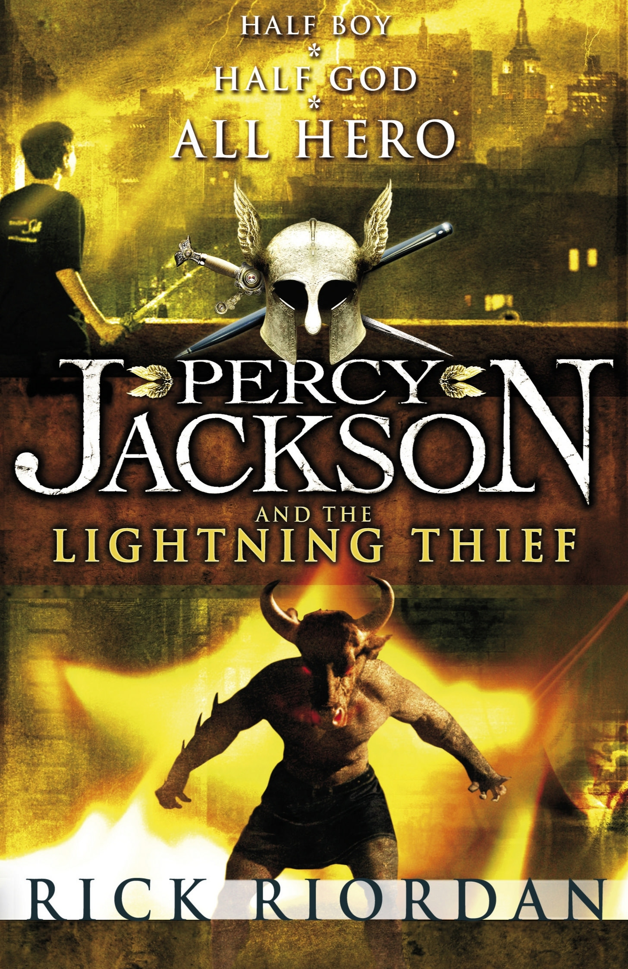
Non Fiction Focus | Recount – Fox Howl (real life) | Explanation – Fiction Queens Knickers | Persuasion – Leaflet | Persuasive Advert | Debate: How should the money be spent? | Non Chronolgical report: Greek Gods
Non Fiction Apply (Previous taught to apply across English and LC) |  | Recount (newspaper or diary) |  | Explanation non-fiction focus (end of term) |  | Non Chronological Report (leaflet or brochure)
Class Author Study | Helen Ward | Nigel Hinton | Nicola Davis | Dick King Smith | Jeff Brown | Roald Dahl
Poetry Focus | Michael Rosen  A Great Big Cuddle  Focus: Reading, learning to recite, developing vocabulary. Poems to perform. |  | Rodger McGough – Poetry Pie  See CLPE  Focus: reading, learning to recite, developing vocabulary. Shape poetry and calligrams |  | Grace Nichols Sun is Laughing  See CLPE  Compare poem to Jackie Kays Poem – The Moon at Knowle Hill?  Focus: Reading, learning to recite, developing vocabulary, Language play
Theme | Victorian Warrington | Ancient Greece | What Makes the Earth Angry?  Study of Pompeii |  | The Stone Iron and Bronze Age | Our European Neighbours
Educational Visits and Residentials | Fox Howl Residential Visit  Artist Study – see below – linked to Black Lake  Outdoor adventurous activities  Visit to Warrington Museum – Victorian Warrington  Tatton Hall | Christmas Theatre Visit  (Writing for a purpose opportunity) | Rocks to Schools Workshop  www.rockstoschools.co.uk |  | Visit to Tatton Park  Stone, Bronze and Iron Age Study Day  Laura Armitage  01625374428
Science  . | How can Usain Bolt move so quickly?  Animals including humans  identify that animals, including humans, need the right types and amount of nutrition, and that they cannot make their own food; they get nutrition from what they eat  identify that humans and some other animals have skeletons and muscles for support, protection and movement. | May the Force Be With  You!  Forces and Magnets  KS2 Science  compare how things move on different surfaces  notice that some forces need contact between two objects, but magnetic forces can act at a distance  observe how magnets attract or repel each other and attract some materials and not others  compare and group together a variety of everyday materials on the basis of whether they are attracted to a magnet, and identify some magnetic materials  describe magnets as having two poles  predict whether two magnets will attract or repel each other, depending on which poles are facing. |  | Plants  How did the blossom become an apple?  Plants  identify and describe the functions of different parts of flowering plants: roots, stem/trunk, leaves and flowers  explore the requirements of plants for life and growth (air, light, water, nutrients from soil, and room to grow) and how they vary from plant to plant  investigate the way in which water is transported within plants  explore the part that flowers play in the life cycle of flowering plants, including pollination, seed formation and seed dispersal. | What do rocks and soils tell us about the way the earth was formed?  Rocks  compare and group together different kinds of rocks on the basis of their appearance and simple physical properties  describe in simple terms how fossils are formed when things that have lived are trapped within rock  recognise that soils are made from rocks and organic matter. | How can you light up your life?  (Light)  recognise that light appears to travel in straight lines  use the idea that light travels in straight lines to explain that objects are seen because they give out or reflect light into the eye  explain that we see things because light travels from light sources to our eyes or from light sources to objects and then to our eyes  use the idea that light travels in straight lines to explain why shadows have the same shape as the objects that cast them
History | Local History Study – Victorian Warrington  How did the Victorian Period help to shape the Warrington we know today?  Local Study of a period that shaped locality – Greenall’s Brewery, education, library (Warrington first national library), work houses, poor map, fashion, inventions and Christmas. | Ancient Greece  A astudy of greek life and their acheivements abnd their influence on the western world. |  |  | Who first lived in Britain? – Stone Age, Bronze Age and Iron Age?  Settlers  Hunter Gatherers  Early Farming  Bronze age and iron Age
Geography | Recap knowledge of 7 continents and 5 seas  (ongoing)  Name and locate counties and cities in the UK  Key Vocabulary:  Asia, Africa, North America, South America, Antarctica, Australia, Oceania, Australasia, Europe, oceans: Arctic, Southern, Pacific, Atlantic, Indian |  | What makes the Earth Angry?  Physical  What makes the Earth Angry?  Name and locate geographical regions and their identifying human and physical characteristics, key topographical features, land use patterns and how these have changed over time (hills, mountains, coasts)  Why Warrington? Link (Compare landscapes) Begin with topography of UK first (hills and mountains), then volcanoes and earthquakes  Physical  Volcanoes, Earthquakes and Tsunamis – The Power of the Earth.  Understand geographical similarities and differences through the study of human and physical geography of a region in a European country  Study on a European Country in the Mediterranean – Italy with a focus on Pompeii  Locate the world’s countries in Europe (including Russia)  ( a period of History that shaped a locality)  Trip to Pennines, Lake District?  Virtual Reality company visit to school  Key Vocabulary:  Hills, mountains, coasts, landscape, Pennines, Grampians, Cambrians, Southern Uplands, Cotswolds, North and South Downs, erosion, deposition, earthquake, volcano, alps, geology, minerals, chalk, slate, granite, sandstone, climate, contour |  |  | Our European Neighbours – focus on France  Humnan and Physical Geography  Holiday destinations  Famous cities
Art | Painting  The Great Wave off Kanagawa  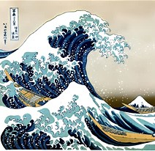  Create a piece of art work in response to the artist – colour, pattern and shape.  Mix and match colours and work on different scales- scraping through paints and layers – mix shades and tones. | Collage  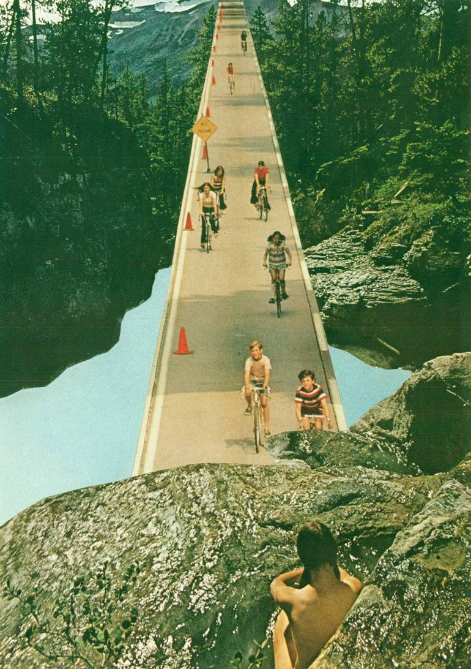  Create images from a variety of media e.g. photocopies material, fabric, crepe paper, magazines etc.  Arrange and glue materials to different backgrounds  Sort and group materials for different purposes e.g. colour texture  Fold, crumple, tear and overlap papers  Work on different scales  Collect, sort, name match colours appropriate for an image. | Drawing  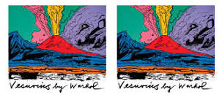  Experiment with ways in which surface detail can be added to drawings.  Experiment with different grades of pencil and other implements to create lines and marks.  Begin to show an awareness of objects having a third dimension.  Apply tone in a drawing in a simple way.  Create textures with a wide range of drawing implements. | Sculpture  Plan, design and make models from observation or imagination.  Join clay adequately and construct a simple base for extending and modelling other shapes.  Create surface patterns and textures in a malleable material. | Printing  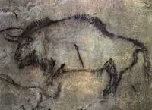  Create simple printing blocks with press print  Design more repetitive patterns  Experiment with overprinting motifs and colour. | Textile  Felting  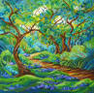  Cut and shape fabric using scissors/snips. Apply shapes with glue or by stitching.  Apply decoration using beads, buttons, feathers etc.  Create fabrics by weaving materials  Use a variety of techniques, e.g. printing, dyeing, weaving and stitching to create different textural effects.
Artist Study | Hokuai | Artist Study  Edward Saidi Tingatinga in 1968  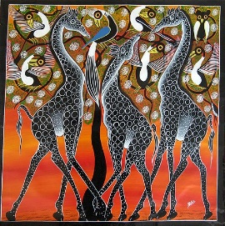 | Artist Study  Georgia O’Keeffe 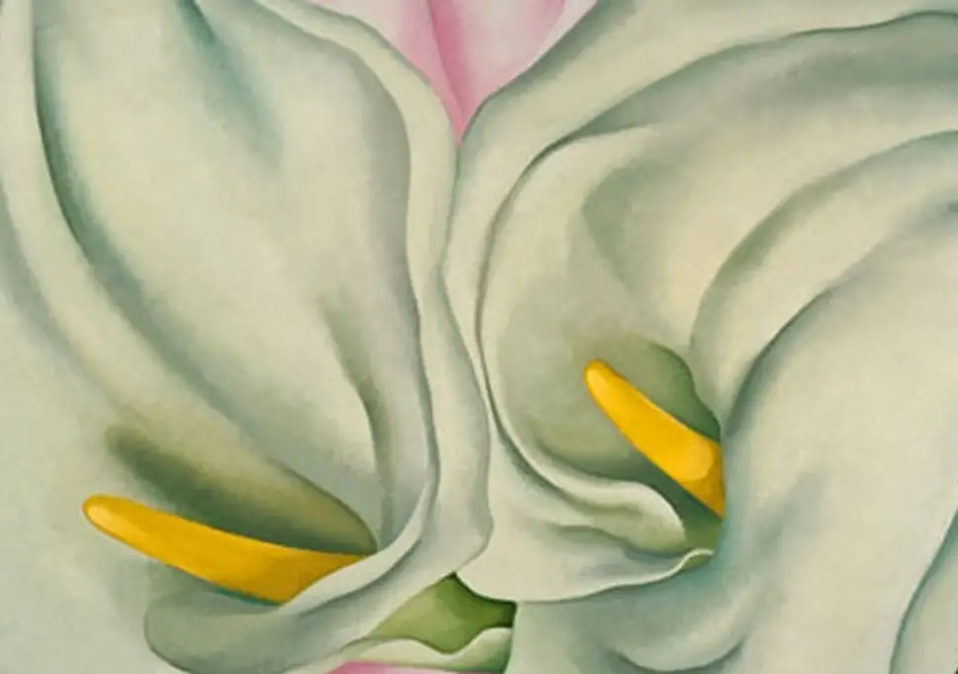 | Artist Study  Antonio Gaudi  (architect study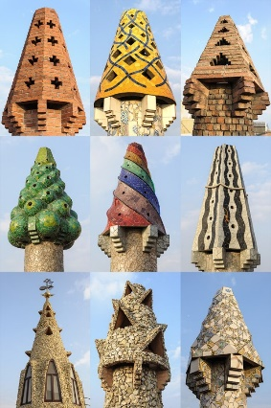  Suggested Material: Air Drying Clay | William Morris  Kehind Wiley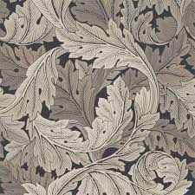 | Ali Scott  www.aliscottfeltartist.co.uk  Crafts Person
Design Technology (including cooking) |  |  | Focus – mechanical systems.  Levers and linkages – design and make a science information leaflet with a flap. Link to information on rocks.  Design - develop, model and communicate their ideas through drawing, templates, mock ups  MAKE – select and use a wide range of materials and components according to their characteristics.  EVALUATE – EVLAUATE A RANGE OF EXISTING PRODUCTS – MATERIALS and tools that are needed to create a lever/flap.  Technical Knowledge– Understand and use lever and linkage mechanisms.  • Distinguish between fixed and loose pivots.  • Know and use technical vocabulary relevant to the project. |  | Focus – building a volcano – 2d shape to 3d product.  • Generate realistic ideas through discussion and design criteria for an appealing, functional product fit for purpose and specific user/s.  • Produce annotated sketches, prototypes, final product sketches and pattern pieces.  Making  • Plan the main stages of making.  • Select and use a range of appropriate tools with some accuracy e.g. cutting, joining and finishing.  • Select fabrics and fastenings according to their functional characteristics e.g. strength, and aesthetic qualities e.g. pattern.  Evaluating  • Investigate a range of 3-D textile products relevant to the project.  • Test their product against the original design criteria and with the intended user.  • Take into account others’ views.  • Understand how a key event/individual has influenced the development of the chosen product and/or fabric.  Technical knowledge and understanding  • Know how to strengthen, stiffen and reinforce existing fabrics.  • Understand how to securely join two pieces of fabric together.  • Understand the need for patterns and seam allowances.  • Know and use technical vocabulary relevant to the project.
Music  Charanga | Let your spirit fly | Glockenspiel Stage 1 | Three Little Birds |  | The Dragon Song | Bringing Us Together
Computing  Digital Literacy | Computer Networks  Powerful Passwords | Creativity  My Online Community | Productivity  Things for Sale | Creativity | Programming | Communication  Writing Good Emails  Showing Respect Online
PE  Real PE / Games | Real PE  Swimming | Real PE  Gym | Real PE  Dance | Real PE  Invasion | Real PE  Net Games | Real PE  Striking and Fielding
MFL | A New Start  Greetings, feelings  Names  Numbers 0-12  Age  I know 6 colours  Classroom instructions | The calendar and celebrations  Days of the week  Months of the year  Numbers 13-31  Birthdays –asking and giving an age  Classroom instructions  Christmas activities | Epiphany celebrations  Animals I like and don’t like  Animals and animal sounds  Animals that come from target language countries  Common names for household animals  Old MacDonald  Brown Bear Brown Bear What do you see? | Carnival and colours  Carnival cultural facts  Colours at the carnival  Carnival masks  Playground clapping rhymes – based on colours/days of the week/months and numbers (Revisit)  Easter | Food we eat everyday  Food and drink I like  Food and drink I don’t like  Food and drink I might eat and drink in target language country | Going on a Bear Hunt  Sounds  Actions  Listening and joining in with a rhyme  Listening and joining in with a story  Having a picnic  Simple food and drink for a picnic  Asking politely and saying thank you.
Religious Education  Who should we follow? (Founders and Leaders) | Hindu Dharma  Who should we look up to?  Diwali | Christianity – Jesus  Can one person change the world?  Christmas | Buddhism  What can we learn from the life of people who started a religion? | Christianity – The Church  What qualities make a good leader?  Easter | Islam  Are the founders of the faiths good role models? | Christianity – God  What does it mean to be inspired?
PHSCE | Community Boundaries  Why do we need rules?  Rules in the classroom  Rules at home  Similarities and  differences  Reasons why  ** Kidsfe Revision Unit** | Friendships & Relationships  Anti-Bullying Week  What makes a good friend?  Conflict and Causes  Recognising and  acknowledging  emotions in  difficult situations  Resolving difference | People and their Work  Jobs  Work roles  Similarities and differences in jobs  Explore how adults feel about work  Money  Enterprise | The Local Community  What is a community?  Which communities  do I belong to?  How does it impact  on me?  How do I affect it?  Local Community:  who lives in it?  who supports us?  who do we support? | Health and Wellbeing: Keeping Safe  Safety at school  Rules at school to stay safe  Home  Fire safety  Healthy lifestyle (physically and mentally) | In Someone Else’s Shoes  Celebrating difference  Challenging stereotype  Feelings  Social groups  Different cultures  Respecting people’s feelings, rights and bodies
Character Education - Missions | Ed Stafford  Walking in the Amazon |  | Nellie Bly  Around the World in 72 days |  | Sir Earnest Shalkleton  Endurnace

