Year 5 Curriculum Overview 2019 / 2020
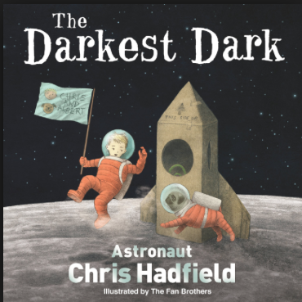
Year group:  Five | Autumn 1  7 weeks 2 days | Autumn 2  7 weeks |  | Spring 1  6 weeks |  | Spring 2  6 weeks | Summer 1  5 weeks | Summer 2  7 weeks
Maths | Number – place value  Number – Addition and subtraction | Number – multiplication and division  Prime Numbers  Squared Numbers |  | Statistics  Number - Fractions |  | Number – Decimals  Number - Percentages | Measures – Time  Geometry – Position and direction | Measures – Perimeter + Area  Measures - Volume  Geometry – Angles  Geometry – Shape
English | Poetry – 2 weeks  Queen of the Falls by Chris Van Allsburg – 5 weeks (combined with additional text)  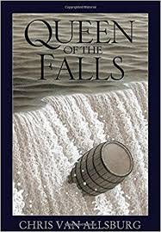  Climb Novel: Goodnight stories for rebel girls  Elena Favilli | Poetry – 1 week  The Darkest Dark  Chris Hadfield  Climb Novel: Journey to the river sea |  | Poetry – 1 week  The Lost Happy Endings by Carol Ann Duffy – 5 weeks (combined with additional text)  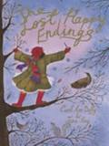  Climb Novel: Friend or Foe – Michael Morpurgo (links to WWII) |  | Poetry – 1 week  Room 13 by Robert Swindells – 4 weeks  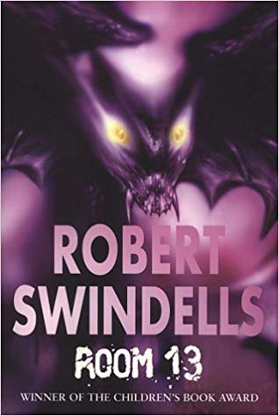  Climb Novel: Room 13 | The Paperbag Prince by Colin Thompson  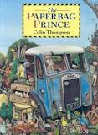  Climb novel: The Last Wild  Piers Torday | Poetry – 1 week  Arthur and the Golden Rope by Joe Todd Stanton – 3 weeks  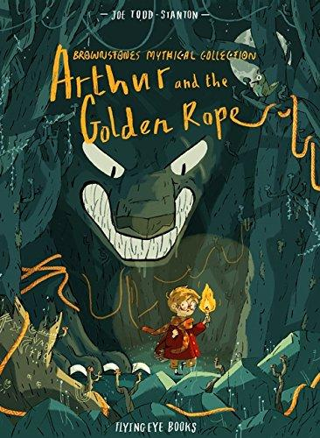  Climb Novel:  Who let the gods out?  Maz Evans
Outcome | Outcome  Recount: series of diaries  Greater Depth  Series of diaries with viewpoint of other characters | Outcome  Recount : non chronological report  Greater Depth  Write a leaflet/ letter to a film director explaining why ‘The Darkest Dark’ should be made into a film |  | Outcome  Fiction: traditional tale  Greater Depth  Traditional tale from another character’s POV |  | Outcome  Fiction: Mystery narrative  Greater Depth  Apply figurative language to objects within the mystery. | Outcome  Persuasion/information:  Hybrid leaflet  Greater Depth  Write an oral presentation for a TV or online broadcast as expert | Outcome  Fiction: myth  Create heroes, villains and monsters  Greater Depth  Vary the viewpoint from which the myth is told
Sentence | Use fronted adverbials | Relative clauses to add detail and description  Use adverbs to indicate degrees of possibility |  | Use expanded noun phrases to convey complicated information concisely |  | Relative clauses to add detail and description  Use adverbs to indicate degrees of possibility  Adapt sentence length and vocabulary to change and enhance meaning | Use modal verbs to indicate degrees of possibility  Select appropriate grammar and vocabulary (Formal) | Use expanded noun phrases to convey complicated information concisely  Relative clauses to add detail and description
Text | Plan writing by identifying audience and purpose  Organise paragraphs around a theme | Link ideas across paragraphs using adverbials |  | Describe settings, characters and atmosphere  Integrate dialogue to convey character and advance the action |  | Link ideas across paragraphs using adverbials  Apply dialogue to convey character and advance the action | Use devices to build cohesion within a paragraph  Choose the appropriate register | Use a wide range of devices to build cohesion
Punctuation | Commas after fronted adverbials (Y4)  Commas to clarify meaning and avoid ambiguity |  |  | Use of inverted commas and other punctuation to punctuate direct speech (Y4) |  | Use brackets, dashes or commas to indicate parenthesis | Use brackets, dashes or commas to indicate parenthesis | Commas to clarify meaning and avoid ambiguity
Additional Texts: | Goodnight stories for rebel girls –  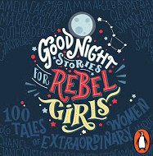  Elena Favilli – 5 weeks (with main text) | 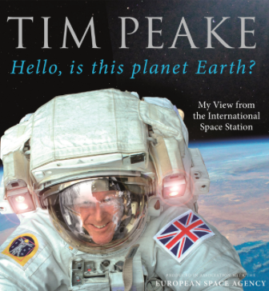  Tim Peake  Hello, Is this planet Earth? |  | The Tear Thief  Carole Ann Duffy – 5 weeks (combined with main text)  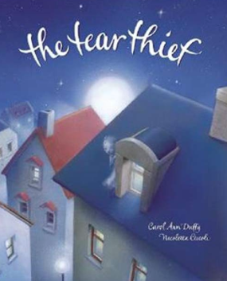 |  | 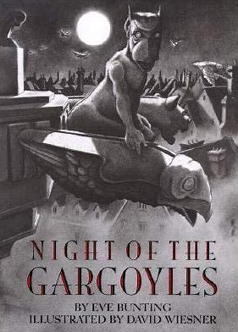  The Night of the Gargoyles – Eve Bunting – 1 week | The Last Wild  Piers Torday  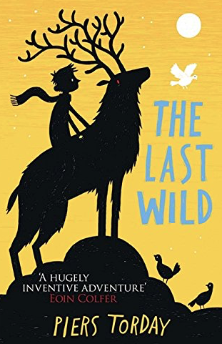 | Who let the gods out?  Maz Evans – 3 weeks  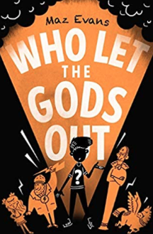
Non Fiction |  |  |  | Persuasion – Brochure (Poaching – elephants, sea turtles, pandas) |  | Non Chron report – linked to Whitby (Room 13) Tourist leaflet | Explanation (Leaflet)
Non Fiction Apply | Recount – newspaper report |  |  |  |  | Instructions – How to kill a vampire  Biography – Anne Frank through learning challenge | Non Chron report – missing page from information book/ museum display | Explanation – speech or comic strip
Class author Study | David Weisner | Lois Sachar |  | Carole Anne Duffy |  | Michael Morporgo | Colin Thompson | Colin Thompson
Poetry Focus | Micheal Rosen  The Great Big Cuddle  Focus: Reading, learning to recite, developing vocabulary |  |  | Jackie Kay  Red Cherry Red Focus: Reading, learning to recite, developing vocabulary – imagery and metaphor  Clpe.org.uk |  |  | John Hegley  Focus: Reading, learning to recite, developing vocabulary  Peter the Parrot  OWL  Nonsense and fantasy
Theme | The Wonders of Brazil !  Why are rain forests important? |  |  | Ancient Egypt | The Impact of WWII on two different towns. |  | Were the Anglo Saxons and Vikings really smashing?
Educational Visits and Residentials | Science Museum Manchester – Forces and Flight Workshop  Animals Take Over – Rainforest Animal Workshop  Christmas Theatre Visit |  |  | Llandudno
Science | Can you feel the force?  Forces  Explain that unsupported objects fall towards the Earth because of the force of gravity acting between the Earth and the falling object  identify the effects of air resistance, water resistance and friction, that act between moving surfaces  Recognise that some mechanisms, including levers, pulleys and gears, allow a smaller force to have a greater effect. |  | Will we ever send another human to the moon?  Earth, Sun and Moon  Describe the movement of the Earth, and other planets, relative to the Sun in the solar system  describe the movement of the Moon relative to the Earth  describe the Sun, Earth and Moon as approximately spherical bodies  Use the idea of the Earth’s rotation to explain day and night and the apparent movement of the sun across the sky. | Do all animals and plants start life as an egg?  Living things and their Habitats  describe the differences in the life cycles of a mammal, an amphibian, an insect and a bird  Describe the life process of reproduction in some plants and animals.  Describe the changes as humans develop to old age. |  | Animal Including Humans  Can they create a timeline to indicate stages of growth in humans?  Can they explain what puberty is? (non statutory)  Do they appreciate that all animals will eventually die?  Can they explain why different animals have a different life expectancy?  Can they make a prediction with reasons?  Can they use test results to make further predictions and set up further comparative tests?  Can they present a report of their findings through writing, display and presentation?  Can they take measurements using a range of scientific equipment with increasing accuracy and precision?  Can they record more complex data and results using scientific diagrams, classification keys, tables, bar charts, line graphs and models? Can they create a timeline to indicate stages of growth in certain animals, such as frogs and butterflies?  Can they explain (in simple terms) a scientific idea and what evidence supports it?  Can they decide which units of measurement they need to use?  Can they explain why a measurement needs to be repeated?  Can they find a pattern from their data and explain what it shows?  Can they link what they have found out to other science?  Can they suggest how to improve their work and say why they think this? | Could you be the next CSI Investigator?  Properties and changes of materials.  compare and group together everyday materials on the basis of their properties, including their hardness, solubility, transparency, conductivity (electrical and thermal), and response to magnets  know that some materials will dissolve in liquid to form a solution, and describe how to recover a substance from a solution  use knowledge of solids, liquids and gases to decide how mixtures might be separated, including through filtering, sieving and evaporating  give reasons, based on evidence from comparative and fair tests, for the particular uses of everyday materials, including metals, wood and plastic  demonstrate that dissolving, mixing and changes of state are reversible changes  explain that some changes result in the formation of new materials, and that this kind of change is not usually reversible, including changes associated with burning and the action of acid on bicarbonate of soda
History |  | . |  | How can we discover the wonders of Ancient Egypt?  Early Civilizations  I can use dates to order and place events on a timeline.  I can compare sources of information available for the study of different times in the past.  I can present findings and communicate knowledge and understanding.  I can compare life in early and late time studied.  I can understand that the types of information available depends on the period of time studied. | How did WW2 impact Warrington and Llandudno?  Aspect of British history beyond 1066  I can use dates to order and place events on a timeline.  I can compare sources of information available for the study of different times in the past.  I can present findings and communicate knowledge and understanding.  I can study different aspects of different people – difference between men and women.  I can examine cause and results of great events and the impact on people. |  | Were the Anglo Saxons and Vikings really smashing?  Settlements  I can use dates to order and place events on a timeline.  I can compare sources of information available for the study of different times in the past.  I can present findings and communicate knowledge and understanding.  I can compare an aspect of life with the same aspect in another period.  I can examine cause and results of great events and the impact on people.  I can give reasons for some important historical events
Geography | What Will We Find Exploring Out Brazil?  Physical Geography  I can explain how rivers erode, deposit and transport materials.  The water cycle recap from year 4  Rainforests of the Amazon  Understand geographical similarities and differences through the study of human and physical geography of a region within North America  I know about the Iguaca falls on the border of Brazil  I can identify the key topographical features of a country.  I can recognise different shapes of countries.  I can describe where a variety of places are in relation to human and physical features.  I can understand weather [patterns from around the world and relate these to climate zones.  Recap knowledge of 7 continents and 5 seas, counties and cities of UK  Recap Locate the world’s countries in Europe (including Russia), introduce countries in North and South America  Human Geography  Types of settlements, land use, economic activity and the distribution of natural resources including energy, food, minerals and water  Geographical Skills and Fieldwork  Use world maps, globes and digital computer mapping to locate countries and describe features studied
Art | Painting  Develop a painting from a drawing.  Carry out preliminary studies trying out a variety of media and painting materials.  Be able to identify primary secondary, complementary and contrasting colours.  Work with complementary colours. | Collage  Add collage to a painted, printed or drawn background.  Use a range of media to create collages.  Use different techniques, colours and textures etc when designing and making pieces of work. |  | Drawing  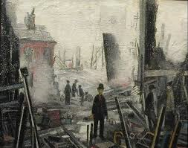  Work from a variety of sources including observation  Develop close observation skills using a variety of view finders.  Use dry and wet media to make different marks, lines, patterns and shapes within a drawing.  Explore colour mixing and blending techniques with coloured pencils.  Use different techniques for different purposes i.e. shading, hatching within their own work. |  | Sculpture  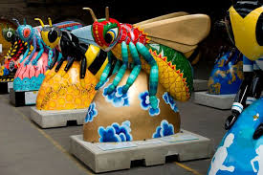  Shape, form, model and construct from observation or imagination.  Use recycled, natural and man‐made materials to create sculptures.  Plan a sculpture through drawing and other preparatory work.  Produce intricate patterns and textures in a malleable media. | Printing  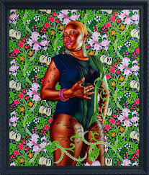  Create printing blocks by simplifying an initial sketch book idea.  Work into prints with a range of media e.g. pens, colour pens and paints. | Textile  Shibori Tie Dye  Experiment with colour and dying techniques.  Experiment with a range of media to overlap and layer creating interesting colours and textures and effects.
Artist Study | Claude Monet  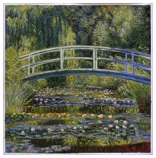 | Kurt Schwitters WWII  (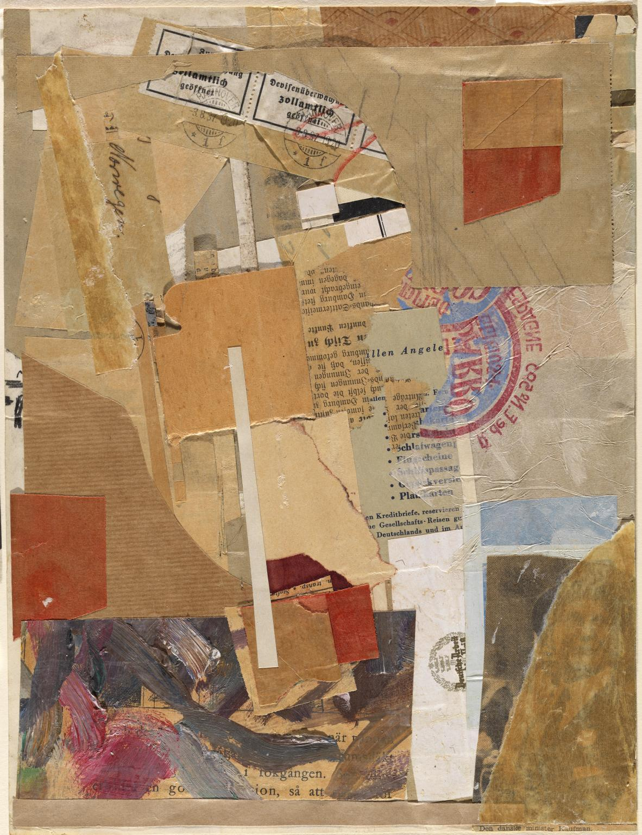 |  | LS Lowry  Blitzed Site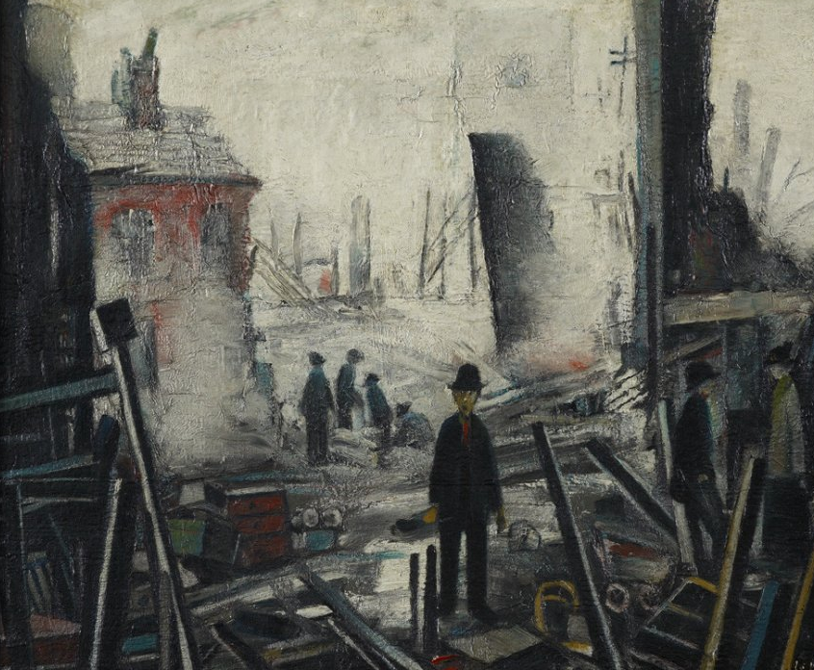 |  | The Manchester Bee’s  (Science link)  Suggested Material: Recycled Materials & Modrock | Andy Warhol  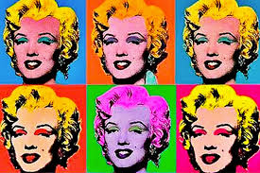
Design Technology | Focus - Pulleys or Gears- Recognising that some mechanisms, including Pulleys and Gears allow a smaller force to have a greater effect. Link to Science.  Designing  • Generate innovative ideas by carrying out research using surveys, interviews, questionnaires and web-based resources.  • Develop a simple design specification to guide their thinking.  • Develop and communicate ideas through discussion, annotated drawings, exploded drawings and drawings from different views.  Making  • Produce detailed lists of tools, equipment and materials. Formulate step-by-step plans and, if appropriate, allocate tasks within a team.  • Select from and use a range of tools and equipment to make products that that are accurately assembled and well finished. Work within the constraints of time, resources and cost.  Evaluating  • Compare the final product to the original design specification.  • Test products with intended user and critically evaluate the quality of the design, manufacture, functionality and fitness for purpose.  • Consider the views of others to improve their work.  • Investigate famous manufacturing and engineering companies relevant to the project.  Technical knowledge and understanding  • Understand that mechanical and electrical systems have an input, process and an output.  • Understand how gears and pulleys can be used to speed up, slow down or change the direction of movement.  - Know and use technical vocabulary relevant to the project. |  |  | Focus - Frame structures – could they design a modern day bomb shelter?  Designing  • Carry out research into user needs and existing products, using surveys, interviews, questionnaires and web-based resources.  • Develop a simple design specification to guide the development of their ideas and products, taking account of constraints including time, resources and cost.  • Generate, develop and model innovative ideas, through discussion, prototypes and annotated sketches.  Making  • Formulate a clear plan, including a step-by-step list of what needs to be done and lists of resources to be used.  • Competently select from and use appropriate tools to accurately measure, mark out, cut, shape and join construction materials to make frameworks.  • Use finishing and decorative techniques suitable for the product they are designing and making.  Evaluating  • Investigate and evaluate a range of existing frame structures.  • Critically evaluate their products against their design specification, intended user and purpose, identifying strengths and areas for development, and carrying out appropriate tests.  • Research key events and individuals relevant to frame structures.  Technical knowledge and understanding  • Understand how to strengthen, stiffen and reinforce 3-D frameworks.  • Know and use technical vocabulary relevant to the project. |  |  |  | Focus - Celebrating culture and seasonality –design a celebration food linked to end of year celebrations  Designing  • Generate innovative ideas through research and discussion with peers and adults to develop a design brief and criteria for a design specification.  • Explore a range of initial ideas, and make design decisions to develop a final product linked to user and purpose.  • Use words, annotated sketches and information and communication technology as appropriate to develop and communicate ideas.  Making  • Write a step-by-step recipe, including a list of ingredients, equipment and utensils  • Select and use appropriate utensils and equipment accurately to measure and combine appropriate ingredients.  • Make, decorate and present the food product appropriately for the intended user and purpose.  Evaluating  • Carry out sensory evaluations of a range of relevant products and ingredients. Record the evaluations using e.g. tables/graphs/charts such as star diagrams.  • Evaluate the final product with reference back to the design brief and design specification, taking into account the views of others when identifying improvements.  • Understand how key chefs have influenced eating habits to promote varied and healthy diets.  Technical knowledge and understanding  • Know how to use utensils and equipment including heat sources to prepare and cook food.  • Understand about seasonality in relation to food products and the source of different food products.  • Know and use relevant technical and sensory vocabulary.
Music | Livin’ on a Prayer | Classroom Jazz 1 |  | Make you feel my love |  | The Fresh Prince of Bel Air | Dancing in the street | Reflect, Rewind and Replay
Computing  Digital Literacy | Computer Networks  Digital Citizenship Pledge | Creativity  Picture Perfect |  | Productivity  You’ve Won A Prize |  | Creativity  How To Cite A Site | Programming | Communication  Strong Passwords
PE | Fundamental movement skills  Personal skills  Games | Fundamental movement skills  Social skills  Games |  | Fundamental movement skills  Cognitive skills  Games |  | Fundamental movement skills  Creative skills  Games | Fundamental movement skills  Applying physical skills  Games | Fundamental movement skills  Personal skills  Games
MFL | My school  Returning to school- daily routine.  An intercultural comparison of our school with a school in the target language speaking country.  How to introduce my teacher, my classmates and my school to a target language guest?  Numbers 0-31/Days of week-revisit  School subjects and likes and dislikes of subjects | Where I live  Revisit names of shops and places nearby  Investigate a large city or town from a target language country  Travel and tickets in the town |  | Healthy Eating  Fruits and vegetables  Likes and dislikes  Making a healthy dish to eat- recipes  Keeping fit and healthy  Taking exercise - physical activity instructions  (jump/run/turn/ move/ catch / throw/ fast /slowly .....times) |  | Going to the beach  Come to the beach – a persuasive spoken text  What’s in the beach bag?  A game to play on the beach  Revisit ice creams  Snacks and ice cream role plays on the beach  A seaside story | Carnival- costumes, colours and descriptions  Clothes, colours and descriptions  A fashion show | Weather and countries  What’s the weather like?  Making links between countries and weather  Investigate ways you can travel to and around target language countries  Extreme weather  Weather forecasts
Religious Education  Where can we find guidance about how we live our lives? (Sacred books and Revered Literature) | Understanding religion around the world.  Should we be religious?  Christianity - Harvest focus | Christianity – God  Why is it sometimes difficult to do the right thing?  Christmas |  | Christianity Church  What guidance should we follow? |  | Christianity Jesus  Easter  What do religious texts teach about human life? | Islam  Should religious teaching affect our laws today? | Hinduism  What can sacred stories tell us?
PHSCE | Who Decides?  Own choices and opinions  Respect of others choices and opinions  Value diversity  Resisting pressures  Attitudes towards dugs and people who misuse them  **Kidsafe revision Unit** | We’re All Different  Anti-Bullying Week  Difference caused by genes and environments  Different cultures  Tolerance  Acceptance  Respect  What is bullying?  Why is it wrong?  What is anti-social  behaviour?  Why is it wrong? |  | Being Involved in my Community  Interest in the local community  Social responsibility  Understand that they can cause change for the better and take on a wider sense of social responsibility  Planning to support  a charity  Working in partnership  with parents  visitors |  | Looking at the World  Public provision, locally and nationally and know it isn’t free  Communities we belong to e.g. family, school, local, national & worldwide  Willingness to move on personal opinions after considering new information or perspectives  Benefits and costs of personal spending decisions on themselves | Health and Wellbeing and Puberty  Choose healthy options in relation to food, exercise and rest  Hygiene  Development  Changes  Males/females | Media Influence  Increased leisure time  Internet  Social networking  Mobile phones  Personal safety  Getting help  Implications for me  Emergency Response  Personal safety  Emergency aid  Emergency services
Character Education – Missions | Tim Peake  Blast Off |  |  | Ralph Fiennes  Transglobal Adventure |  |  | Kira Salak  Gorillas in the Mist (challenge up)

