New National Curriculum Overview – 2019 / 2020

Year group:  Six | Autumn 1  7 weeks 2 days |  | Autumn 2  7 weeks |  | Spring 1  6 weeks | Spring 2  6 weeks | Summer 1  5 weeks | Summer 2  7 weeks
Maths | - Place value including decimals  - Mental and written addition  - Mental and written multiplication (time)  - Mental and written subtraction  - Mental and written division |  | - Fractions  - Fractions, percentages, ratio and proportion  - Geometry – position and direction |  | - Number- decimals  - Number- percentages  - Number algebra | - Measurement: converting units  - Measurement: perimeter, area and volume  - Number: ratio | - Geometry: Properties of shapes  - Problem solving  - Statistics | - Investigation and consolidation
English | Poetry - 2 weeks  Can we save the tiger?  by Martin Jenkins – 3 weeks  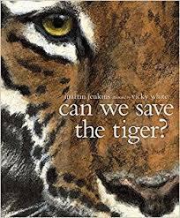  Climb novel: The Explorer:  Katherine Rundell |  | Poetry - 1 week  Star of fear Star of Hope  Joe Hoestlandt - 6 weeks for both texts  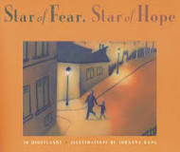  Climb novel: The boy in the striped pyjamas  John Boyne |  | Poetry - 1 week  Manfish  by Jennifer Berne – 3 weeks  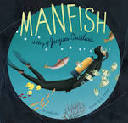  Climb novel:  Wonder  RJ Palacio | Poetry - 1 week  Selfish Giant  by Oscar Wilde – 3 weeks  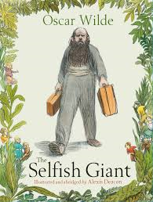  Climb Novel: Goldfish Boy  Lisa Thompson | Jemmy Button  by Alix Barzelay – 3 weeks  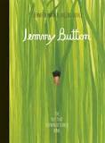  Climb Novel: Skychasers by Emma Carroll | Poetry - 1 week  Transition Unit  Shakespeare – 6 weeks  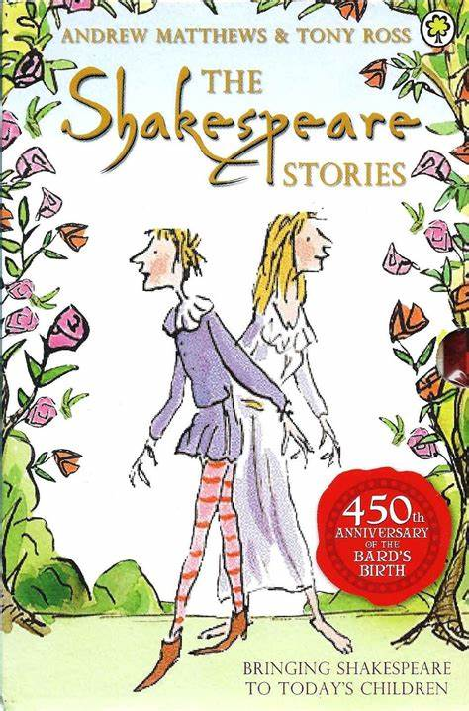  Climb Texts: Shakespeare
Outcome | Outcome  Hybrid text - information and explanation  Greater Depth  Write a Newsround TV style story |  | Outcome  Flashback story  Information text  Greater Depth  To write a narrative with a flashback |  | Outcome  Biography /hybrid text  Greater Depth  Add in a script commentary about role in conservation debate | Outcome  Classic fiction  Explanation  Greater Depth  Write the narrative from a different viewpoint | Outcome  Journalistic  Discussion  Greater Depth  Write a magazine article/hybrid text | Outcome:  Modern retelling narrative  Greater Depth  Comparison of same event from two viewpoints.
Sentence | Use modal verbs or adverbs to indicate degrees of possibility  Use expanded noun phrases to convey complicated information concisely |  | Use expanded noun phrases to convey complicated information concisely  (Y5)  Use passive verbs |  | Use relative clauses beginning with who, which, where, when, whose, that or an omitted relative pronoun (Y5) | Recognise vocabulary and structures for formal speech and writing, including subjunctive forms  Use passive verbs | Use passive verbs  Use consistent and correct tense  Use the perfect form of verbs | Recognise vocabulary and structures for formal speech and writing, including subjunctive forms
Text | Select appropriate grammar and vocabulary |  | Link ideas across paragraphs using a wider range of cohesive devices (recap from Y5)  Integrate dialogue to convey character and advance the action |  | Use a wide range of devices to build cohesion | Distinguish between the language of speech and writing  Integrate dialogue to convey character and advance the action | Use a wide range of devices to build cohesion  Use layout devices | Identify the audience and purpose for writing  Choose the appropriate register
Punctuation | Use brackets, dashes or commas to indicate parenthesis |  | Use a colon to introduce a list  Punctuate bullet points consistently |  | Use a colon to introduce a list and use of semi-colons within lists  Use hyphens to avoid ambiguity | Use semi-colons to mark boundaries between independent clauses | Use colons or dashes to mark boundaries between independent clauses | Use semi-colons, colons or dashes to mark boundaries between independent clauses
Additional Units | Explorer  Katherine Blundell – 2 weeks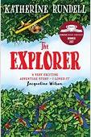 |  | Additional text – The Boy in Striped Pyjamas John Boyne – 6 weeks combined  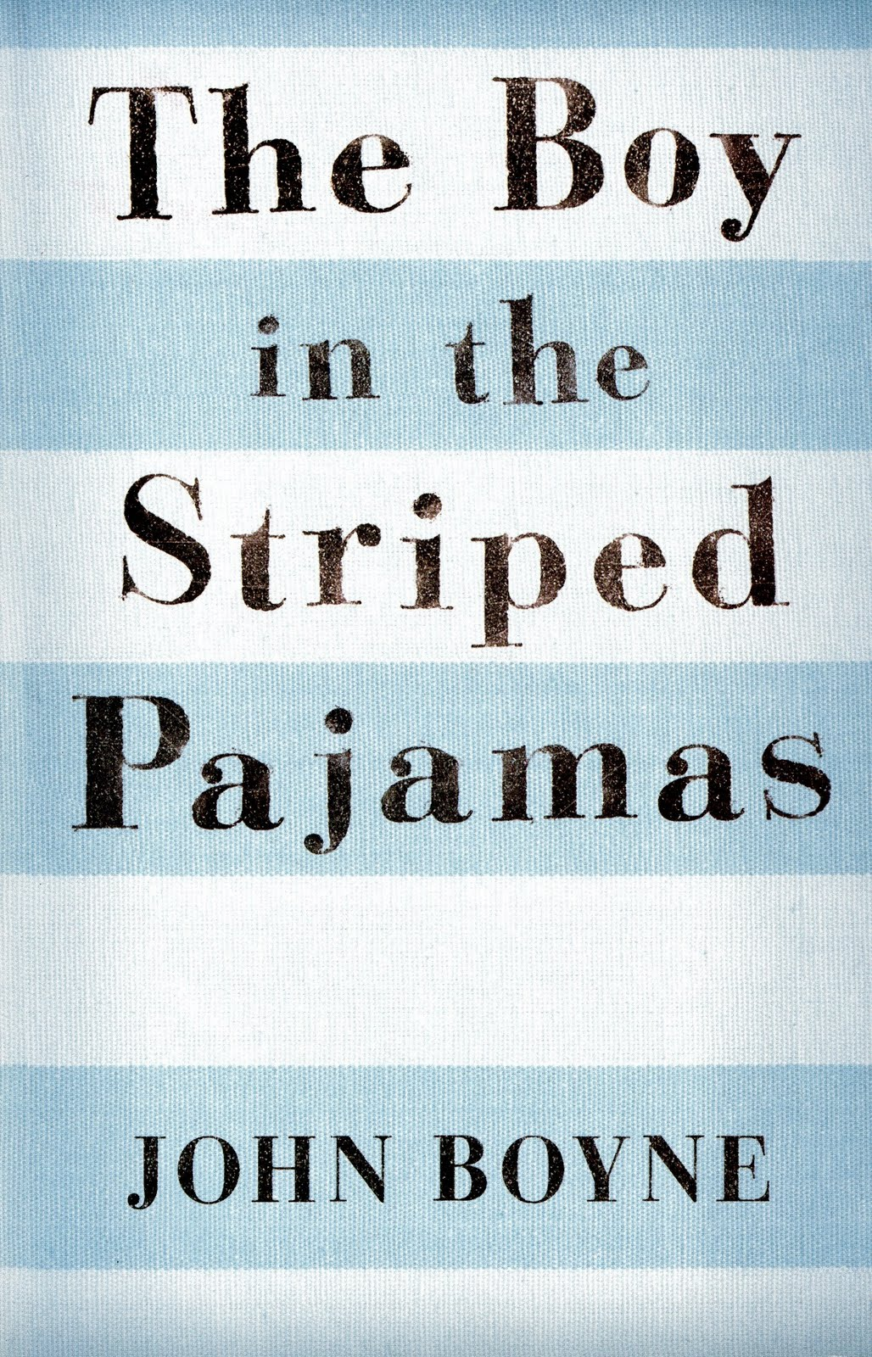 |  | Additional Text:  Wonder RJ Palacio – 2 weeks  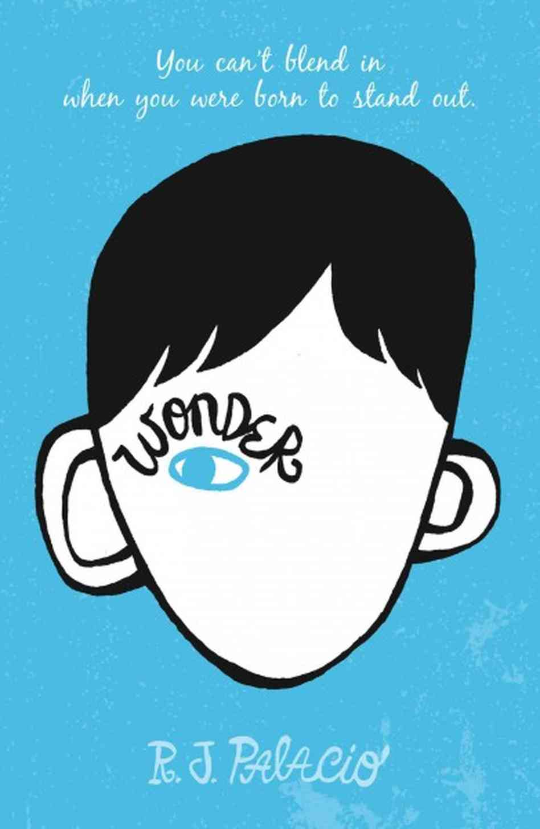 | Additional Text:  Giant’s Necklace by Michael Morpurgo – 2 weeks  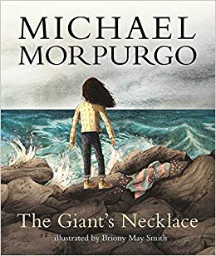 | 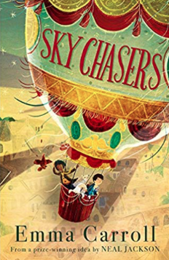  Additional Text:  Skychasers by Emma Carroll – 2 weeks | Shakespeare Performance
Non fiction | Discussion: balanced or persuasive argument (Tigers – choose audience speech?) |  | Non-chronological report (War – Page in an Information text) |  |  | Explanation (The Selfish Giant – choose audience)  Recount: Newspaper report (Giant’s Necklace)
Non fiction Apply | Non-chronological report (Tigers – leaflet/brochure) |  |  |  | Recount: Biography (Manfish) | Discussion (Jemmy Button- choose audience, TV show?) | Recount: Newspaper report (Jemmy Button) | Explanation (link to topic/English – different formality to Spring 1)
Class Author Study | Shaun Tan |  | John Boyle |  | RJ Palacio | Nicola Davis – World Book Day Focus and Art Week | Frank Cotteral Boyce | Anthony Horowitz
Poetry Focus | Micheal Rosen  The Great Big Cuddle  Focus: Reading, learning to recite, developing vocabulary, imagery |  |  |  | George Szirtes - The Land of the Giants - Apple Tree  Focus: reading, learning to recite, developing vocabulary – metaphor and personification  www.clpe.org.uk |  | Michela Morgan  - Star and other poems  - www.clpe.org.uk  Focus: Reading, learning to recite, developing vocabulary, finding a voice.
Theme | Water Water … |  |  | The Holocaust |  | The Mayans | Getting Secondary Ready!
Educational Visits and Residentials | London Visit |  |  |  |  |  |  | Robinwood  Prom Night
Science | What would a journey through your body be like?  Animals including humans  - identify and name the main parts of the human circulatory system, and describe the functions of the heart, blood vessels and blood  - recognise the impact of diet, exercise, drugs and lifestyle on the way their bodies function  - describe the ways in which nutrients and water are transported within animals, including humans |  |  |  | Could you be the next X Box Apprentice?  Electricity  - associate the brightness of a lamp or the volume of a buzzer with the number and voltage of cells used in the circuit  - compare and give reasons for variations in how components function, including the brightness of bulbs, the loudness of buzzers and the on/off position of switches  - use recognised symbols when representing a simple circuit in a diagram. |  | Have we always looked like this?  Evolution and inheritance  - recognise that living things have changed over time and that fossils provide information about living things that inhabited the Earth millions of years ago  - recognise that living things produce offspring of the same kind, but normally offspring vary and are not identical to their parents  - identify how animals and plants are adapted to suit their environment in different ways and that adaptation may lead to evolution.  . | Living things and their habitats.  - describe how living things are classified into broad groups according to common observable characteristics and based on similarities and differences, including micro-organisms, plants and animals  - give reasons for classifying plants and animals based on specific characteristics.
History |  |  |  | How were the victims of the Holocaust supported by Britain after the war?  A study of Great Britain beyond 1066  To develop a chronologically secure knowledge and understanding of British, local and world history, establishing clear narratives within and across the periods they study  Skills:  *Address and devise historical valid questions about change, cause, similarity and difference and significance.  *Construct informed responses that involve thoughtful selection and organisation of relevant historical information.  *Use a range of sources for independent research. *Understand how our knowledge of the past is constructed from a range of sources.  Knowledge:  *Note connections, contrasts and trends over time and show developing, appropriate use of historical terms.  *Describe a chronologically secure knowledge and understanding of British, local and world history establishing clear narratives within and across the periods studied. |  | Early Islamic Civilisation including a study the Mayan Civilization  A Non-European Society
Geography | I’m A Year 6 Pupil – can you get Me Out of Here?  Linking to London visit  Identify the position and significance of latitude, longitude, Equator, Northern Hemisphere, Souther Hemisphere, the Tropics of Cancer nad Capricorn, Arctic and Antarctic circle, Prime/Greenwich Meridian and time zones (including day and night)  Geographical Enquiry  I can choose the best way to collect information needed and decide the most appropriate units of measure  I can make careful measurements and use the data  I can use maps, aerial photos, plans and web resources to describe what a locality might be like  Physical Geography  I can give an extended description of the physical features of different places around the world  I can describe how some places are similar and others are different in relation to their human features  I can understand the term sustainable development  I can apply this in different contexts  Human Geography  I can give an extended description of the human features of different places around the world  I can describe how some places are similar and others are different in relation to their physical features  I can explain how human activity has caused environmental change  Geographical Knowledge  I can recognise key symbols used on ordnance survey maps |  |  |  |  |  | Will You Ever See the Water You Drink Again?  The Water Cycle
Art | Painting  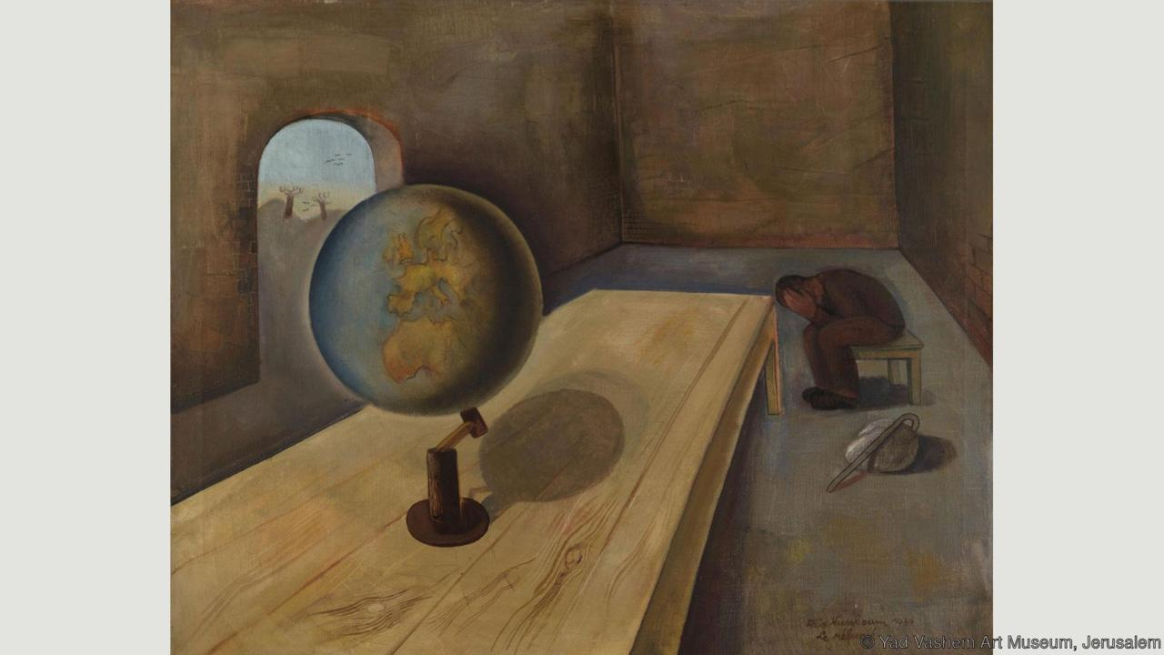  Develop a painting from a drawing.  Carry out preliminary studies, trying out different media and materials and mixing appropriate colours.  Mix and match colours to create atmosphere and light effects.  Be able to identify primary secondary, complementary and contrasting colours.  Work with complementary colours.  Can explain the style of their work and how it has been influenced by the work of the famous artist  The Wandering Jew |  | Collage  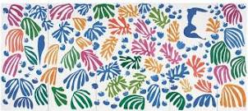  Add collage to a painted, printed or drawn background.  Use a range of media to create collages.  Use different techniques, colours and textures etc when designing and making pieces of work.  Use collage as a means of extending work from initial ideas. |  | Painting  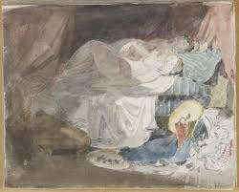  Work from a variety of sources including photographs and digital images.  Begin to use simple perspective in their work using a single focal point and horizon.  Begin to develop an awareness of composition, scale and proportion in their paintings e.g. foreground, middle ground and background | Sculpture  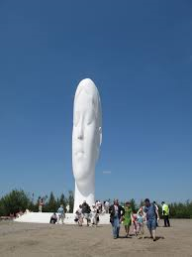  Develop skills in using clay inc. slabs, coils, slips, etc  Plan a sculpture through drawing and other preparatory work.  Produce intricate patterns and textures in a malleable media | Printing  Screen printing  Use relief or impressed method.  Create prints with three overlays.  Work into prints with a range of media e.g. pens, colour pens and paints. | Textile  Silk Painting  Experiment with batik techniques  Experiment with a range of media to overlap and layer creating interesting colours and textures and effects.
Artist Study | Felix Nussbaum, The Refugee (1939)  Looking at other artists from the Holocaust  http://www.bbc.com/culture/story/20160203-art-from-the-holocaust-the-stories-behind-the-images  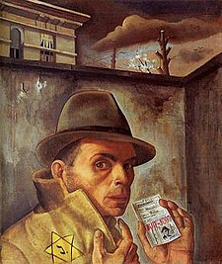 |  | Henri Matisse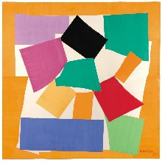  Sir Christopher Wren- Architect Study St Paul’s Cathedral (London Trip) |  | Turner – London Life 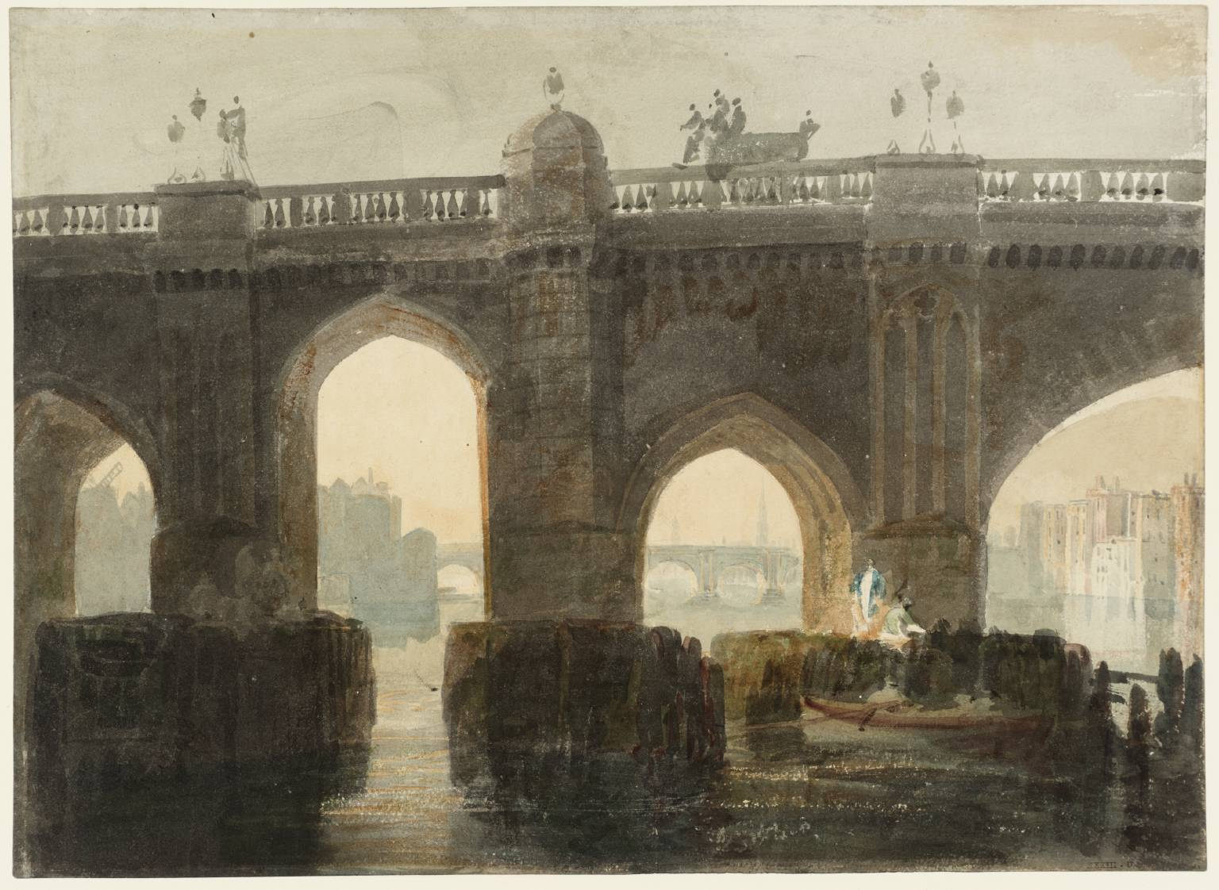 | Jaume Plensa  (The Dream)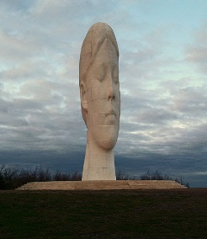 Suggested Material: Firing Clay | Orla Kiely  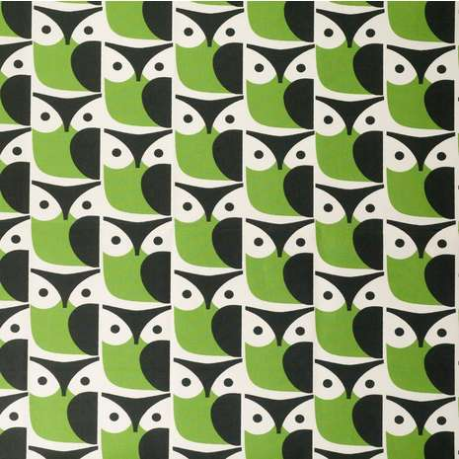
Design Technology (including cooking) |  |  |  |  | Focus - More complex switches and circuits – science link – electricity.  Designing  • Use research to develop a design specification for a functional product that responds automatically to changes in the environment. Take account of constraints including time, resources and cost.  • Generate and develop innovative ideas and share and clarify these through discussion.  • Communicate ideas through annotated sketches, pictorial representations of electrical circuits or circuit diagrams.  Making  • Formulate a step-by-step plan to guide making, listing tools, equipment, materials and components.  • Competently select and accurately assemble materials, and securely connect electrical components to produce a reliable, functional product.  • Create and modify a computer control program to enable an electrical product to work automatically in response to changes in the environment.  Evaluating  • Continually evaluate and modify the working features of the product to match the initial design specification.  • Test the system to demonstrate its effectiveness for the intended user and purpose.  • Investigate famous inventors who developed ground-breaking electrical systems and components.  Technical knowledge and understanding  • Understand and use electrical systems in their products.  • Apply their understanding of computing to program, monitor and control their products.  • Know and use technical vocabulary relevant to the project. |  | Focus - Celebrating culture and seasonality – can they design and make an End of Year 6 celebration item? Cake for prom, compare celebration cakes and how they have changed throughout history.  Designing  • Generate innovative ideas through research and discussion with peers and adults to develop a design brief and criteria for a design specification.  • Explore a range of initial ideas, and make design decisions to develop a final product linked to user and purpose.  • Use words, annotated sketches and information and communication technology as appropriate to develop and communicate ideas.  Making  • Write a step-by-step recipe, including a list of ingredients, equipment and utensils  • Select and use appropriate utensils and equipment accurately to measure and combine appropriate ingredients.  • Make, decorate and present the food product appropriately for the intended user and purpose.  Evaluating  • Carry out sensory evaluations of a range of relevant products and ingredients. Record the evaluations using e.g. tables/graphs/charts such as star diagrams.  • Evaluate the final product with reference back to the design brief and design specification, taking into account the views of others when identifying improvements.  • Understand how key chefs have influenced eating habits to promote varied and healthy diets.  Technical knowledge and understanding  • Know how to use utensils and equipment including heat sources to prepare and cook food.  • Understand about seasonality in relation to food products and the source of different food products.  • Know and use relevant technical and sensory vocabulary. | Focus - Combing fabric shapes - Link to LC – Islamic Civilisations  Designing  • Generate innovative ideas by carrying out research including surveys, interviews and questionnaires.  • Develop, model and communicate ideas through talking, drawing, templates, mock-ups and prototypes and, where appropriate, computer-aided design.  • Design purposeful, functional, appealing products for the intended user that are fit for purpose based on a simple design specification.  Making  • Produce detailed lists of equipment and fabrics relevant to their tasks.  • Formulate step-by-step plans and, if appropriate, allocate tasks within a team.  • Select from and use a range of tools and equipment to make products that are accurately assembled and well finished. Work within the constraints of time, resources and cost.  Evaluating  • Investigate and analyse textile products linked to their final product.  • Compare the final product to the original design specification.  • Test products with intended user and critically evaluate the quality of the design, manufacture, functionality and fitness for purpose.  • Consider the views of others to improve their work.  Technical knowledge and understanding  • A 3-D textile product can be made from a combination of accurately made pattern pieces, fabric shapes and different fabrics.  • Fabrics can be strengthened, stiffened and reinforced where appropriate.
Music  Charanga | I’ll be there |  | Benjamin Britten  A New Year Christmas Carol |  | Classroom Jazz | Happy | You’ve got a Friend | The Fresh Prince of Bel Air  Reflect, Rewind and Replay
Computing  Digital Literacy | Computer Networks  Talking Safely Online – What is Cyberbullying? |  | Creativity  Privacy Rules |  | Productivity | Creativity  Selling Stereotypes | Programming | Communication  Super digital Citizen
PE | Real PE  Invasion Games  Rugby  Hockey | Real PE  OAA 3 weeks  Gymnastics 4 weeks |  |  | Real PE  Dance – Topic related | Real PE  Athletics 2 weeks  OAA 3 weeks | Real PE  GYmnastics | Real PE  Fielding Games  Badminton 3 weeks  Cricket 3 weks
MFL | My everyday life/your everyday life- a comparison  Returning to school- daily routine – compare our school with a school in target language speaking country.  Numbers 0-31/Days of week-revisit  Number games 0-60  Revisit 24-hour clock  Times – o’ clocks and half pasts  Times and simple daily routine phrases  Eating a meal at the table | Where I live / where you live  Welcome to my house!  Comparison of houses and rooms in the houses here and in target language country.  Describing what you can do in locality where you live and finding out more about your friend’s life style in target language country  Christmas celebrations- a Christmas meal  Eating a meal |  |  | Playing sport and enjoying hobbies  Sports and hobbies  Revisit classroom instructions and physical instructions  Play a board game e.g. Snakes and ladders  Investigate a famous tournament from target language country.  Likes, dislikes and opinions of sport and hobbies  Going to the funfair. Investigate a website for a target language funfair.  Buy a ticket for a ride | A famous target language sports star/ musician  Create a simple personal information interview with famous person  Create a short report about a famous person – either interview or 3rd person report.  A game to play and enjoy  Listen to and learn a song from target language.  Music to listen to for pleasure | Going to the Restaurant  Restaurant role plays  Revisit known foods and drinks  Investigate recipes and menus from target language country.  Understand simple ingredients  Express opinions about foods  Learn about traditional target language meals  Ask for items  Ask for the bill  Order drinks and meals | Performing plays for enjoyment  Dopey waitress sketch  The magician’s sketch  Super star sketch  Restaurant song
Religious Education  Is Life a Journey?  (Life as a journey) | Christianity  (Jesus)  Can saying sorry really change things? |  | Christianity  (God)  Should we prepare for the future?  Christmas |  | Islam  What should our attitudes be on our journey? | Christianity  Baptism  What do we commit ourselves to on our journey?  Easter | Hinduism  Do we have to lead our lives a certain way? | Buddhism  The eightfold path and the four noble truths.  Can people really change?
PHSCE | The Global Community- Rights, Respect and Responsibilities  What is Global  Citizenship?  What is aid for?  Is aid important?  Is aid always good?  What is fair trade?  Is fair trade  Charities  ** Kidsefe Revision Unit** |  | Managing Conflict, Friendships and Relationships.  Anti-Bullying Week  Peer pressure, bullying, racism, hate crime & homophobia  Resolve conflicts democratically  Managing emotions  Strategies to avoid conflict in situations  Coping with pressure  to take substances  Personal Responsibility  Social Responsibility  Media Bias  Can newspapers  be biased?  Stereotypes  How trustworthy is  information on the  internet? |  | Responsibilities for my own Actions  Effects of use / misuse  Law related to alcohol,  tobacco and solvents  effects of use/misuse  Role models  Responsibilities for their bodies and behaviour  Choosing the right decision making approach in real or simulated situations  Recognising when to ask for support/help and where to turn | Health and Wellbeing: Changes  What is a teenager?  Social changes  Emotional changes  Relationships  (family and other)  Grooming  Child sexual  Exploitation  Love & Relationships  Emotions  Fears & Worries | World of Work  The Law and money  Interview people about their jobs  Range of jobs  How does learning  help?  Making the most of me  Respect other people’s career choices  Balance between leisure and work  Life skills | Transition and managing Change  Transition to ...  new key stage  new school  Looking Forward  Positive mental health  Present themselves confidently and positively  What have I Achieved?  How will it help me?  in the future?  Reviewing/setting personal goals
Character Education - Missions | Nancy Wake – The White Mouse  WW2 British Special Operations Executive |  |  |  | Ibn Battuta – Eastern Odyssey  Morocan Muslim Schollar and Traveller |  | Amelia Earhart – Final Flight  Fisrt female to fly over the atlantic

