Behaviour and Anti-Bullying Policy
Chesterton Primary School

Last reviewed on: | 02.02.2024
Next review due by: | September 2024

Chesterton Primary School
Behaviour Policy

Aims
It is the primary aim of our school that every member of the school community feels valued and respected, and that each person is treated fairly and consistently. We are a caring community, where values are built upon mutual trust and respect for all. The schools’ behaviour policy is, therefore designed to support the way in which all members of the school can live and work together in a supportive way. It aims to promote an environment where everyone feels happy, safe and secure. The primary aim of the behaviour policy is a means of promoting good relationships, so that people can work together with the common purpose of helping everyone to learn. This policy supports the school community in aiming to allow everyone to work together in an effective and considerate way. The school expects every member of the school community to behave in a considerate way towards others. The school provides a consistent approach to the management of behaviour and discipline. This policy aims to help children to grow in a safe and secure environment and to become positive, responsible and increasingly independent members of the school community.

Therefore the aims of this behaviour policy are:
1. To encourage pro-social behaviours and respect for others.
2. To establish a clear set of values.
3. To ensure everyone knows and understands the values so they may be consistently implemented.

School Rules
The school rules and values give guidance as to acceptable and unacceptable behaviour and they are displayed throughout the school.

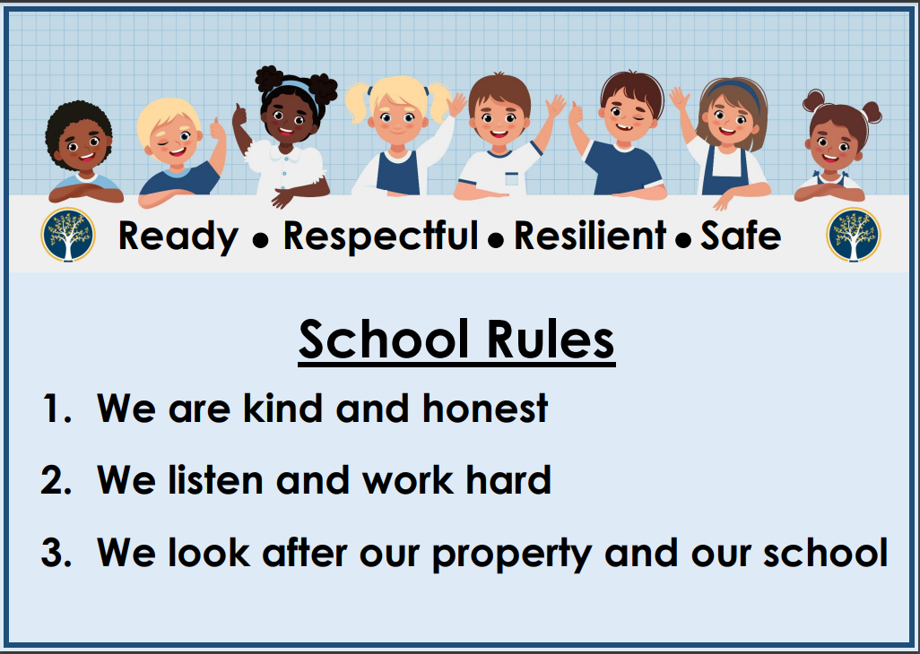

Our school values are: Ready, Respectful, Resilient and Safe.

The class teacher regularly discusses the school values with their class. In addition to the school values, each class may have agreements regarding day-to-day practices, for example, exiting the classroom to go to the toilet. In this way, every child knows the standard of behaviour that is expected in our school.

The school will not tolerate:
- physical and verbal aggression towards staff or pupils;
- prejudice or discriminatory language;
- bullying of any kind (Appendix A);
- persistent and deliberate disruption to others learning.

We act immediately to stop any occurrences of such behaviour and apply the behaviour system consistently.

The school adheres to the Equality Act 2010 and the Children and Families Act 2014. For children with Education, Health and Care plans (EHCP) the school cooperates with the Local Authority.

Definitions

Anti-social behaviour: Behaviour that causes harm to an individual, a group, to the community or to the environment.

Behaviour: Everything a person says or does. The spectrum of behaviour goes from extreme pro-social to extreme anti-social behaviour. A behaviour policy should increase pro-social behaviour and reduce anti-social behaviours through planned responses.

Consequence: A logical, explainable response to a pro-social or anti-social behaviour; a logical outcome of something occurring earlier; a conclusion reached via reasoning. Consequences are designed to help children learn and develop pro-social behaviour transferable to all contexts.

Pro-social behaviour: Relating to behaviour which is positive, helpful, and values social acceptance.

Behaviour at Lunchtime, Playtime, Onsite and Offsite
Positive behaviour expectations apply throughout the school day, both on and off the school site.

The School Behaviour System
The school has strategies in place for pupils following the values and educational or protective consequences for those who are not following them.

- Emphasis on encouraging and motivating pupil e.g. positive feedback, descriptive praise, give attention for success
- Raising self-esteem by ensuring pupils experience and recognise their own success.
- Headteacher Awards: these are presented to pupils in each class (one per week) who produce work of an exceptional standard (appropriate for that individual)
- Dojo points to be given out for consistent good work or behaviour, or to acknowledge outstanding effort or acts of kindness in school. These need to be handed out consistently by teachers. Pupils can exchange their rewards for individual and class prizes.
- Staff congratulating children and celebrating achievements with others, either in class or during our Celebration Assemblies.
- Positive feedback to parents (verbal and written via Postcard home, for example), stickers and presenting good work to the Headteacher or other class teachers.
- Positive praise and recognition
- Maximising opportunities for pupils to take responsibility for themselves in their behaviour by providing choices wherever possible

Managing Incidents of Anti-Social Behaviour
Our aim is to change a pupil’s behaviour to pro-social behaviour before putting a consequence in place. The restorative approach will be used at all stages, including the use of the restorative approach questions. It is part of the language of teachers and pupils. It encourages children to take responsibility. There will be a focus on rights and British values. It focuses on building positive relationships, learning from mistakes and is fully inclusive. It is based on idea that we all have the right to feel safe at all times and that this includes staff as well as pupils. At all stages, consequences are non-judgemental and the approach must centre on the behaviour, not the child.

Initially, we always aim to achieve this through these techniques as outlined by Cambridgeshire Therapeutic Thinking:

- Positive phrasing:
  - Stand next to me, thank you
  - Put the pen on the table, thank you

- Chance to amend behaviour and the use of reminders
  - What are you supposed to be doing?
  - You still have not started your work, this is your reminder

- Limited choice
  - Put the pen in the box or on the table, thank you
  - Talk to me here or in the corridor
  - Are you going to sit with an adult or on your own?

- Disempowering the behaviour
  - You can listen from there
  - Come and find me when you come back

- Use of de-escalation script
  - Use the person’s name
  - Acknowledge their feelings
  - Offer to help (talk to me I will listen)
  - Offer a get out (positive phrasing)

All incidents of low-level disruption should be logged on MyConcern.

Although we are an inclusive school, we recognise that a child may sometimes need to be removed from a classroom to calm down. In these incidents, the staff identified on the Predict, Prevent and Progress plan, will be called for and the child will come back to class once they have calmed down. After these incidents, a restorative conversation will take place between the pupil and the teacher and recorded on MyConcern. Staff working with the pupil will follow the Predict, Prevent and Progress plan to ensure appropriate adaptations are in place to mitigate the anti-social behaviours.

If behaviour is re-occurring, a restorative conversation will take place. This will be logged on MyConcern and the outcome of the conversation logged as well. Educational and protective consequences will be in place to teach behaviour or manage the risk of harm.

If the behaviour still does not change, then it will be referred to the Deputy Headteacher or Headteacher. A Risk Management Plan and Therapeutic Tree will be set up with the child, parents and class teacher.

Lastly, if the behaviour still does not improve then it will be referred to the Head Teacher. The Head Teacher will meet with the pupil`s parents or carers through a formal conference.

Consequences
Stage 1 – warning and rule reminder
Stage 2 – working in a different space then speaking with phase leaders
Stage 3 – Sent to the office to work with SLT
Stage 4 – Parents contacted

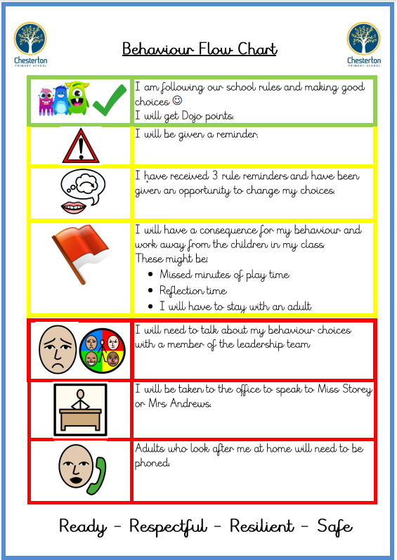

Protective Consequences
Protective consequences are necessary measures to manage the risk of harm. Protective consequences may limit freedoms.

Protective consequences may include:
- Temporary increased staff ratio
- Limited access to outside space
- Escorted in social situations
- Restricted off site activities
- Differentiated teaching space
- Differentiated curriculum or resources

Educational Consequences
The essential learning, rehearsing or teaching to enable behaviour change.

Educational consequences are the specific teaching following anti-social behaviour, designed to enable the young person when faced with the same situation to be equipped to react/respond differently.

Education consequences are designed to inspire a young person to moderate, and self-regulate their behaviour in order for freedoms to be returned

Educational consequences may include:
- Learning and understanding the relevance of a task
- Rehearsing and practising behaviour
- Understanding and assisting with repairs
- Educational opportunities (chance to learn)
- Researching the implications of behaviour
- Conversation and exploration (developing empathy, tolerance and understanding)

Conversation and Exploration: Restorative De-brief

At each stage, staff need to take time to repair relationships with the pupils, to try to avoid escalation of behaviour. Staff will not refer to previous incidents (unless directly relevant) but try to focus on positive behaviour and the way forward. The restorative approach will be used when necessary to help resolve conflict. At each stage, children will be praised for improving their behaviour.

Children will have a restorative conversation with an adult to explore and reflect on what happened and who/what was hurt.

- Everyone must be given enough time to calm down before the restorative discussion takes place.
- Pupils can conduct the restorative discussions themselves depending on their age, and the severity of the disagreement. Otherwise it must be an adult that was involved in the incident who supports with the discussion.
- All members of staff and children know that issues will be dealt with fairly with a ’no blame’ approach, and the language used in discussions is fair, consistent and respectful.
- Discussions are held in a calm, quiet, private place.
Process of restorative de-brief:
- Identify who has been affected and how.
- Consider how we can repair relationships.
- Plan for a different response to the same experiences or feelings re-occurring.

Questions discussed during de-brief:
1. What happened?
2. What were you thinking at the time?
3. What have your thoughts been since?
4. Who has been affected by what you did?
5. In what way have they been affected?

How Children Can Sort Out Their Own Difficulties

Children should be encouraged to take responsibility for sorting out their own conflicts. This means that adults must take responsibility for teaching them and modelling strategies for doing this, and for seeing that children carry them out and reach a successful conclusion. Children should be encouraged to be assertive, to express their feelings and to resolve conflict without resorting to violence, swearing or abuse. Children learn about such strategies and how to relate to each other as part of our RSE/PSHE curriculum.

Expectations of Staff in the School
- Create strong relationships with pupils in the school
- Treat all children with respect and understanding; deal with incidents with sensitively and calmly
- Adults treat each child fairly and equally, consistently promoting classroom agreements and the school values
- Adults follow the principles of behaviour management as outlined in the Cambridgeshire Therapeutic Thinking training.
- All adults in school have high expectations of children in terms of behaviour and strive to ensure that all children work to the best of their ability, by modelling accepted behaviour.
- It is the responsibility of class teachers to ensure that the school values are applied within classes and that the class behaves in a responsible manner during lesson time.
- Class teachers involve all adults working within their class in demonstrating, by example, a fair and consistent approach to the management of behaviour.
- Refrain from using sarcasm, scathing remarks or belittling any member of the school community
- Praise, encourage and reward pupils’ wherever possible
- Encourage pro-social behaviours rather than rely on consequences
- Use seating arrangements to promote pro-social behaviours
- Make sure that all children enter and leave the classroom in an orderly and respectful manner
- Create a stimulating learning environment
- Liase, through the SENDCo, with external agencies concerned with behaviour
- Contact and report to parents through Class Dojo, phone calls or face to face meetings to discuss the behaviour of their child
- Raised voices or shouting are only acceptable in emergency situations.
- All adults should ensure that children maintain self-esteem and difficulties are resolved in such a way that problems are de-escalated.

The Use of Reasonable Force
- There are circumstances when it is appropriate for staff in school to use reasonable force to safeguard children.
- The term ‘reasonable force’ covers a broad range of actions used by staff that involve a degree of physical contact to control or restrain children.
- ‘Reasonable’ in these circumstances means ‘using no more force than is needed’.
- Members of staff have the power to use ‘reasonable force’ to prevent pupils committing offenses, injuring themselves or others or damaging property and to maintain good order.
- Authorised school staff may also use such force as is reasonable given the circumstances when conducting searches for knives, weapons, alcohol, illegal drugs, tobacco, fireworks, stolen items etc.
- The school will consider the risks of using ‘reasonable force’ recognising any specific vulnerabilities of the child including SEND, mental health or medical conditions.
- Staff members may occasionally have to intervene physically between pupils. Records of incidents will be kept and parents informed.
- Staff receive training in guides and escorts.

Searching, Screening and Confiscation
- School staff can confiscate, retain or dispose of a pupil's property as a disciplinary penalty in the same circumstances as other disciplinary circumstances.
- Staff will consider whether the confiscation is proportionate and consider any special circumstances relevant to the case.

Removal from the Classroom
- Removal is where a child, for a serious disciplinary reason, is required to spend time out of the classroom at the instruction of a staff member.
- The use of removal will allow for the continuation of the pupil’s education in a supervised setting such as the Headteacher’s office.
- The continuous education provided may differ to the mainstream curriculum but will be meaningful to the child.
- Removal from the classroom will only take place where pupils are not safe or there is significant disruption to the learning of other children. It should only be used when other behaviour management strategies have been exhausted.
- The school will consider if the sanction of removal is proportionate and consider whether there are any special circumstances relevant to its imposition.
- Removal is distinguished from the use of separation spaces (e.g. the sensory room) for non-disciplinary reasons. For example, a child may be taken out of a classroom to regulate his or her emotions because of identified sensory overload as part of a planned response.
- All exit incidents will be reported on MyConcern and the data will be regularly analysed in order to identify repeat patterns and reflect on the effectiveness of removal.

Removal will be used for the following reasons:
- to maintain the safety of all pupils and to restore the stability following an unreasonably high level of disruption;
- to enable disruptive pupils to be taken to a place where education can be continued in a managed environment; and
- to allow the child to regain calm in a safe space.

Serious Incidents Report Forms
All serious incidents are reported via MyConcern. These are to be completed as soon as possible after the incident.

The Senior Leadership Team and Governors analyse the data collected on a regular basis in order to address any recurring triggers, behaviours or incidents. Outcomes are then addressed and planned for through the School Improvement Plan. The impact is reported to all staff, parents and governors. Prejudice issues are reported to governors once a term and all incidents are recorded.

Behaviour Expectations and Pupils with Special Educational Needs and/or Disability (SEND)
The Government document Behaviour in schools (September 2022) provides advice for the Headteacher and school staff in relation to the behaviour expectations for pupils with SEND. The document notes that a school’s culture should consistently promote high standards of behaviour and provide the necessary support to ensure all pupils can achieve and thrive both in and out of the classroom.

As a school, we consider how our whole school approach meets the needs of all pupils including pupils with SEND so that everyone feels that they belong to the community and that high expectations of behaviour are maintained for all pupils.

Some behaviours are more likely to be associated with particular types of SEND. Behaviour will be considered in relation to a pupils SEND although it does not follow that every incident of misbehaviour will be connected to their SEND. When a pupil is identified as having SEND, the graduated approach is always used to assess, plan, do and review the impact of the additional support being provided.

Under the Equality Act 2010, schools should take steps as are reasonable to avoid any disadvantage caused by the school’s policies and practices.

The Children and Families Act 2014 states that the school has a duty to use ‘best endeavours’ to meet the needs of those with SEND.

If a pupil has an EHCP, the provision set out must be secured and the school must cooperate with the local authority and other governing bodies.

Adaptations and ‘best endeavours’ will be personalised to the child’s needs. Some examples are below:

· movement or brain breaks;

· individual sticker charts;

· personalised sanctions or rewards;

· access to a regulation area such as the sensory room;

· staff training in conditions such as autism;

· now and next boards;

· personalised curriculums;

· additional adult support in class;

· social interaction interventions;

· reduced timetables.

Role of the Parent
The school works collaboratively with parents so children receive a consistent message about how to behave at home and at school. We explain the school rules on the school website and in the home/school agreement given when children join the school.

We expect parents to support their child’s learning and to cooperate with the school. We try to build a supportive dialogue between home and school and we inform parents immediately if we have any concerns about their child’s welfare or behaviour. If there are ongoing difficulties, parents are informed and their cooperation is sought to remedy the situation. If necessary an Individual Behaviour Plan is written. It may be necessary to put a Risk Assessment in place.

The Role of the Governors
The Governing Body has the responsibility of setting down these general guidelines on standards of discipline and behaviour and of reviewing their effectiveness. The governors support the headteacher in carrying out these guidelines.

Suspension and Permanent Exclusions
The school has regard to the DFE Exclusions Guidance document and the Active Learning Trust Exclusions Policy. In the event of a suspension or exclusion, guidance would be followed as recommended in these documents. The headteacher has the responsibility for implementing suspensions to individual children for serious acts of misbehaviour. For repeated or very serious acts of misbehaviour, the headteacher may permanently exclude a child.

Following a suspension, a reintegration meeting will take place with the headteacher as outlined in the Active Learning Trust Exclusions Policy. A record of this meeting will be logged on the reintegration form.

Responding to the behaviour of Pupils with SEND
The schools will consistently and fairly promote high standards for all pupils and provide support where needed to ensure pupils can achieve and learn as well as possible. The school will not assume that because the pupil has SEND, it must have affected their behaviour on a particular occasion - this is a question of judgment for the school on the facts of the situation.

However, as a school we will consider whether the pupil's SEND has contributed to the misbehaviour and if so, whether it is appropriate and lawful to sanction the pupil. In considering this, schools should refer to the Equality Act 2010 and schools guidance.
The school will consider whether any reasonable adjustments need to be made to the sanction in response to any disability the pupil may have. This does not mean that a SEND child will be exempt from sanction, but that reasonable adjustments to provision and sanction would be made and considered. When making decisions about appropriate sanctions, as for all pupils, the welfare and education of the child and the other children will also be considered.

Preventing recurrence of misbehaviour
The school will adopt a range of initial interventions strategies to help the child manage their behaviour and to reduce the likelihood of suspension or any further suspensions. Some pupils may need more support than others.

Examples of interventions the school may adopt are:
- Frequent and open engagement with parents;
- Engaging with local partners and agencies to address specific challenges;
- Cambridgeshire Therapeutic Thinking principles and paperwork to identify the root cause of the behaviour;
- The graduated response of Assess, Plan, Do, Review;
- Contact with the LA, if a child has an EHCP, to inform them about the behavioural issues;
- An Early Help Assessment complete for a multiagency assessment.

Monitoring
The Headteacher monitors the effectiveness of this policy on a regular basis. They also report to the governing body on the effectiveness of the policy, and if necessary, makes recommendations for further improvements. The Headteacher keeps a record of any pupil who is excluded for a fixed term or who is permanently excluded. It is the responsibility of the governing body to monitor the rate of exclusions and to ensure that the school policy is administered fairly and consistently.

Review
The governing body review this policy regularly. The governors may, however, review the policy at any time if the government introduces new regulations or if the governing body receives recommendations on how the policy might be improved.

Appendix A

Anti-Bullying Policy
Aims
The main aim of this policy is to ensure that the whole school community understands what is meant by bullying and how we, as a school, deal with such behaviour. In this school, we believe that bullying is unkind behaviour. We do not allow unkind or cruel behaviour in our school but recognise not all unkind behaviour is bullying. The key characteristics that turn unkindness into bullying have been arrived at after discussions with all staff and children at Chesterton Primary School.

What is bullying?
- Bullying is unfair.
- Bullying is deliberate.
- Bullying is repeated over a period of time.
Young children sometimes fall out with friends or say unkind things when they are angry. We explain to children that this is different from bullying. We call these situations incidents of bad behaviour.

What is an incident of anti-social behaviour?
- It can be meant to hurt.
- It can be an accident.
- It can be a thoughtless action.
- It is an isolated case.

Bullying or an incident of anti-social behaviour may include:
- name-calling;
- teasing;
- physically hurtful behaviour;
- verbally hurtful behaviour;
- threatening behaviour;
- taking and/or breaking another child’s possessions;
- excluding.

The main difference is that bullying is persistent and targeted over a period of time. An incident of bad behaviour is an isolated event.
All staff at Chesterton Primary School are aware of the importance of being proactive in dealing with such incidents. We address bullying by trying to prevent it from happening in the first place and by tackling it consistently, fairly and effectively when it does.

The following strategies have been shared and agreed with staff in order to address the issue of bullying:
- Ensure the playground is monitored at break times, children are never allowed on the playground unsupervised.
- Toilets, corridors and cloakrooms are monitored during break times.
- Be aware of children leaving the classrooms during lessons.
- Be watchful of all children, get to know them and be aware of any change in behaviour.
- Records of incidents reported on MyConcern.
- Immediate removal from the playground/classroom of any child involved in a serious incident.
- Headteacher and deputy head to take the lead role in resolving on-going problems.
- Parents of both bully and victim to be involved.
- PSHE and RE lesson times and assemblies used to address aspects of bullying.
- Children are taught the difference between targeted bullying and incidents of bad behaviour.
- Children are encouraged to express feelings and opinions.
- LISTEN when children talk about incidents or issues, allow all children to speak calmly.
- BE ASSERTIVE when dealing with bullying but not aggressive or hostile (this will only add to the bully’s ammunition).
- Most importantly encourage all children and adults to TELL SOMEONE, THEN TELL THEM AGAIN!

The headteacher and deputy head will take the lead in resolving on-going problems. All parties involved will be treated fairly and have a chance for reflection and to give their side of events. The parents of both the bully(s) and the victim(s) will be involved whenever necessary and events recorded. We believe that all children can change their behaviour with appropriate support.

All staff at Chesterton Primary School will endeavour to:
- establish what is bullying and what is an incident;
- prevent bullying through consistent strategies;
- deal effectively with bullying if it occurs;
- promote our positive behaviour policy;
- teach children that bullying will not be tolerated/accepted.

These posters are displayed throughout the school:

What is Bullying? | What is an incident?
1. Somebody is picking on me again and again and again.  2. I am frightened and worried.  3. This makes me feel unhappy all the time. | 1. Someone was unkind to me today.  2. I was hurt and upset.  3. I don’t think this will happen again. I must tell someone.
I MUST TELL SOMEONE

Appendix B

Common language when talking with children about their behaviour

It is important to ensure the children are clear about the behaviours that are unacceptable and also to give positive feedback when the behaviour is good.

De-escalation Script

- Learner’s name
- I can see something has happened
- I am here to help
- Talk and I will listen
- Come with me and……..

Positive phrasing:
Come sit next to me for a story.
Limited choice:
Would you like to sit on the chair or bean bag?
Disempowering the behaviour:
You can listen to the story from there.
Consequence:
We will check you understand the story before going out for break time.

Remember:
- consistency is very important;
- tone of voice should be firm, but not angry, exasperated or irritated.

Zero tolerance does not mean that stages are skipped or that a more firm approach is used.

Zero tolerance means that the staged approach is applied consistently and immediately. This may not be the most appropriate option for the youngest children; they may need more teaching and modelling of the desired behaviours.

Appendix C

Class Dojo
