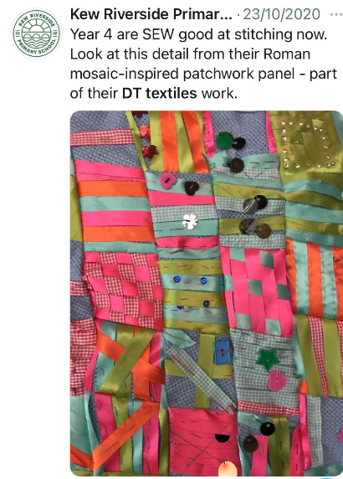

| **Area of DT - Textiles**    Product: Roman Mosaic patchwork  Purpose:  User:  Designer study: Faith Ringold- story quilts | | | | | | |
| --- | --- | --- | --- | --- | --- | --- |
|  | **Session 1** | **Session 2** | **Session 3** | **Session 4** | **Session 5** | **Session 6** |
| Knowledge Objective: | To investigate a variety of quilts and discuss the pictures and what this may mean. | To understand the importance of a seam allowance. | To design a product considering the user and purpose. | To create my story quilt collaboratively. | To create my story quilt collaboratively. | To evaluate my final product using a design criteria. |
| Skills Objective: | To discuss the techniques used in this textile and how they are joined. | To join materials with the appropriate stitching. | To design a product considering embellishment inspired by designers study. | To consider embellishment and the final product. | To join with appropriate stitching. | To evaluate ideas and products against their own design criteria and consider the views of others to improve work. |
| Pillar | Investigate and experiment. | Investigate and experiment. | Design | Create | Create | Evaluate |
| Assessment | Identify some of the great designers in all areas of study to generate ideas for designs.  **All-**-With support from a teacher, children can make comments about the techniques the designer has used.  **Most-** Children can discuss a range of the designer's techniques and use these to provide inspiration for designs.  **Some-** Children show an in-depth knowledge of some of the designers techniques and use these for inspiration and ideas for designs. | **All-**-With the support of a teacher, materials are joined using the correct stitching.  **Most-** With growing independence, materials are combined using the appropriate stitching.  **Some-** With high levels of independence materials are combined using the appropriate stitching and children are able to explain their reasoning for this joining technique. | **All-**- When supported by a teacher, designs created meet the user and purpose.  **Most-** With growing independence, designs have a clear purpose and intended user are created.  **Some-**With a high level of independence and a good understanding that designs require a purpose and user, very good designs are created considering techniques from the designer study. | **All-**-When supported by a teacher, children begin to create their product with encouragement to refer back to their designs.  **Most-**Children create their product with growing independence referring to their design, using their knowledge of stitching.  **Some-**With a high level of independence children create their product selecting appropriate stitching and referring to their design throughout. | **All-**-When encouraged, techniques are refined throughout the project to improve the design  **Most-**Generally designs are evaluated and refined throughout the project.  **Some-** Designs are continually evaluated and improved throughout a project, resulting in high-quality products. | **All-**-Their product is evaluated against the users likes and dislikes.  **Most-**With support, there is understanding of the need for feedback for their product and with support they can actively improve their product.  **Some-**There is awareness and understanding of the need for feedback and independent action to improve their product. |
| Resources needed | material, sequins, buttons, needles, thread, fastening, pattern, | | | | | |
| Vocabulary | fastening, pattern, template, blanket stitch, running stitch, back stitch. | | | | | |