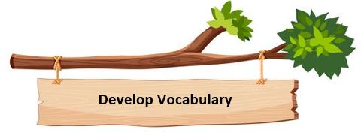
Vocabulary is important as it is closely connected with reading and writing. Children need to be able to understand words if they are to develop understanding of what they read.
Children learn words by hearing them and seeing them, so speaking and listening are important too. The more times they see and hear words, the more they can learn. Children are good at learning words, but they may need help.

Teaching & Learning
We use a number of practical strategies to help children to develop their vocabulary
- Class reading: vocabulary is discussed in the context of the book being read. Children are encouraged to apply this learning in their class discussions and written work.
- Class environment: working walls display specific vocabulary for children to refer to and adopt in their own writing.
- Specific teaching where the teacher identifies certain words and provides direct instruction in word learning strategies (looking at root words, finding synonyms and definitions, etc.).
- We create excitement about discovering new words (it is okay not to know what a word means).
- Children are encouraged to use new vocabulary accurately within full sentences in their speech as well as their written work. Ambitious or new vocabulary adopted by the children is celebrated through verbal and written feedback.

