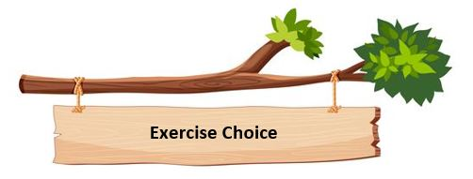
The purpose of our reading work in school is to engage and then extend the children with their reading and instil a love of books (and other printed material). By giving the children the opportunity to find authors and genres they love, they will read for pleasure, recognising the importance and value of reading in their lives. For this reason, we have school librarians who help develop reading areas in each classroom and create reading lists.

