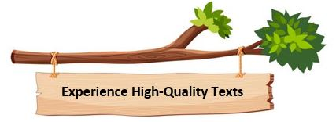
We have carefully selected the texts that drive our English reading and writing units from Reception to Year 6, this includes a range of fiction, non-fiction and poetry. We have worked hard to guarantee that we have high-quality texts as stimuli across the curriculum. These culturally diverse texts and authors have been chosen to reflect the unique cultures and experiences that our children bring to our school.

