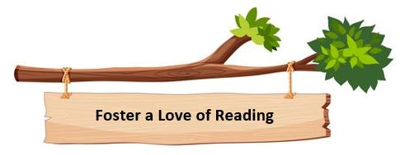
We encourage a love of reading whenever and wherever we can; children have time daily to read books, and read books that they want to read. All classes have a library area, which the children are involved in managing and stocking with up-to-date books. We have areas around the school for children to recommend books to others and follow-up on recommendations given.

