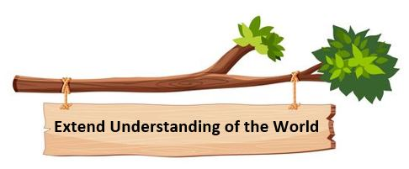

Our Reading curriculum is driven by high-quality diverse texts and progressively builds knowledge, understanding and skills. Through careful mapping, we have ensured that we have strong links across all curriculum areas to ensure knowledge does not sit in isolation. Meaningful links with other subjects are made to strengthen connections, enable a deeper understanding of vocabulary and allow opportunities for our pupils to transfer knowledge and language across the curriculum areas, thus enhancing communication, language and literacy across the curriculum.

