Dear Parents,
Please find below a suggestion of learning tasks for the coming week. We as a school, want to reassure you that a high priority of ours is well-being. Particularly the mental well-being of the children, yourselves and our staff at such a tough time. Therefore we do not want the activities below to become a source of extra stress for you. Please know that the teachers are available by email to provide support, if needed. The most important activities for you to complete with your child(ren) is daily reading and language development through conversation. We also recognise that activities you do with your children such as craft, baking, playing games, etc have many educational benefits and would encourage you to continue completing activities both you and your child enjoy doing together.

Year 1 Home Learning Menu | Week beginning 20.04.20
P.E. | Creative  (Music, Art, Drama)
Joe Wicks has become the UK’s PE teacher. Go on YouTube at 9.00am everyday to follow along.  If you have not access to You tube, can your child make up their own workout for you and the rest of the family to have a go at. | Drama - Role play being a nurse. Pretend someone has broken their leg. What are you going to do? Act it out!  Music – Listen to your favourite song and write down the instruments you can hear.  DT – Use some cooked noodles or pasta to write your name, take a picture.
Weekly Subject Focused Project:
History
Big Question: Do you think Edith Cavell/ Mary Seacole/Florence Nightingale were real life superheroes?  Focus: Who was Florence Nightingale?  Key Tasks:  Watch the video about Florence Nightingale https://www.youtube.com/watch?v=Frow559jWSE  Sort the pictures of the hospital conditions before and after Florence’s arrival into 2 different columns.  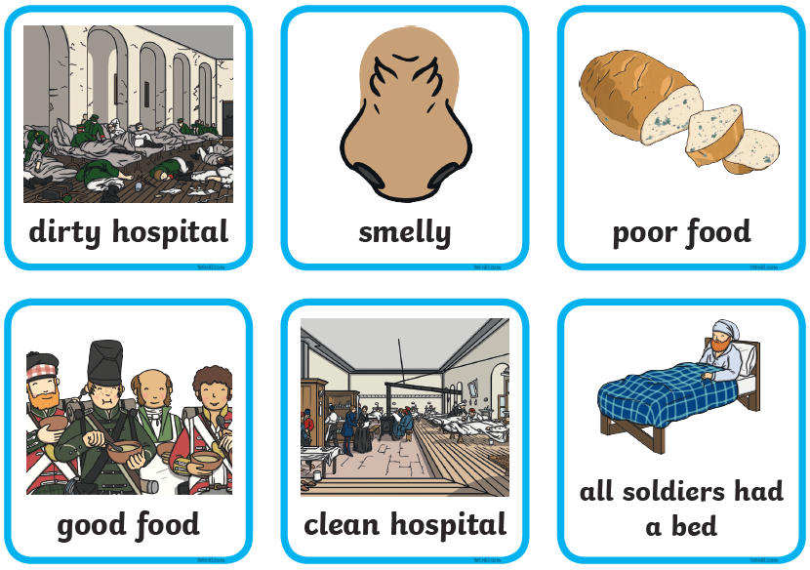  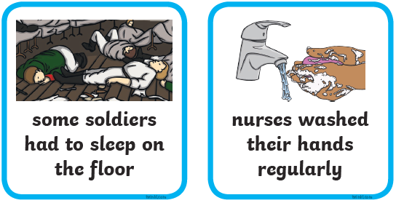  Mild – Sort the pictures into before and after Florence Nightingale’s arrival by copying them into different columns.  Chilli – Write full sentences for each picture in correct columns. E.g. Florence Nightingale cleaned the hospital. | Additional suggested tasks:  Find where Italy is on a map or globe.  Pretend to be the Queen and write a letter thanking Florence for her hard work.  Watch the longer video about Florence Nightingale’s life to find out more about her life.  https://www.youtube.com/watch?v=jONlz7vaMnU
Spelling and Grammar
This week’s focus is words with the ‘au’ sound:  haul, pause, launch, haunt, August, because  Write out the words and add sound buttons.  Use each word in a sentence.  Practice spelling each word by writing them out. You could write them in sand with a stick, paint them, use your finger in a tray of flour/rice/shave foam etc.  Match each verb to it ‘ed’ partner to change it into past tense.  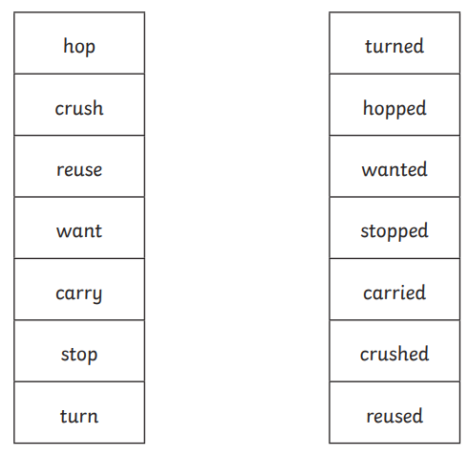 | How many tricky words can you find?  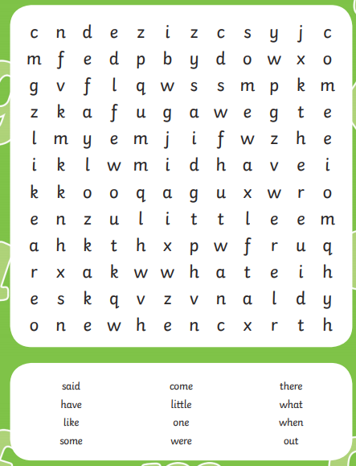  Challenge  Try to create your own word search with the some words you know.
Reading
Read for 15 minutes a day. Then use some of the sentences stems below to come up with questions about what you have read. Select a different focus for each day.
Alternatively, if you would like a change from coming up with your own questions go to www.pobble365.com and there are pictures and a story starter with questions to answer.
Vocabulary | Explain
The main character was …  A another word for __________ is…  The word(s) ______________________ suggest that the character is feeling...  A definition for the word ___________ is… | The most interesting/exciting part was... because…  The best structural/literacy feature was ... because...  The author makes the story interesting by...
Inference | Retrieve
The description of (character) shows that they are...  The following word(s) makes the reader feel...  I can tell that... because....  The character behaved in this way because.... | The key characters in the text are…  The story takes place in a/near to a …  With adult support, consider appropriate responses to:  How did...? How often...? How ... is ...? Who had...? Who is...? Who did....?What happened to...? What does ... do? Where did ... go?
Prediction | Summarise
Based on the front cover, I think this text will be about... I think this story will be about...because…  In the next section, I think (character) will... because.... The story is set in.... this makes me think that...  I think (character) will change their mood/behaviour/feelings in the future because… | The first thing that happened was...  The key events in order are…  A new title for this story could be... because...  At the beginning... In the middle… At the end...
Writing
Informative Text  Read the information by yourself or with an adult about looking after your body. Write your own informative text about how to take care of your teeth.  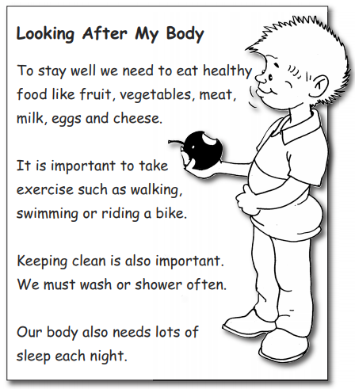  Mild – With an adult fill in the sentence stems about how to take care of your teeth.  It is very important to take care of your teeth so that they are _____  If you don’t you might get tooth aches or they might fall ______  One way to keep your teeth healthy is to ________  You should also _________________________ to keep them clean.  You could also visit the ______________ to check if they are healthy.  To stop holes you should avoid eating _____________________  Medium – Fill in the information for the below statements to provide information about how to take care of teeth.  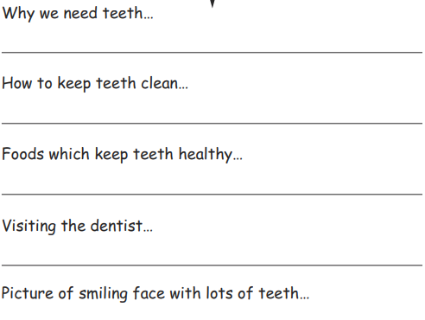  Chilli – Write out your own informative text using punctuation, explaining why it is important to keep your teeth healthy. | Additional suggested tasks:  Watch the noun and verb rap videos at  https://www.theteachertrain.com/mc-grammar  Use a coloured pencil to edit your work. Have you missed any full stops or capital letters? Have you made any spelling mistakes? Could you add any extra describing words?  Type your story up on Word and print it!
Maths
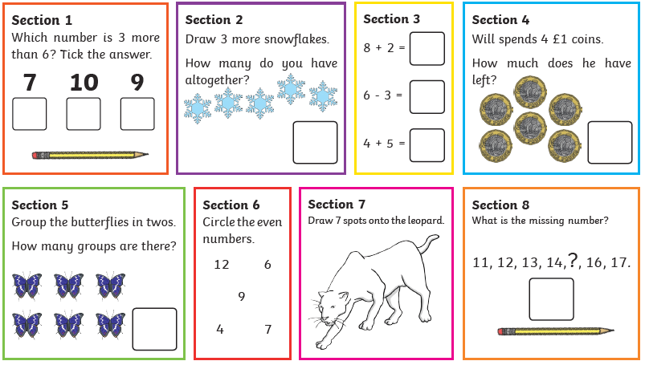  Solve each question independently or with adult help. Show your working out. | If you have access to a computer, use: https://whiterosemaths.com/homelearning/  Here you will be able to access a lesson a day of maths, there is a video of what to do  Play hit the button to practise addition https://www.topmarks.co.uk/maths-games/hit-the-button  Challenge:  Use a ruler (or the straight edge of a book if you don’t have one) to make numberline and practise skip counting by 2s, 5s, 10s  Mild: Numberline to 10  Medium: Numberline to 20  Chilli: Numberline to 50  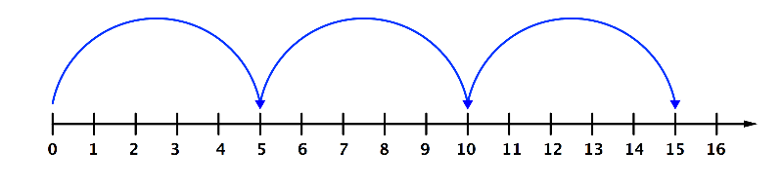
Additional Suggested Activities
https://www.phonicsplay.co.uk/
https://www.spellingcity.com/spelling-games-vocabulary-games.html
https://www.bbc.co.uk/bitesize/topics/zkxxsbk
https://www.storylineonline.net/
https://home.oxfordowl.co.uk/

