Dear Elm class,
Welcome back to another week of home learning! I hope you have been enjoying all the warm weather we have been having and not getting burnt! Please choose the activities that you find most suitable for your learning. I know many people have been baking and gardening as well as doing lots of arts and crafts. Please do not stress about getting every activity completed, we do not want the activities below to become a source of extra stress for you. The most important jobs to prioritise this week are learning the new spelling words, writing and the white rose maths. I am still always available by email at cbowers@chestertonprimary.org if you have any questions or would like to show me some of the work you have doing. Please remember that you need to be reading daily. This could be books, recipes, instructions, magazines or letters.
Have an amazing week if you are still learning from home, otherwise I look forward to having another fantastic week with those in school,
Miss Bowers.

Year 1 Home Learning Menu | Week beginning 29.06.20
P.E. | Creative  (Music, Art, Drama)
Joe Wicks has become the UK’s PE teacher. Go on YouTube at 9.00am every day to follow along.  If you have not got access to You tube, can your child make up their own workout for you and the rest of the family to have a go at.  How high can you jump? Get a piece of chalk or something similar. Stand next to a wall outside and jump as high as you can! Mark where you can jump to with the chalk in your hand as you jump. Keep practising… can you improve your jumps over the week??? | Music – Log into Charanga and follow the lessons for summer 2.  Go on a walk - Create a musical instrument from nature e.g. clapping sticks, rattle using stones, crunchy leaves. What sounds can you make?  Art – What would you put on your flag?  Key Tasks:  Evaluate your flag that you have created by answering the following questions in FULL SENTENCES:  - What was your favourite part of the design?  - What was the least favourite part?  - What worked well?  - What would you change for next time?
Weekly Subject Focused Project:
Science
Big Question: Is England ever hotter then Africa  Focus: Winter  Key Tasks:  Look at Winter in England https://www.youtube.com/watch?v=X0Bv6hchrg0  What do you notice? What happens to the leaves? What happens to the temperature? Do you think it ever snows in Africa? Watch to find out! https://www.youtube.com/watch?v=P-qoE13eK9E  Snowfall is rare in Africa but does happen sometimes!  Read the information about winter in the UK:  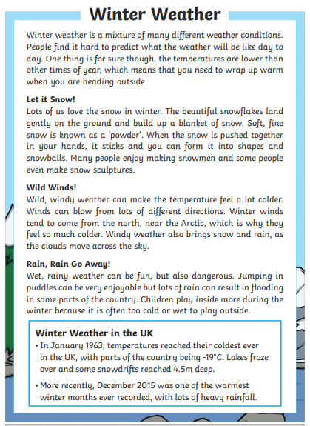  Draw labelled pictures of all the things we would need to pack if we were going on a winter holiday. | Additional suggested tasks:  Write a Winter poem  Use cotton balls to make a snowman  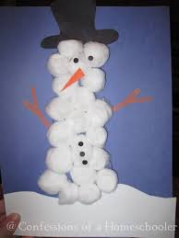  What is your favourite season? Write an explanation saying why.
Spelling and Grammar
This week’s focus High Frequency Words that are commonly used in year 1.

Because, came, your, friend, children

Write out the words and add sound buttons.
Use each word in a sentence.
Practice spelling each word by writing them out. You could write them in sand with a stick, paint them, use your finger in a tray of flour/rice/shave foam etc.

Use a dictionary (or the internet if you don’t have one) to write down defintions of these words:
Trudge-
Frequently –
Disgusting –
Furious –
Foolish -

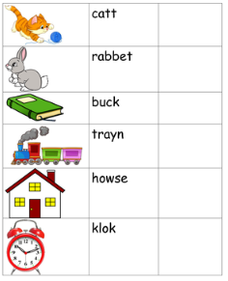
Correct the spelling mistakes
Reading
Read for 15 minutes a day.
Challenge – Read the Chesterton Chronicles to see what the other children have been doing.
Visual Literacy – Look at the picture and answer the questions below.
How many children are in each boat?
Where are they going?
How do you think they are feeling?
Why are they in boats?
Where are the adults?
What time of day could it be? How do you know?
What do you think is under the water?
Writing
- Look at the completed story map from the first week of learning about Kassim and the Hungry Fox. We are going to change the setting. Instead of a big city children need to think about a new place where the story could be set instead of a big city. A jungle? Village? Desert? Seaside? Think about what else would need to change in the story if the setting changes. Would they still go past the some places? Draw new pictures of the story map for the new setting on coloured pieces of paper and stick over the top of the old story map.  - Children ‘box up’ their innovated stories using the template at the end of the home learning pack. This means segmenting the story placing each part of the story into a box by drawing a picture and writing a sentence underneath it. The children ALL know how to do this.  - Write the first part of the story using the new setting  - Write the middle part of the story using the new setting  - Write the ending of the story using the new setting. Go through the story and edit it, check for spelling mistakes and check to see if it makes sense. | Additional suggested tasks:  Write a book review for your favourite book.  Create a new front cover for your favourite book.  Practice retelling the story.  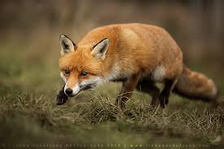
Maths
Monday – Number families. Number families are very important in maths. Look at the picture below and think about what number shapes can you see? What is the total if we add two and five? How could you write it as a calculation? What is missing from each of these calculations? Which number represents the whole shape? What numbers are parts of the shape?  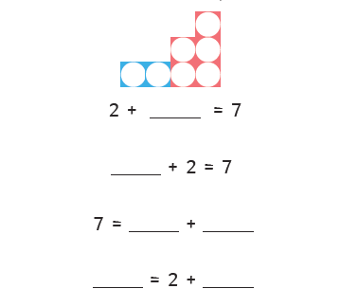  Mild – use the part whole models to 10 to write 4 different number sentences for each.  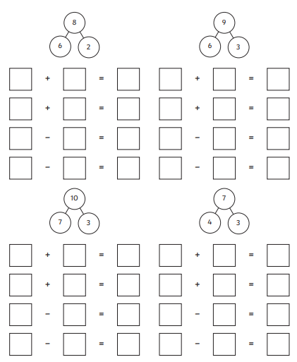  Chilli – Fill in the part whole models and write 4 number sentences for each.  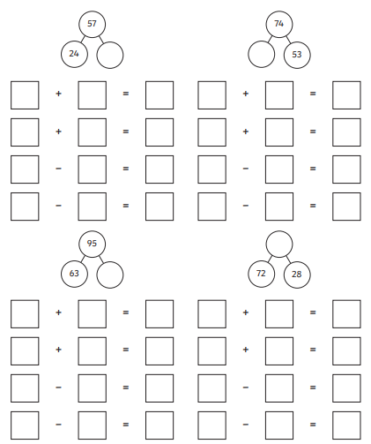  Tuesday – Number families. Use the bar models to fill in the missing numbers and write 4 number sentences about them each.  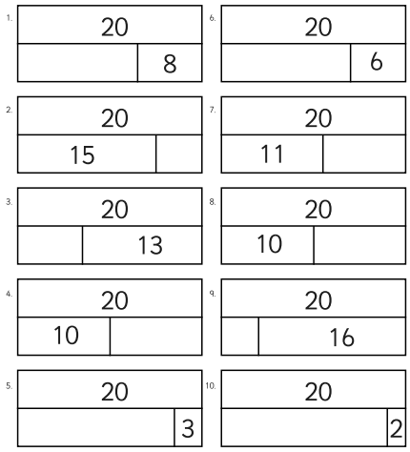  Wednesday – Doubles. Watch the video about doubling numbers. https://www.youtube.com/watch?v=At0quRa90rs Why do we need to know this? How can it help us? Practice doubling numbers by rolling a dice and doubling the number you roll. Make sure to write a number sentence to go with it. E.g 6 + 6 = 12  Challenge – can you double the numbers using a uno pack or a deck of cards?  Thursday – Watch the video about place value https://www.youtube.com/watch?v=a4FXl4zb3E4  Use reasoning to read and solve the problems:  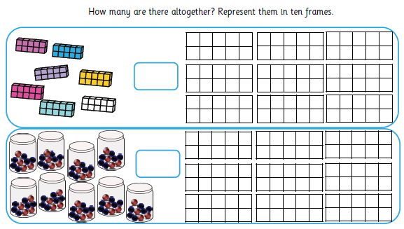  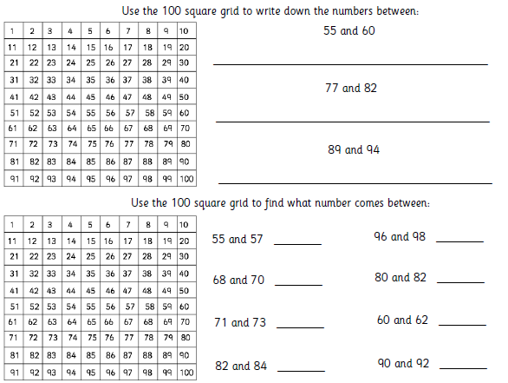  Friday – Solve the following problems and ask an adult to check your answers.  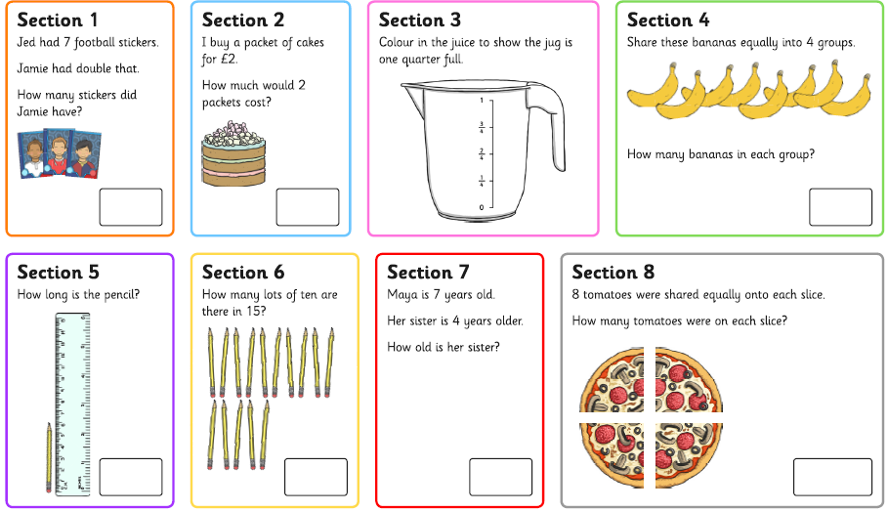 | If you have access to a computer, use: https://whiterosemaths.com/homelearning/  Here you will be able to access a lesson a day of maths, there is a video of what to do. Whiterose has unfortunately stopped providing free worksheets for each day. I will attach a separate email containing the worksheets. BBC Bitesize are offering daily videos that would be very useful to watch alternatively.  Play hit the button to practise addition https://www.topmarks.co.uk/maths-games/hit-the-button  Play snakes and ladders with your board game
Additional Suggested Activities
Complete the video challenges on the webstie.
Practice handwriting
https://www.phonicsplay.co.uk/
https://www.spellingcity.com/spelling-games-vocabulary-games.html
https://www.bbc.co.uk/bitesize/topics/zkxxsbk
https://www.storylineonline.net/
https://home.oxfordowl.co.uk/
https://www.youtube.com/watch?v=WpvquS6c5vk
https://www.youtube.com/watch?v=siVkXoEQDNc

