Dear Elm class,
Welcome back to another week of home learning! I hope you have been enjoying all the warm weather we have been having and not getting burnt! Please choose the activities that you find most suitable for your learning. I know many people have been baking and gardening as well as doing lots of arts and crafts. Please do not stress about getting every activity completed, we do not want the activities below to become a source of extra stress for you. The most important jobs to prioritise this week are learning the new spelling words, writing and the white rose maths. I am still always available by email at cbowers@chestertonprimary.org if you have any questions or would like to show me some of the work you have doing. Please remember that you need to be reading daily. This could be books, recipes, instructions, magazines or letters.
Have an amazing week if you are still learning from home, otherwise I look forward to having another fantastic week with those in school,
Miss Bowers.

Year 1 Home Learning Menu | Week beginning 6.7.20
P.E. | Creative  (Music, Art, Drama)
Joe Wicks has become the UK’s PE teacher. Go on YouTube at 9.00am every day to follow along.  If you have not got access to You tube, can your child make up their own workout for you and the rest of the family to have a go at?  How high can you jump? Get a piece of chalk or something similar. Stand next to a wall outside and jump as high as you can! Mark where you can jump to with the chalk in your hand as you jump. Keep practising… can you improve your jumps over the week??? | Music – Log into Charanga and follow the lessons for summer 2.  Go on a walk - Create a musical instrument from nature e.g. clapping sticks, rattle using stones, crunchy leaves. What sounds can you make?  Art – Create a collage of all your memories from Elm class by looking through a magazine, catalogue or newspaper and finding things that remind you of things we have done. E.g animals you might have seen at the zoo, things we have learnt about, new words you have learnt. You could even stick some pictures of your friends in if you have any.
Weekly Subject Focused Project:
Science
Big Question: Is England ever hotter then Africa?  Focus: Answer the BIG QUESTION  Key Tasks: Think about the Big Question. Do you think England is ever hotter than Africa? Write an explanation of why England is sometimes hotter than Africa by describing the seasons and the Northern and Southern hemispheres. | Additional suggested tasks:  Put a bottle of water outside for a whole day and night and see how much rain you collect.
Spelling and Grammar
This week’s focus High Frequency Words that are commonly used in year 1.  Little, called, said, once, there  Practice spelling each word by writing them out. You could write them in sand with a stick, paint them, use your finger in a tray of flour/rice/shave foam etc.  Write out the words and add sound buttons.  Use each word in a sentence.  Think of an adjective for each of these words:  Bedroom  Children  Shops  Cottage  City  snake | Correct these incorrectly spelt words:  Cyoot  Pritty  Dukc  Cayk  Unscramble these words:  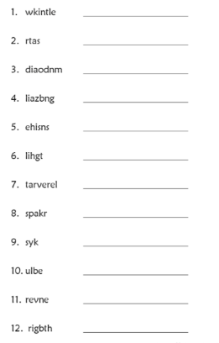
Reading
Read for 15 minutes a day.
Challenge – Read the Chesterton Chronicles to see what the other children have been doing.

Challenge - Go for a reading treasure hunt – how many places in your house can you find words to read? Why are they there? Who reads them?
Writing
Weekly Focus: Instruction writing.  - With an adult bake cake or plant some flowers. Write a list of all the things/equipment needed.  - Imperative verbs/ bossy words. What are bossy words? Watch the video https://www.youtube.com/watch?v=oApd0goKJDM. Bossy words are words that tell someone to do something. Write sentences with these imperative verbs for someone in your house to do:  - Get  - Clean  - Put  - Go  - follow  - Read the instructions on how to make a jam sandwich. Find and highlight or circle all the imperative verbs. What else do you notice about the instructions? What features do they have? (Title, subheadings, list, diagrams or pictures, short clear sentences, numbers or letters showing the order in bullet points). Use the time words to complete the instructions on how to make a jam sandwich.  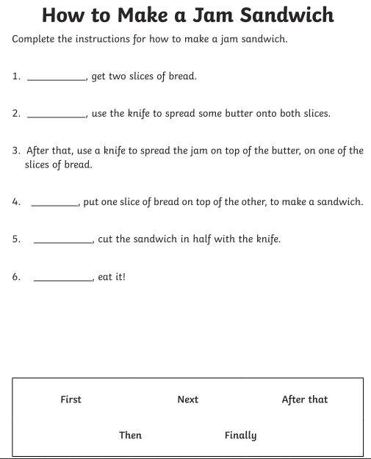  - Write the instructions for the activity that you completed with your adult e.g. baking a cake or planting some flowers. What happens if you don’t give enough detail? https://www.youtube.com/watch?v=Ct-lOOUqmyY. Check for correct spelling, imperative verbs, heading, subheadings, time words.  - Add diagrams and pictures to your instructions. Edit your instructions and type them up on a computer. | Additional suggested tasks:  Write a book review for your favourite book.  Create a new front cover for your favourite book.  Write a letter to the children who are at school or in a different bubble and tell them what you’ve been doing.  Hide something in the garden or around the house and write instructions of how to find it.
Maths
Weekly Focus: Place Value  Monday – What are numberlines? Why do we use them? They can help us with addition by counting from a number. Fill in the missing numbers on the number lines below.  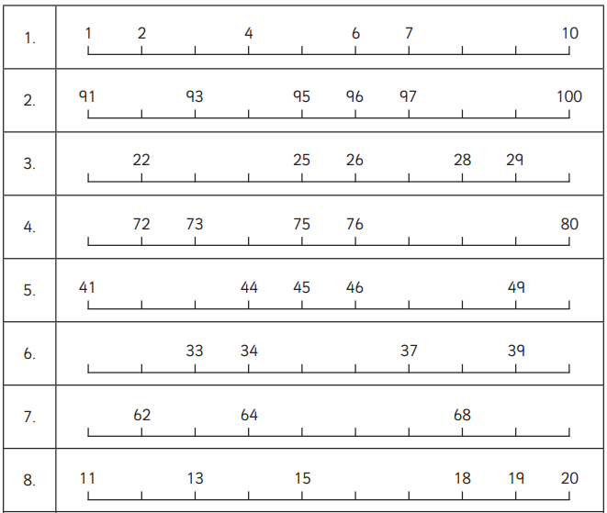  Tuesday – Numberlines can be used for skip counting in twos, fives, or tens and by going up or down, Use a ruler to draw these number lines:  - Counting forwards by 2s starting at 0  - Counting forwards by 5s starting at 0  - Counting forwards by 10s starting at 0  - Counting backwards by 10s starting at 50  - Counting forward by 2 starting at 11  - Counting backwards by 5s starting at 45  Wednesday – Using the number lines below, follow the instructions to label the numbers.  –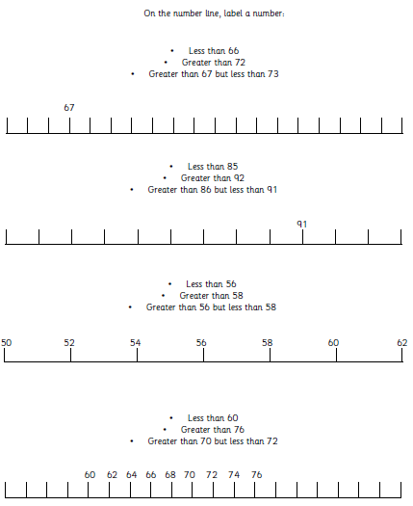  Thursday – Watch the video on hundreds, tens and ones https://www.youtube.com/watch?v=a4FXl4zb3E4. Use your knowledge of place value to compare the amounts below by writing either greater than, less than or equal to.  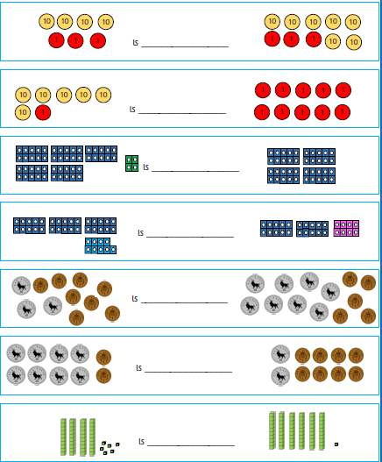  Friday – Answer the questions and have an adult check them with you.  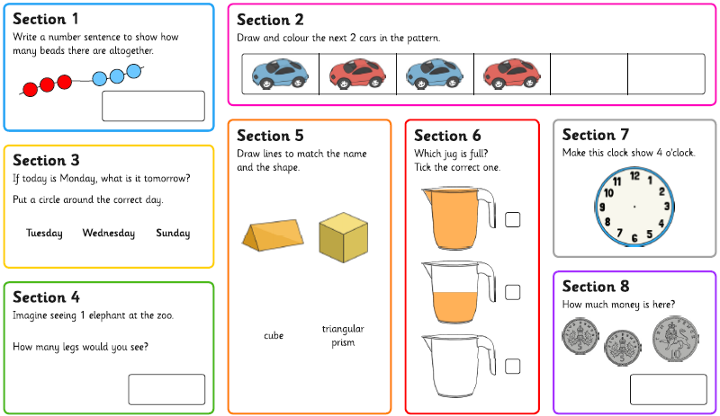 | If you have access to a computer, use: https://whiterosemaths.com/homelearning/  Here you will be able to access a lesson a day of maths, there is a video of what to do.  Whiterose has unfortunately stopped providing free worksheets for each day. I will attach a separate email containing the worksheets. BBC Bitesize are offering daily videos that would be very useful to watch alternatively.  Play hit the button to practise addition https://www.topmarks.co.uk/maths-games/hit-the-button  Write the numbers 1 to 20 in numerals
Additional Suggested Activities
Complete the video challenges on the webstie.
Practice handwriting.
Help an adult with the cooking or cleaning up.
https://www.phonicsplay.co.uk/
https://www.spellingcity.com/spelling-games-vocabulary-games.html
https://www.bbc.co.uk/bitesize/topics/zkxxsbk
https://www.storylineonline.net/
https://home.oxfordowl.co.uk/
https://www.youtube.com/watch?v=WpvquS6c5vk
https://www.youtube.com/watch?v=siVkXoEQDNc

