Communication and Language |  | Personal, Social and Emotional Development |  | Physical Development
Show and Tell and Basil Bear - encourage children to speak in front of an audience, ask and answer questions.  Discuss people who help us encouraging the children to talk about things they recognise and make links to their own experiences and exploring any new vocabulary.  In speaking and listening games encourage children to talk about different problems, the different types of people who help us and the roles of different people who help us.  Look at photos of different people who help us or, encourage children to use dressing-up clothes, model the uniforms. Encourage the children to talk about the different features of the uniforms.  Dress up as someone who helps others and encourage children to ask questions to find out more about your occupation.  Encourage children to incorporate new vocabulary from their learning into their everyday play. |  | Jigsaw – Dreams and Goals. Creating our own goals, discussing how to achieve these goals using perseverance and what it feels like to be proud of what we have achieved.  Talk about the different types of people who can help us with different problems. Ask the children to think about how the people experiencing problems might be feeling and how they might resolve the situation.  Invite people from the local community to talk to the children about their job.  During circle time, talk about all the little ways that we can be kind and helpful. Share and praise some examples of helpful behaviour with the whole group.  Create a ‘Help Stop’ where children can help each other with problems that can arise in the setting. Children will see themselves as the heroes of their classroom and understand that they are valuable individuals.  Encourage children to construct large-scale models of emergency vehicles as a team, allowing them to build relationships with each other at the same time as persisting with a challenging activity.  Encourage children to make thank you cards for someone who has helped them. Ask them to think about why the person deserves a card and how the person will feel when they receive the card. |  | Dance – Choreographed dance to be performed to an audience at the ‘Dance Umbrella’.  Play a people who help us movement game. Children will decide on an action for each type of person, mime these actions each time the poster is held up or an action is called out and will develop this by fluently moving between actions.  Explain to the children that many people who help us need to be very fit. Can they tell you what ‘fit’ means? Children will create obstacle courses to have a go at completing. Can they include a range of skills such as coordination, balance and agility or improve their times for completing their course?  When using equipment, remind the children of the rules we have to keep everyone safe and happy.  Taking part in activities to improve small and large motor skills E.g. Using tweezers, weaving and cutting.
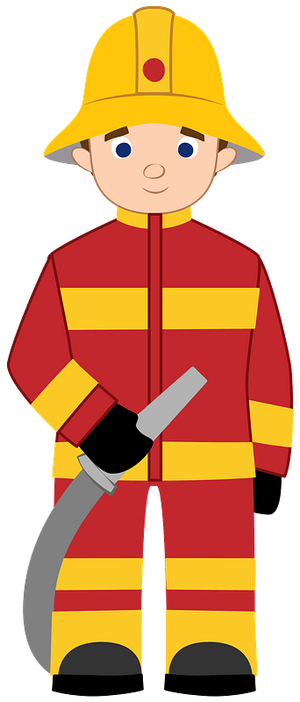 People Who Help Us 
Literacy | Mathematics |  | Understanding the World |  | Expressive Arts and Design
Teach the remaining Phase 3 graphemes and corresponding phonemes.  Teach Phase 3 Mastery phase in Phonics.  Revise previously taught letter sounds and common exception words.  Sing the alphabet song whilst pointing to letters of the alphabet.  Practise segmenting and blending for spelling.  Practise segmenting and blending for reading.  Rehearse oral segmenting and blending.  Rehearse spelling previously taught common exception words.  Reading and writing words, captions, sentences and questions.  Correct letter formation.  Fiction and Non-Fiction Books linked to topics.  Writing for a variety of reasons.  Guided reading and writing sessions.  Share stories and non-fiction books about people who help us.  Non-Fiction. What is a non-fiction text? What features does a non-fiction text have? How is a non-fiction text similar/ different to a fiction text? Can we sort fiction and non-fiction texts?  Introduce ‘Drawing Club’ to the class and begin a new story each week. Every week a focus story will be read, key vocabulary will be discussed and a variety of writing stimuli will be shared and modelled for the children to use as their own provocation for writing in their free choice. | Count in 1s from 0 – 30 and count back in 1s from 20/ 10 - 0.  Count and create sets of objects using counting rules.  Use 5 and 10 frames when counting objects and discuss what the children ‘notice’ and patterns that can be seen.  Start counting from different numbers when counting forwards and backwards in 1s.  Start to count in 10s from 0 to 100.  Continue to rehearse quick recall of number bonds to 5.  Introduce number bonds to 10.  Subitising – Work on the children’s ability to subitise and describe non-standard patterns.  Ensure all children are able to recognise numerals 0 – 10.  Compare numbers using apparatus such as 10 frames.  Order numbers both forwards and backwards.  1 more and 1 fewer using 10 frames.  Add and subtract single digit numbers using tens frames.  Continue to ask children to ‘show’ numbers from 0 - 10 on hands. Can they show these numbers in different ways?  Explore the concept of ‘wholes’ and ‘parts’.  Explore the concept of ‘equal’ and ‘not equal’.  Explore the term double and begin to recall doubles.  Watch Series 2 Episodes 7 – 15. Revisit some episodes from Series 1/ Series 2 to provide a provocation for children’s play/ to explore in depth/ to recall. E.g. Number bonds to 5 and doubles.  Name and describe 2D and 3D shapes.  Measure capacity. |  | RE – Special Places: What places are special to the children? Are there objects that remind them of this place? We will consider the church as a special place to Christians and think more deeply about the role of a church by visiting St Andrews Church for a class baptism and holy communion. We will contrast our work on the Christian church by thinking about a Jewish synagogue, considering the similarities and differences between the roles and symbols used.  Chinese New Year. The children will listen to the story of Chinese New Year, look at where China is on a map, watch a video showing how this festival is celebrated, learn some interesting facts about China, cook Chinese food and will make lanterns and dragons. The children will also compare and contrast China with the UK.  People Who Help Us – We will discuss and ask who helps us? How do they help us and why? How do these people make us feel? To support this work, we will have visits from people who help us in the local community giving the children the opportunity to hear how and why these people help us, what they use to help them fulfil these jobs and ask their own questions about what these people do. We will look at pictures of different firefighter uniforms from the past. How are they different? What is the same? Can the children think of reasons why the uniform has changed? |  | Chinese New Year crafts including lanterns and dragons.  Role play and imagining including the use of puppets linked to class topics.  Music – Charanga Scheme of work. Topic: Everyone!  Draw around hands and decorate with images of people who help them for a helping hands display.  Portraits of someone who helps them, choosing their own materials and techniques.  Using a variety of instruments, the children will experiment making a siren for emergency service vehicles.  Sing People Who Help Us songs.  Children will make simple gifts and cards to say thank you to people who help them.  Create and decorate their own emergency vehicles using junk modelling.  Combine materials to design and make their own superhero.
- Replace title (keep title and footer pink)
- Change images to pngs relevant to new topic
- Keep the headers and colours as they are (they use the EYFS specific colours for the areas of learning)
- Replace bullet points with text from teacher content. Hyperlinks within the bullet points should be bold, blue and underlined.
- Try to keep content to 1 page (ask Lucy if unsure to do this)
- Delete this instructions box

