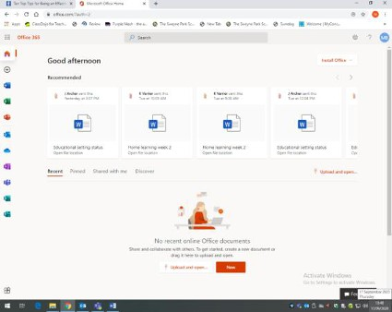
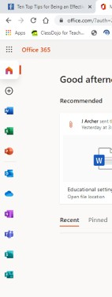
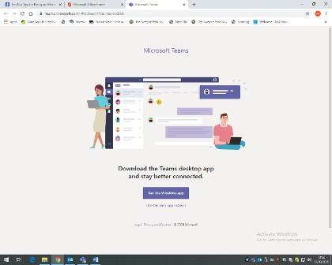
Dear Parent/Carer

Using Teams for Home Learning at Chew Stoke Church School
Teams is part of Microsoft Office 365, which enables children and teachers to work remotely
together.
Children have their own account and are assigned to their class group.

Your child’s log in and password have been provided. Please contact the school if you do not have this information.

How to set up Teams

If you have an android, iPhone, iPad or tablet you can get the Microsoft Teams app in the app store.
If you are using a desktop computer, login to office 365.com https://www.office.com/
Once logged in you should see a page similar to this:

This page will be shown. You can either choose
to get the windows app or can continue using
the web app.

Click

How to use Teams
When you have Teams up and running, on the left-hand side it will say Teams and there will be a class group team.
Files - This is where work will be posted each day. Your teacher will post messages in the general chat section.

Assignments - Find the assignments tab to see all current assignments for your child.
To enable this to run smoothly and to ensure the platform is used safely, in line with online safety and safeguarding expectations, please adhere to the following guidelines.

• Do not allow your child to post unnecessary ‘chat’ or silly comments in their Team space.
Teachers are able to block children if they are misusing the resource. Comments made by the
children/teacher in the general Team space will be seen by everyone, so it is very important
that these comments are appropriate and relevant. Please discourage your child from using
the space as a general chat room and we discourage the use of GIFs and emojis please.
Children will not be able to use this email to email outside of the organization and should not try to use it to email each other. ALL emails are monitored and recorded.

• Do not use your child’s Team space to directly message the teacher - this space is to be used
by the teacher and pupils ONLY. If you as the parent/carer have questions or concerns then
please contact us via the school office in the agreed way and we will get back to you as soon
as we can- please be patient with us.

• Do not panic or allow the Teams work to cause undue stress at home. If the workload is too
much, do what you can and ONLY that!

We hope that you find Teams accessible, useful and beneficial in supporting your child’s home learning during this challenging time. If you have any queries, please contact
office@chewstokeacademy.org

