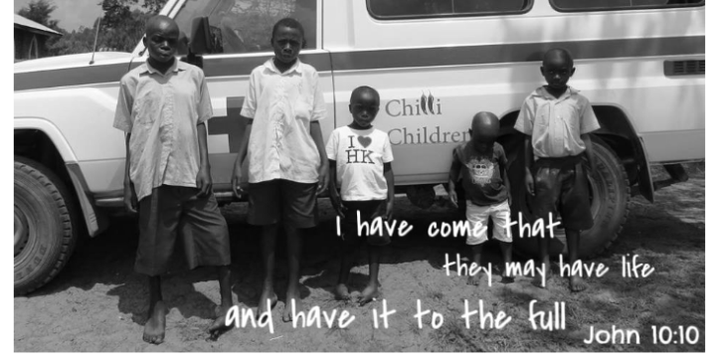
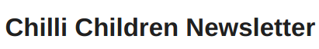

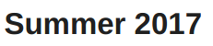

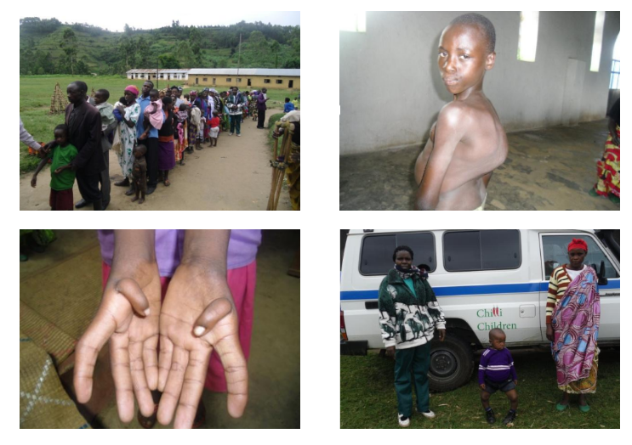

Kisoro Field Survey
Earlier in the year the team ran a field survey in the Kisoro District of Uganda. As usual hundreds of families came to 13 different centres, which the team had set up in villages across the district and 262 children were registered. The children had cases ranging from post burn contractures (21), spine deformities (21), growth tumours (7), those needing Occupational Therapy (45) and 8 urgently needing to go on a feeding program. Each of these cases will be provided with the care they need - and all thanks to your generosity. Thank you! On 2nd July, the 21 spine cases travelled to Mbarara, a couple of hours from Rukungiri, for a spine surgery camp. Please be in prayer for these precious children and complicated operations.

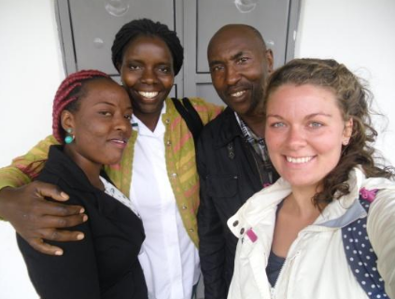
Kitazigurukwa School
Kitaz (for short!) is the school where the Project's educational unit for disabled children is based.
From June, Ebany (left) began working as teacher support at Kitaz. This is partly due to teacher Charity going on maternity leave, and partly due to the new intake of children we are having at the Unit, thanks to the new dormitory that was completed by Mission Direct last year. Thanks to everyone's support in enabling us to keep growing and growing the school!
Emily, a Chilli Children Trustee based in Uganda full-time is pictured here with Ebony, new school assistant Evas, Project Lead and Occupational Therapist and Henry, Headmaster (left to right)
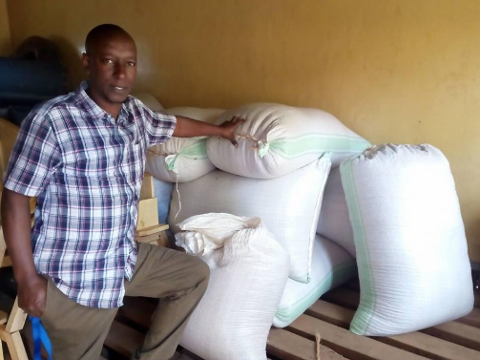

Nelson takes on Chilli Challenge!

Since Warren retired, Nelson, the Project Accounts manager, has become head of the Chilli section. This means he is overall responsible for the chilli growing, harvesting, buying and selling.
This is his report from the April harvest (the first chilli season of the year):

- The number of chilli farmers increased from 312 to 323
- Chilli output was 805kg (!!!)
- In total, farmers received 6,440,000 Ugandan shillings from the sale of their chillies to the Project (over £1,500).
- Most farmers received enough to cover transport to appointments or the Project Office, or some medical/hygiene supplies, or even school fees for a term!
- The staff team visited 33 chilli buying centres, where each elected a chairperson amongst farmers to oversee the setting up of a nursery bed, mobilisation and correspondence with the Chilli Extension Officers (David, Zaire and Martin).
- There is a plan for 4 new buying centres to open by 2018
- There is now a chilli demonstration nursery bed in place at the Project Office, for any new families visiting the Office to see and learn what chilli growing is all about

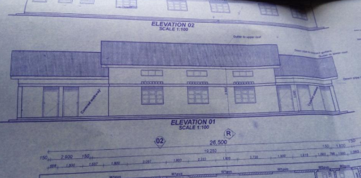
Come and visit us!
There are still spaces available for you to visit the Project and see for yourself the good work that the team is doing in Uganda. Plus, you can lend a helping hand building our new rehab centre! More information can be found through our partner Mission Direct or by emailing us at contactus@chillichildren.com.
Get in touch! Please note our new email address is contactus@chillichildren.com and our mailing address is Chilli Children Trust, 37 Forest Road, Bingham, Nottinghamshire, NG13 8RL.
Join Us! We are still looking for a Treasurer and for volunteers to help with fundraising and talks around the country. If think you can help, please let us know.

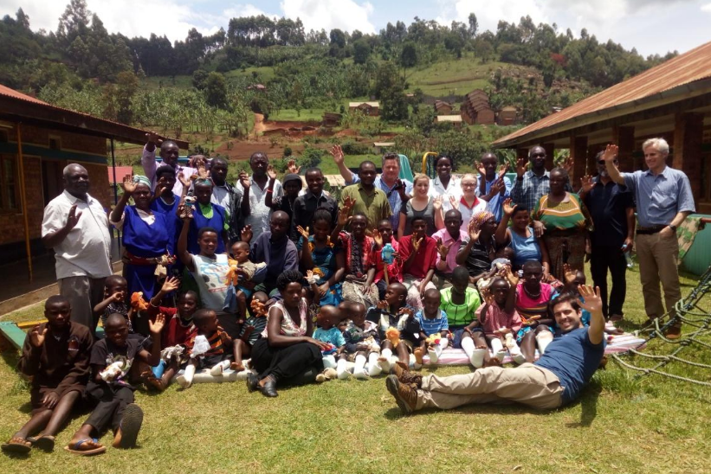
Dr Mark Latimer and Team at Kisizi Hospital
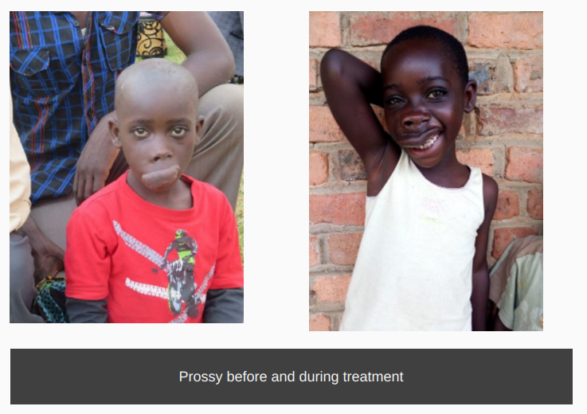
An inspiring medical team of 6 from Peterborough & Stamford came to Kisizi Hospital at the end of March 2017. These were predominantly orthopaedic lower limb conditions and plastic (burns) upper limb conditions. The team gave up their holiday to perform 20 operations on some of the Chilli Children. We are so, so grateful for the time, expertise and love that the team gave to the Project. Here are some amazing before and after photos!

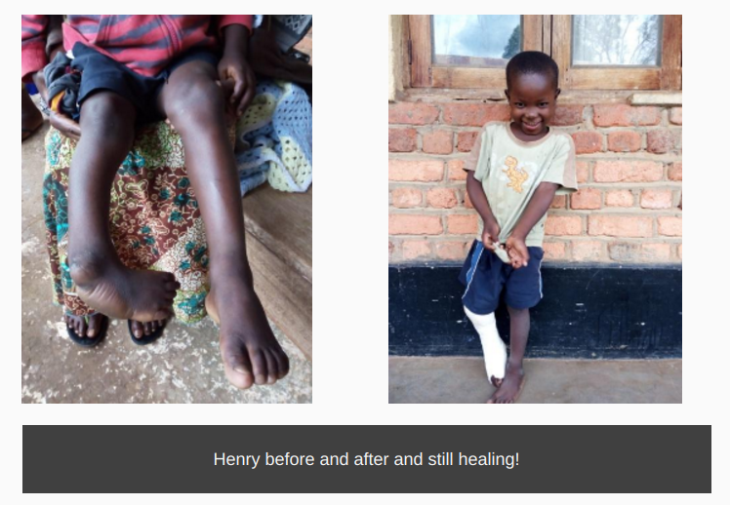
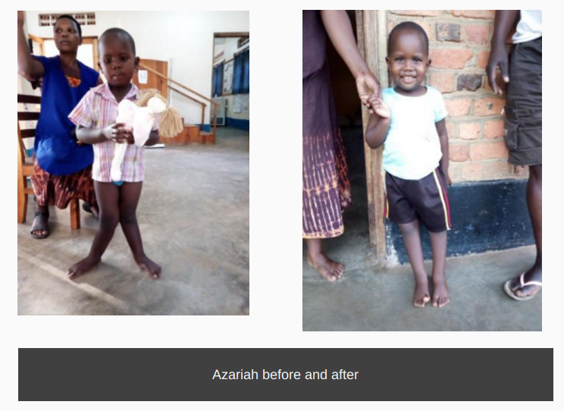

Thank you to all of you for your continued support of the project. This work relies on the generous giving of our supporters. If you have been moved by our work, you can make a donation to the Trust.

Regular giving is important for ensuring that we can send a consistent amount of money to the Project in Uganda. Please consider giving monthly if you can.

Where does your money go?
We are pleased to say that 99% of all funds raised are sent to the Project. Just 1% is used on administration such as postage, running our website and printing. We do not employee any paid staff in the UK. We rely solely on the generosity of volunteers.

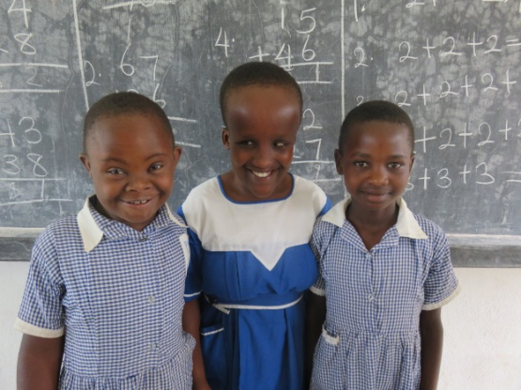
Prayer Requests (Cut out and keep so you remember to pray every day!)
Special guidance and wisdom to trustees and well wishers as they are a backbone to the Project
General funding
Continuity of Mission Direct’s service to the Project
Need for government teachers at Kitazigurukwa
Opportunity for doctors from the UK to run camps (praise God for Dr Jonathan, Mark and team!)
Unity and love among families, staff and community served by Chilli Children Project
Increased interest among families with disabled children to grow more chilli – income generating activities
Good health and safety during the 2017 construction of the Community and Rehab Centre (work for which began in May)

Please help with a donation to The Chilli Children Trust

Name :............................................................................... Signature :....................................................

Address : ...........................................................................................................................................................................

............................................................................................... Postcode :.........................................................

Email address: ................................................................... Tel No.: ........................................................

Please make cheques payable to Chilli Children of Rukungiri Trust. Send to 37 Forest Road, Bingham, Nottinghamshire, NG13 8RL.

Amount £.................................................... Date.....................................

Gift Aid: I am a UK taxpayer and would like the Chilli Children of Rukungiri to claim back tax on my
donations from 6th April 2000 until further notice OR I am not a UK taxpayer (delete as appropriate)

If you are able to give monthly, please email us for a standing order form or go to https://goo.gl/jBGgW1

