

**Winter Newsletter 2017**

# **Update from Evas Nahabwe, Project Manager**

# Thank you to all those who have faithfully supported Chilli Children during 2016—your giving has enabled the Project to change the lives of so many children, and their families. But the need continues - more field surveys (when the team travel to rural areas and invite all the children with disabilities to come for assessment) means more need is identified, and so more funding is needed to meet the need.

# In March 2017 a surgical camp will be held at Kisizi Hospital, and in April 2017 the Kisoro Field Survey will take place.

# Both of the above are vital, and central to the work of the Chilli Children Project, and both, particularly the latter, require extensive funds to complete.

# In March, a team of surgeons from the UK will be coming out to western Uganda for a week, to work alongside Kisizi Hospital and the Chilli Children Project to do surgery and operations on both orthopedic and plastic (burns) cases. Last March, the team came out and successfully completed around 20 operations.

# In April, the staff team will spend 2-3 weeks in the Kisoro District of western Uganda, to complete a survey. This essentially means that they will visit 2 or 3 ‘centres’ (churches generally) per day, where families with children with disabilities come to be registered, assessed and counseled, and put on waiting lists for hospital visits or surgeries where necessary.

# During the survey in the Kabale District in 2016, over 300 children were registered and many of these have now been, or are due to go for operations or corrective surgery in the coming months. We urgently need support for covering the costs of these operations, and those which will be required as a result of the Kisoro Survey in April; costs completely unaffordable for the families.

# Many thanks for your continued prayers and support.

# Many thanks for your continued prayers and support.

# 

# 

# 

# 

# 

# 

# 

# 

# 

…

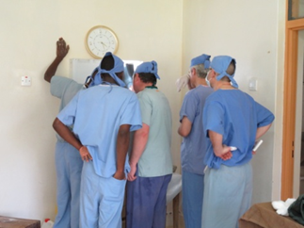

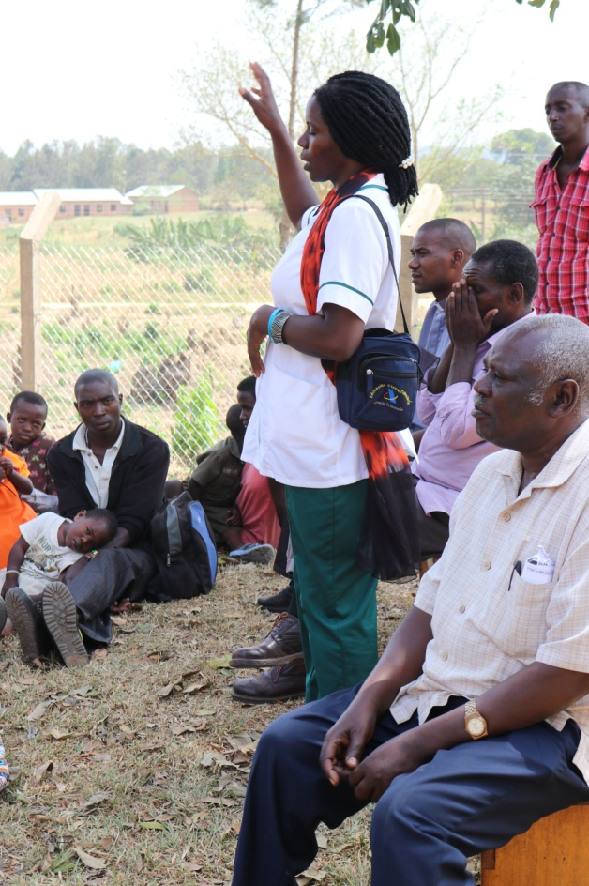

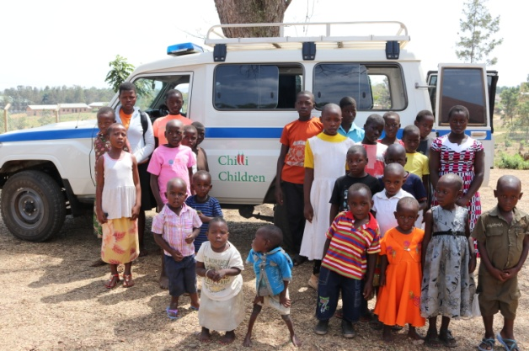

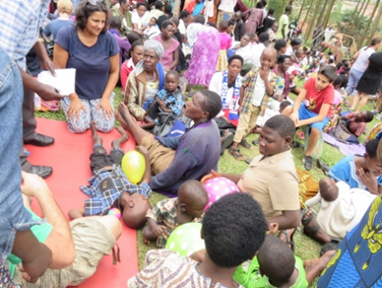

*"For me, the most affecting experience was the afternoon visit to the life skills clinic. In a short space of time I found my emotions shifting from initial amazement at the sheer number of people, to fear about actually engaging with any of them with their serious disabilities, to feelings of great inadequacy in the face of so much suffering, to humble admiration at how many of the Mums (with a few exceptional Dads) were coping with the adversity of a disabled child in that community, where they are shunned and no help is provided at all by the State… It was impossible not to see something of the biblical about the place. It was almost as if Christ himself were there drawing the sick from the surrounding regions. And whatever the charity may or may not have been able to do for children with deformities, what was clear was that it was capable of transforming lives which - from the faces of many of the mothers - showed signs of desolation and despair, to lives which - again from their faces - were filled with hope and love, perhaps even joy”*

**Reflections from a Mission Direct volunteer, who spent two weeks in Rukungiri in November on a Chilli Children team**:

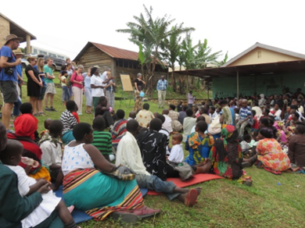

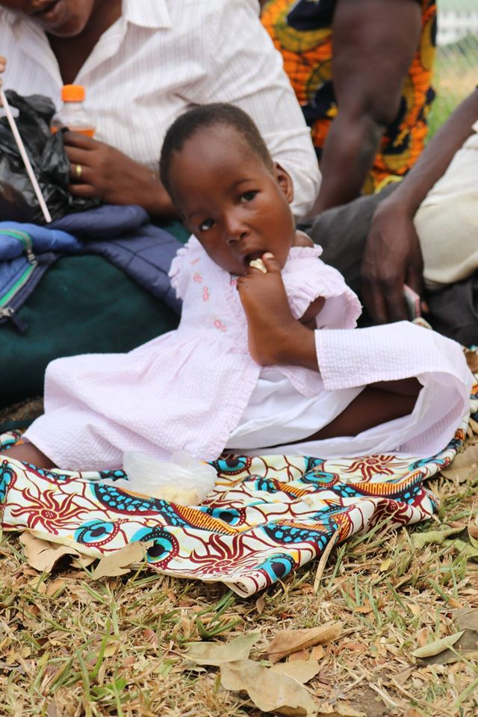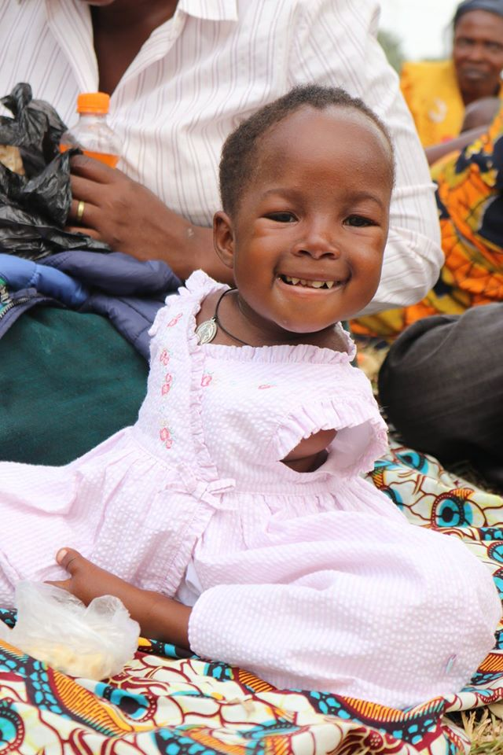

**"This is stunning, and utterly humbling. A baby born with no arms, who through the help of Evas and her loving mother, is able to feed herself and play. No limits...it's all possible!"** - Emily Braybrook, Chilli Children Trustee, at a recent Life Skills Clinic in Kihihi town.



 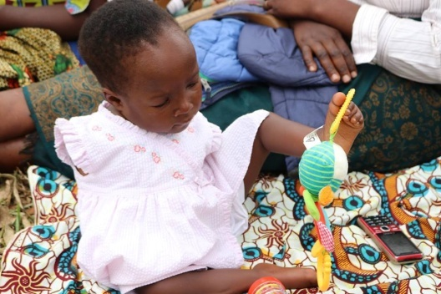

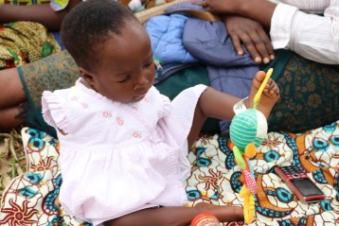

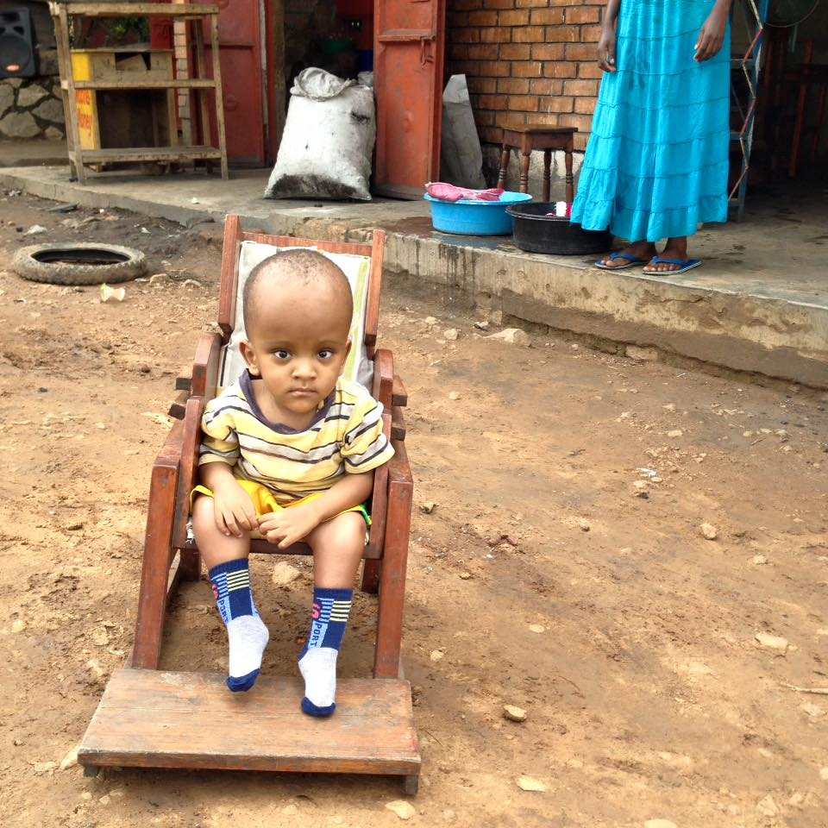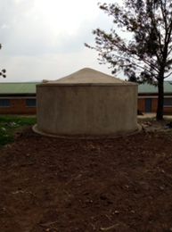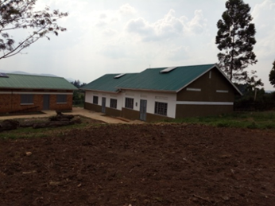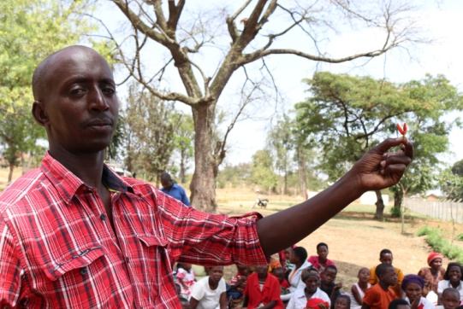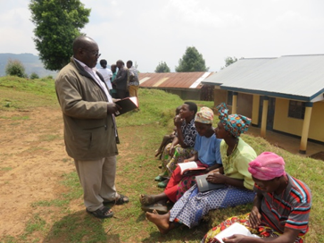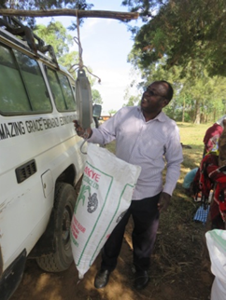

**Praise Report from trustee, Emily**

"I was on the outskirts of Rukungiri town, and as I was travelling, I recognised one of the Chilli Children sitting outside a row of shops in his special chair! I stopped and chatted to his Mum. She has a small shop and she is so grateful for the chair given by the Project, to enable her son to sit outside and watch the world go by, while she is free to run her business. Such a wonderful example of a mother who does not hide her son away, but is proud of him and looks after him beautifully."

**Update from Kitazigurukwa Special Needs Unit**

We are so pleased that the second large dormitory at

Kitazigurukwa has now been finished, along with

another huge water tank, thanks to the hard work of

Mission Direct volunteers in 2016. Within the next

few months, we will be welcoming many more children

to the Special Needs Unit – most will be accessing

education for the first time in their lives.

**Goodbye from Tumutende Warren, and hello to Katunguka Martin**

Warren has been a Field Extension Officer and driver for the Project for 27 years! He has now retired, and these are his goodbye remarks:

" Greetings to all Chilli Children lovers in Jesus’ name.

It is my pleasure to have come this far to say I am retiring from active service with the Chilli Children Project, after serving for 27 years. It has been a pleasure to see God’s work among His disabled children.

Children who were hopeless having a smile on their faces, thought would never walk playing with the bodied children! The poorest of the poor getting income from chillies and many others. I am appealing to trustees, project supporters and lovers of Chilli Children to pray for me as I start my non pensionable retirement. I will be doing some farming although it has some challenges such as transport, my prayer request is for God enable me overcome such challenges and have a good health."

The Project team would

like to introduce Martin,

who has now taken over

duties from Warren.

**Chilli Children Trust**

**UK Charity No. 1106601**

Trust contact address and donations by cheque to :

Chilli Children Trust

84 Stonegate

Spalding

Lincs

PE11 2PH

**chillichildren@gmail.com**

Or donate online and get regular news updates at:

**www.chillichildren.co.uk**

chillichildre@gmail.com

**2017 Project Prayer Requests from Evas**

**Love and unity** among families supported by the Chilli Project. Disability in Uganda often makes one fall into a second class of citizen, and some families break up as a result.

**Special Needs teachers** to be posted by the government at the Chilli Children Kitazigurukwa Special Needs Unit, allowing for the expansion of the Unit and for the children be educated.

**Funding sources** for God to open new gates for provision, and for Him to continue to bless and support those hands that have given already and are still giving.

**For the March Surgical Camp** with a team of doctors from the UK at Kisizi Hospital, and for the Field Survey to be conducted in the Kisoro District in April.

**Continued love and unity** among the staff team.

n a think

**Urgent Request**

The work of both the Trust and Project continues to grow and we thank God for this. Yes, of course we always need more funds to send out to the Project and this year over 95% of the money raised has been sent. We do however have a greater need. We urgently require a book-keeper / treasurer to support our work. If you have sound book-keeping skills or are a church treasurer and could spare a few hours a month, then do please get in touch with us. I don’t think it’s overstating the issue but without a book-keeper / treasurer the work of the Trust may not be able to continue. Please have a think and ask around and see if you could help!

We also need more general helpers and trustees to support the work. Newsletters need to be written and published, admin needs to be done, letters sent, prayer request written… at face value it’s not “big stuff” but I honestly believe that it could be life changing to the children we seek to help. Please have a think.

**Please help with a donation to The Chilli Children Trust**

Name :............................................................................... Signature :....................................................

Address : ...........................................................................................................................................................................

…............................................................................................ Postcode :..................................................

Email address: ................................................................... Tel No.: ........................................................

Please make cheques payable to Chilli Children of Rukungiri Trust. Send to 84 Stonegate, Spalding, Lincs. PE11 2PH

Amount £.................................................... Date.....................................

**Gift Aid:** I am a UK tax payer and would like the Chilli Children of Rukungiri to claim back tax on my donations from 6th April 2000 until further notice  **OR** I am not a UK tax payer (delete as applicable)

Would you like to be on our mailing list? **\*** No thanks **\*** Yes, by email **\*** Yes, by post

**Standing Order Form available on request:** please write or email and we will be delighted to send you one.