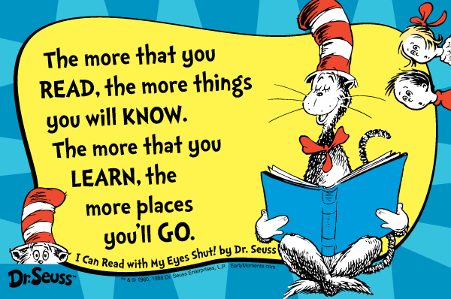

The Chisenhale Core Book Challenge!

We have launched a reading initiative this half term: The Chisenhale Core Book Challenge. The children have been informed about this in assembly and they are excited to get started.

The vision of the core book challenge is to give our pupils the opportunity to access ‘must read’ books for their age range; books which we believe every child should be familiar with and that will help to inspire a love of reading. In addition, the challenge will help children to get well on their way to achieving their ‘reading miles’.
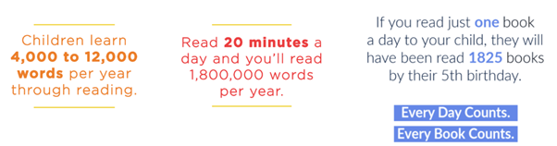
Source: Tower Hamlets
Education Partnership

Each class has been given a box of around thirty wonderful books comprising fiction, non-fiction and some poetry. The challenge is to enjoy as many of these books as possible over the course of the academic year. In KS1, the children are just getting started with learning to read, and so we don’t expect them to read these books on their own - parents/carers can sit down with your child and share the book together, exposing your child to the rich language, quality story structures and opportunities for discussion that these books offer. This can be the same in older year groups as well but they might want more independence in their reading.

In KS1 the children have been given a copy of the book list in their yellow reading record book so that they can tick off the books when they have read them at home. The children will be encouraged to talk to an adult, and each other, about what they have read when they bring their book back to school. In LKS2, each child has a reflection book. Once they have read their book, the children will fill in one page of their reflection book. In UKS2 the children will write down their reflections in their sentence book using the pro forma stuck in the cover of their sentence book. Below is a picture of one of the reflection pages with examples of things they might write in each box.
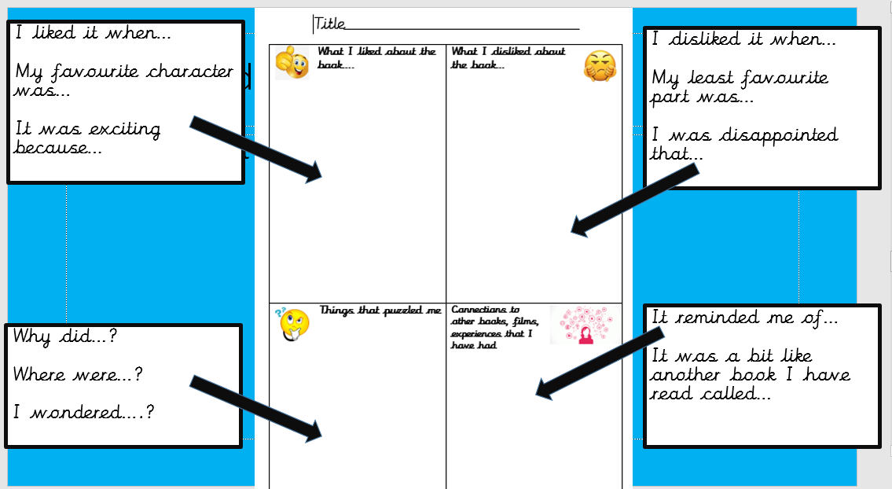

Below are some questions that you might have about the challenge, with answers:

How frequently should my child take home a book from the Core Book Challenge?
It depends on a variety of factors: how quickly they read the books, how much time you have, how long the books are. There is certainly no rush with this challenge. The idea is to read and enjoy new books; talk about the books at home and for children to reflect on what they have read. Trying to get through the books as quickly as possibly is definitely not the focus. In KS1 where the majority of the books are picture books, enjoy these a few times as repetition is great for younger children to pick up on the story language and begin to join in with this.

Year groups will share suggested days for book changes with their class. Please ask the teacher if you would like to know this information.

Does my child still have to take home a home reading book and/or read the allocated books on Bug Club?
Yes. Children will still be expected to read their usual home reading book. In KS1, this is very important as it will ensure that your child consolidates phonics skills they have been learning in class. The Core Book Challenge is an additional project and is centred on your child developing a love for reading.

UKS2 only: Does my child still need to write their daily sentence and continue reading their normal reading book every night?
Yes. All current reading expectations remain the same. This is an extra challenge.

My child has already read one/some of the books in the Core Book Challenge box. Do they have to read them again as part of the challenge?
Yes. Even if they have already read a book from the list, they still need to read and talk about it at home again. Repetition is really good for children and will help them to deepen their understanding.

How will you keep track of the books that are sent home?
Each book is labelled with the year group and 'Core Reading Challenge' on the front cover. Staff will sign out books from a register kept in the classroom. Once the book goes home, we expect children and families to take good care of it. We do have spare book bags if this is helpful, just ask the class teacher if you need one. If a book is lost, a letter will be sent home to ask you to look for this and if this cannot be found, a £5 donation will be requested to go towards the cost of replacing the book.

There are lots of different reading levels in my child's class. What if a book is too easy or too hard for my child?
Each book has been selected carefully for each year group. We have tried to include a range of books that are age-appropriate, with mixed topics, themes and levels. Picture books are a vital part of a child's reading experience and these have been included in every year group, including Year 6. If your child is finding it hard to read one of the books, please read it to or with them. You could extend your child’s understanding by asking them questions about the text, perhaps encouraging them to make predictions, summarise or clarify sections.

If you have any further questions as the challenge gets under way, please email us or speak to your child's class teacher. As a school, we are excited about this challenge and we hope that you will support us with it.
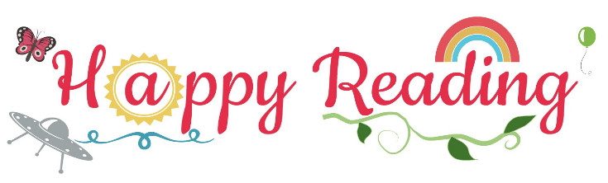
Many thanks for your continuing support,

Charlotte Fallows-Osbourne and Sarah Nyes
English Leads

