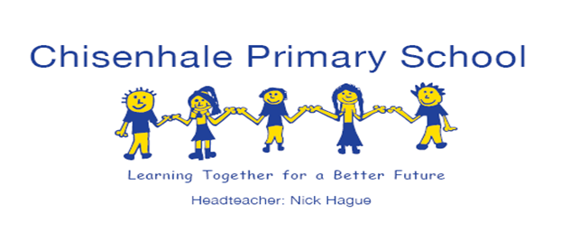

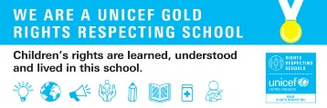

**EYFS Newsletter**

**Autumn 1**

**21st October 2022**

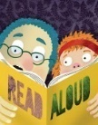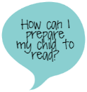

**Trips & Celebrations**

[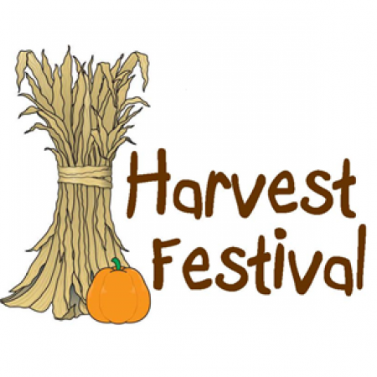](https://www.google.co.uk/url?sa=i&rct=j&q=&esrc=s&source=images&cd=&cad=rja&uact=8&ved=2ahUKEwj-wL_m-r7dAhUEz4UKHb8BDzYQjRx6BAgBEAU&url=http://steelvillefirstassembly.org/events/harvest-festival-family-night/&psig=AOvVaw3pRcOHuR7YqZGorBzxOVcL&ust=1537167891439899) 

This week we celebrated

**Harvest Festival** in school on the Tuesday 18**h October**.

Thank you to all our families for their

**Harvest Festival** donations of   
**non-perishable food** (tins and packets) and **toiletries** which have been gifted to the Bow Food Bank.

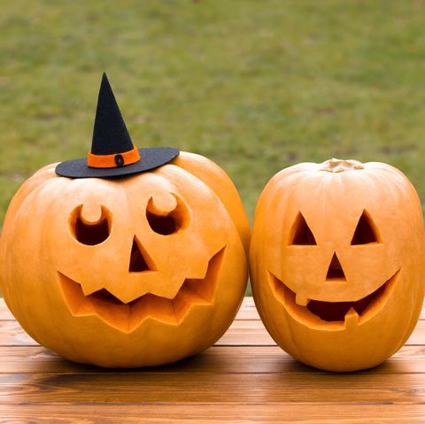

On our first day back after our half term holiday (**Monday 31st October**) we are going to mark the festival of **Halloween** through story-telling, spelling and a spooky rumpus – your child is welcome to dress up for the occasion!

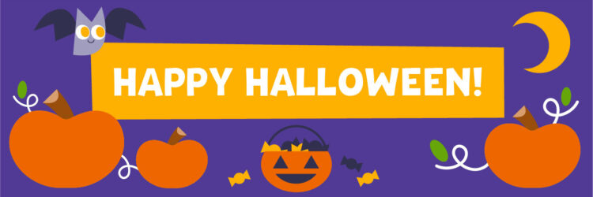

There have been lots of celebrations during the final week of this half term. As well as preparing for and celebrating **Harvest Festival** in our classrooms, we have also marked **Black History Month** through story, song and dance.

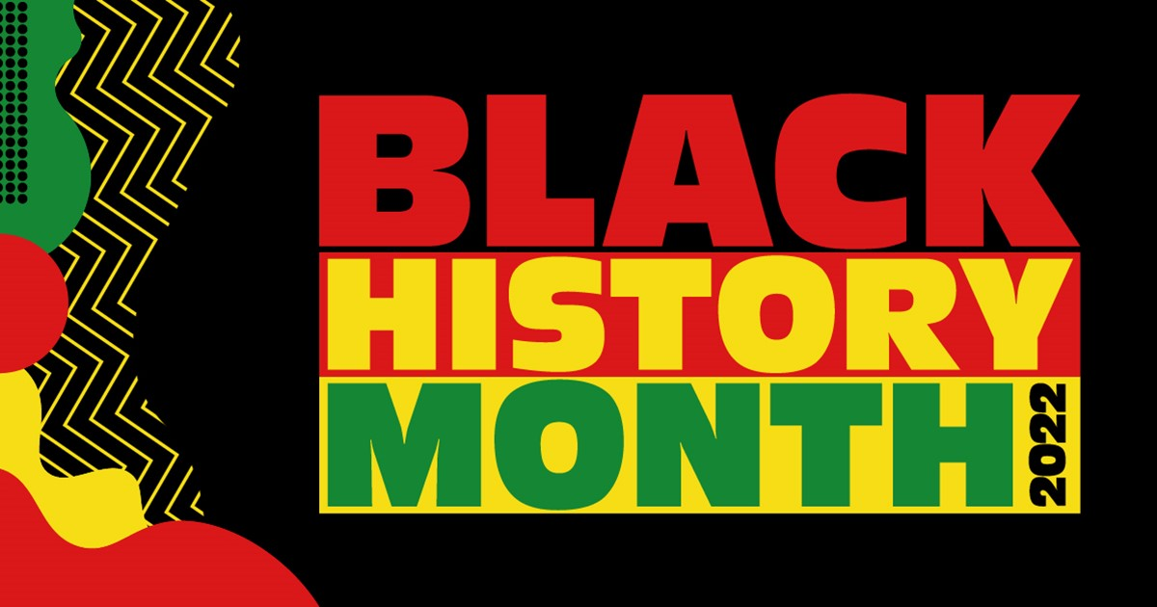 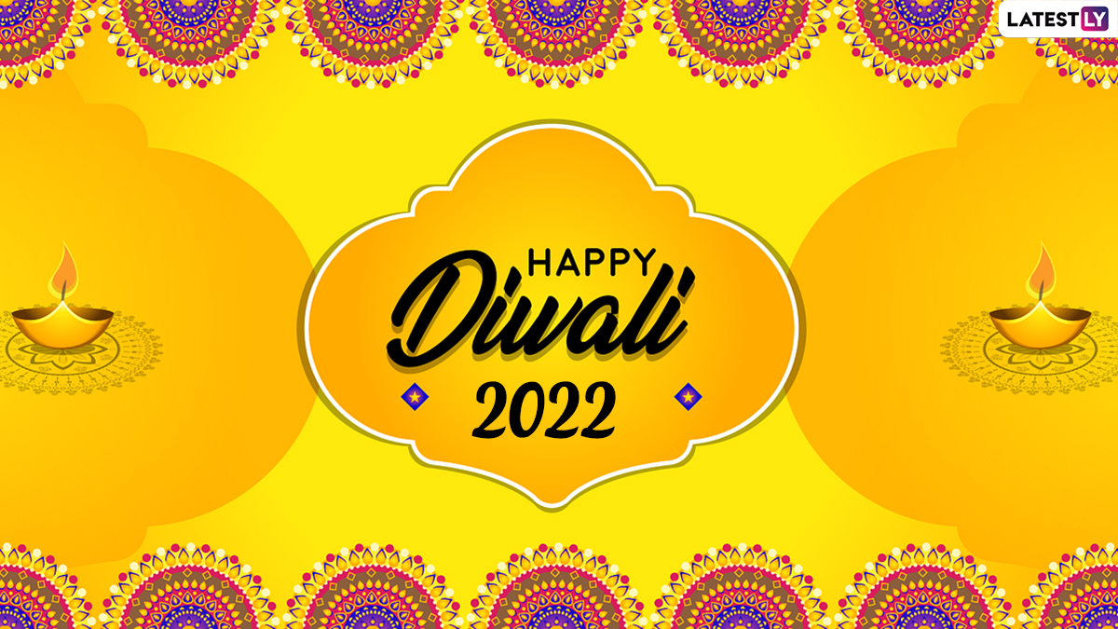

**Reception** have also learnt about the Hindu festival of **Diwali**. They made and decorated their own Diwa lamps and created Rangoli patterns.

They have continued their phonics programme and have encountered the first digraph  **ck.** In mathematics they have looked at shape and pattern and have used this to print their own designs on fabric.

The Nursery children have been learning about **Harvest** and **Harvest Festival**. We read the story of **The Little Red Hen** before baking our own bread rolls and eating them. We used our hand print to make a ‘**Little Red Hen’**. This week we learnt the ring game **‘Oats, peas, beans and barley grow**’ and sang ‘**The Dingle Dangle Scarecrow’.** We also learnt about the continent of Africa for **Black History Month** and shared the stories of ‘**Handa’s Surprise’** and **‘Handa’s Hen’.** On Friday we did some African dancing and made a fruit kebab from the fruit in Handa’s basket.

 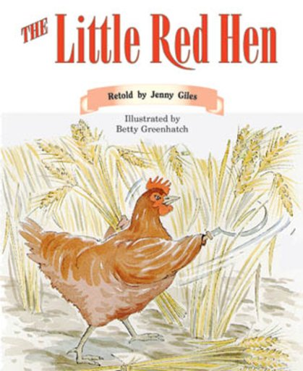 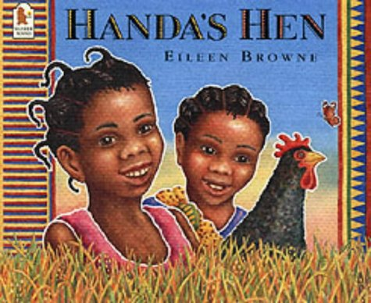

*We would like to thank our parents and children for their contributions to a happy and successful half term of learning in the EYFS*.

**Book Bags & Reading**

Your child needs to bring their book bag into school every day. ***Please check their book bag daily for important letters or information.*** Initially we will be inviting your child to choose a book to take home and share with you every **Friday**.

**How you can help**

You can help by reading to

and with your child every day.

**Bikes & Scooters**

We are able to accommodate bikes and scooters in the Early Years playground if your child chooses to scoot or cycle to school.

**Parent Partnership**

We have two designated email addresses for queries:

[Nurseryteachers@chisenhale.towerhamlets.sch.uk](mailto:Nurseryteachers@chisenhale.towerhamlets.sch.uk)

[Receptionteachers@chisenhale.towerhamlets.sch.uk](mailto:Receptionteachers@chisenhale.towerhamlets.sch.uk)

If you have a child in Sun Nursery you should have received the first book from **Dolly Parton’s Imagination Library.** Your child will receive **‘The Tale of Peter Rabbit’** at school.

From November a new book will be sent each month and delivered directly to your home. These books are for you to keep without any cost. We hope that they will help your child to develop a love of reading that we will also be encouraging in our Nursery classroom.

**Play Spaces & Safer Streets**

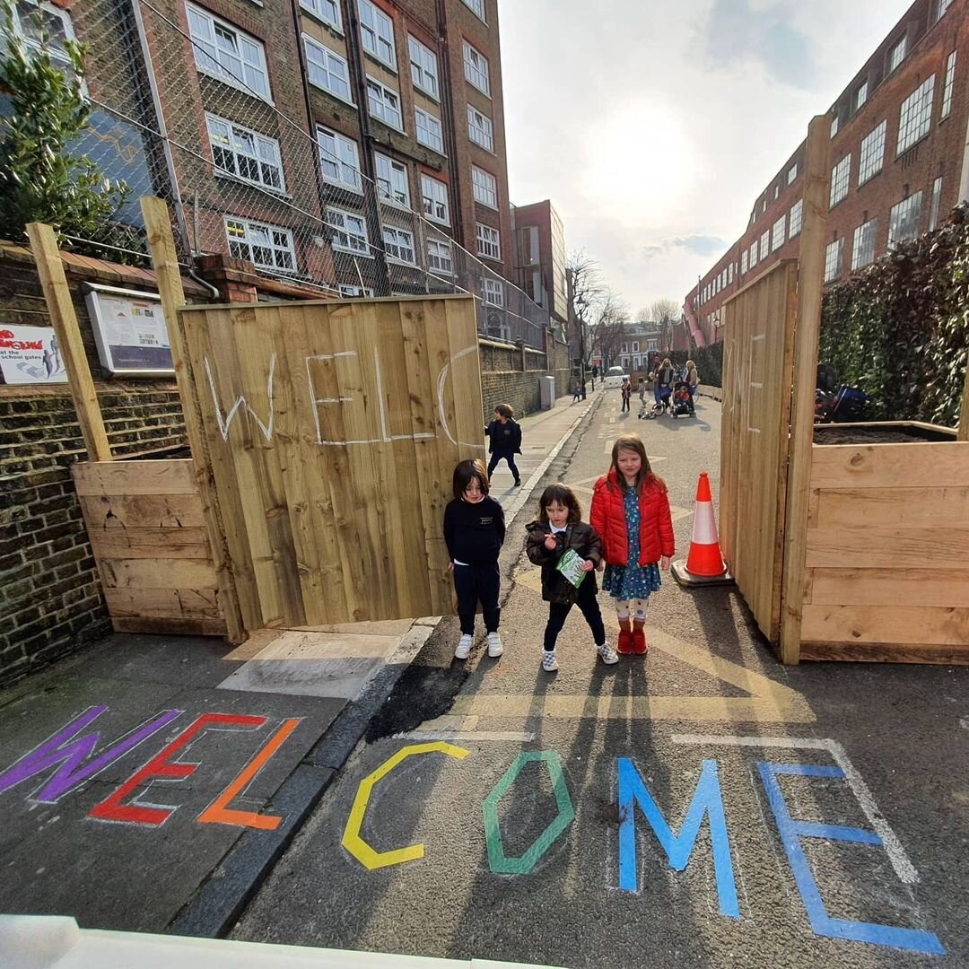

You may be aware that Tower Hamlets Council have decided to remove the Safer Streets Play Space that was created outside the Early Years Foundation Stage entrance in Vivian Road.

We have not been told when this will come into effect but it will have obvious implications for children safely arriving and leaving our setting at the beginning and end of the school day.

We will let you know when we get any further information and our response in due course.

**Half Term Holiday**

The half-term holiday will be from

**Monday 24th-Friday 28th October**.

We look forward to welcoming your child back to school on **Monday 31st October.**