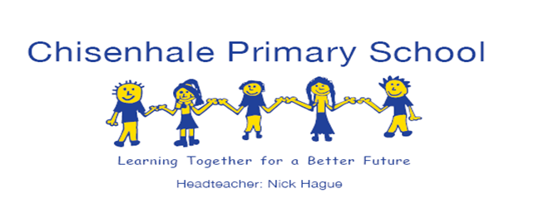

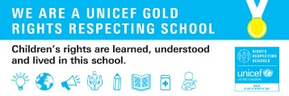

**EYFS Newsletter**

**Summer 1**

**14th May 2021**



**NEWSFLASH!**

We are expecting to receive the duck eggs next **Tuesday!**

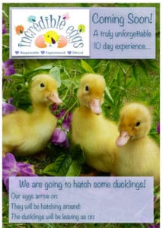

Next week is **Science Week**!

We are going to be ‘training like astronauts’ for our Mission X space-themed learning and activities during the week.

Next **Friday** morning we will be entering the **Space Dome** at the top of our building for more exciting scientific experiences.

To infinity and beyond!

**This week in the EYFS**

We celebrated Eid with a party and activities on Friday morning. This week the children have been sharing and developing their knowledge and understanding of this special time for many of our friends and families.

Eid Mubarak!

This week in Nursery we went ‘Up, Up, Up’ in our theme of moving, journeys and travelling. We read about a hot air balloon trip from Earth to the Moon! We looked at our planet from space using Google Earth.

Our phonic learning has been the letter ‘f’ for frog!

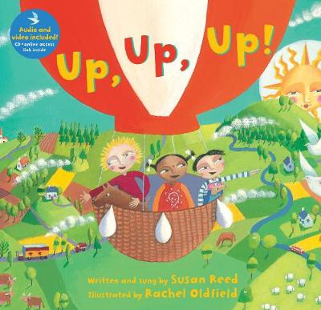 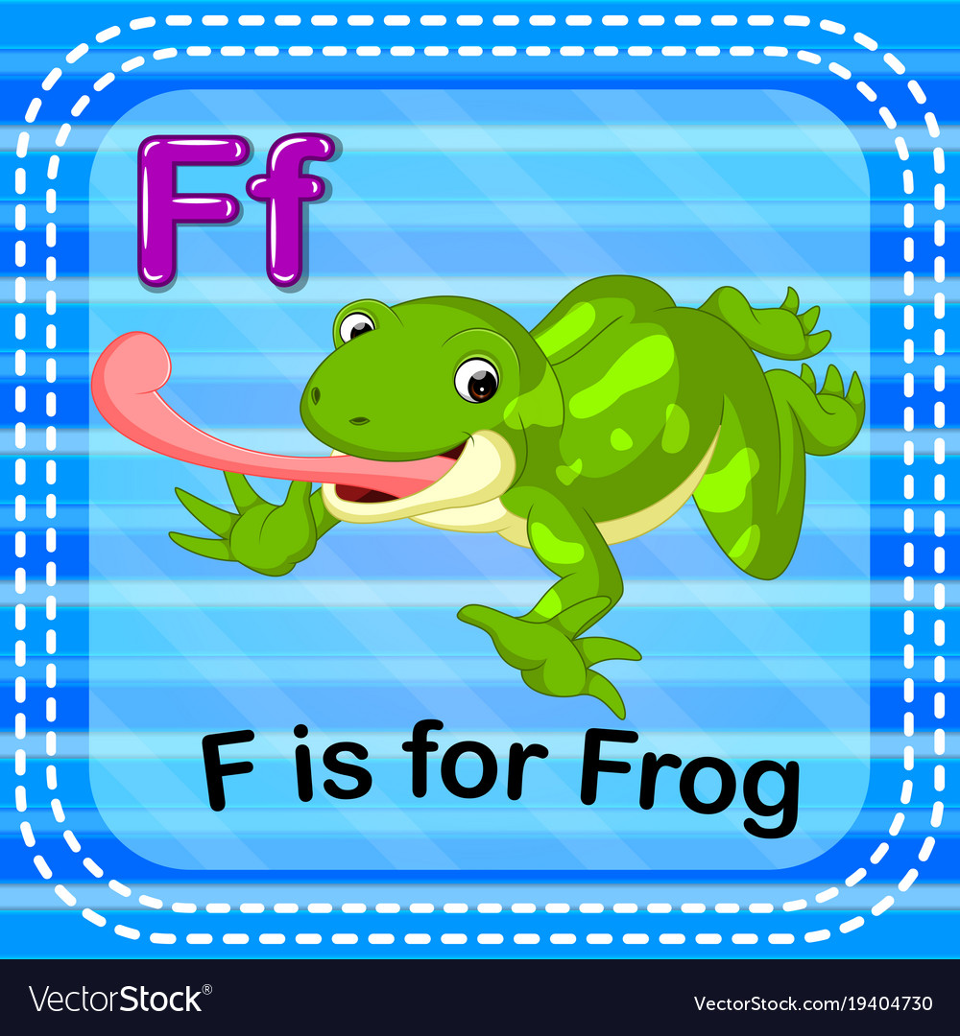

Children in Reception have been writing their own stories about how ‘Aliens in Underpants Save the World!’

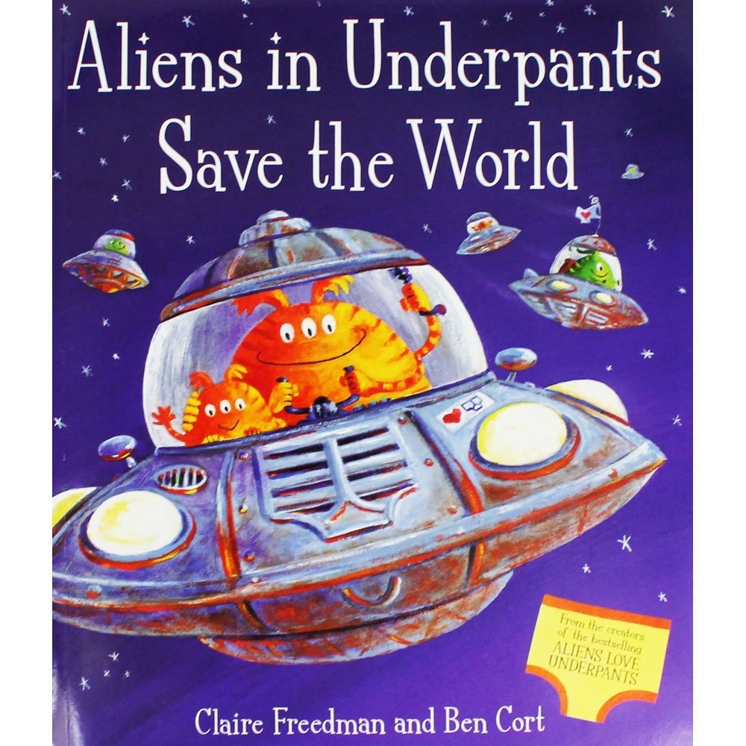

**End of Day Arrangements**

The green screens enable our families to wait safely when dropping off and collecting the children.

Nursery parents should queue **against the wall** from **3.10pm** for pick up at the end of the day, whilst Reception parents should queue **against the green screens** from **3.20pm.**

All queuing from the gate towards the school office.

**Clothing, Water Bottles & Lost Property**

Children need changing bags in school. They can

leave them in school, and we will only send them home if they have had to change during the day. Any wet or dirty clothes will be put in a recycled plastic bag in the changing bag.

***We always need more carrier bags, if you have them.***

Children also need to continue to bring a water bottle,

clearly labelled with their name, into school every day.

This should only contain fresh water.

**All personal property should be labelled clearly with your child’s name and class!**

It will help us to help your child to learn to look after their property.

**Parent Partnership**

We have two designated email addresses for queries:

[**Nurseryteachers@chisenhale.towerhamlets.sch.uk**](mailto:Nurseryteachers@chisenhale.towerhamlets.sch.uk)

[**Receptionteachers@chisenhale.towerhamlets.sch.uk**](mailto:Receptionteachers@chisenhale.towerhamlets.sch.uk)

You can also send us feedback or images.

**Half-Term Holiday**

The half-term holiday will begin from **Monday 31st May.**

School will reopen

after half term on

**Monday 7th June 2021.**