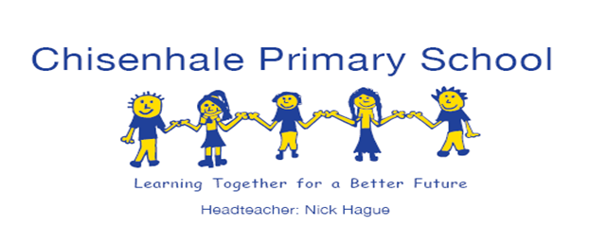



**EYFS Newsletter**

**Summer 2**

**24th June 2022**

**Trips, Events & Celebrations**

Our final big trip of the year for EYFS will be a visit to **Tate Britain** to see the exhibit **‘Procession’** by Hew Locke. **Star Class** will be going next **Tuesday 28th June** & Moon Class on **Thursday** **30th June**.

We plan to celebrate the end of Art Week on **Friday 1st July** with our own procession! This will begin at **2.15pm** in the main playground and will last for approximately 10 minutes so ***please be punctual!***

We will now be having separate Nursery and Reception Sports Day.

**Reception** **Sports Day** will be on the morning of **Monday 4th July** on **Wennington Green** from approximately **9.30am** returning to school in time for lunch at **11.30am.**

**Nursery Sports Day** will be on the morning of 4th July in the school playground from **9.15am.**

***Parents are very welcome to attend these events!***

**This Week in the EYFS**

Early Years will be making our own **‘Procession’** in the playground next Fridayto conclude **Art Week.**

This week in Nursery we have started to prepare for the procession. We have been thinking about the theme of **‘The Whole World in our Hands’** and have begun to make props and decorations. We have also been thinking about sharing in our **‘Think Equal’** Curriculum. We continued our phonics learning, and have now added **x** to the letters and sounds that we know. We have looked at the sound this letter makes e.g in names like Hendrix! We have also been investigating dice, and the number patterns on each face, and we made our own dice!

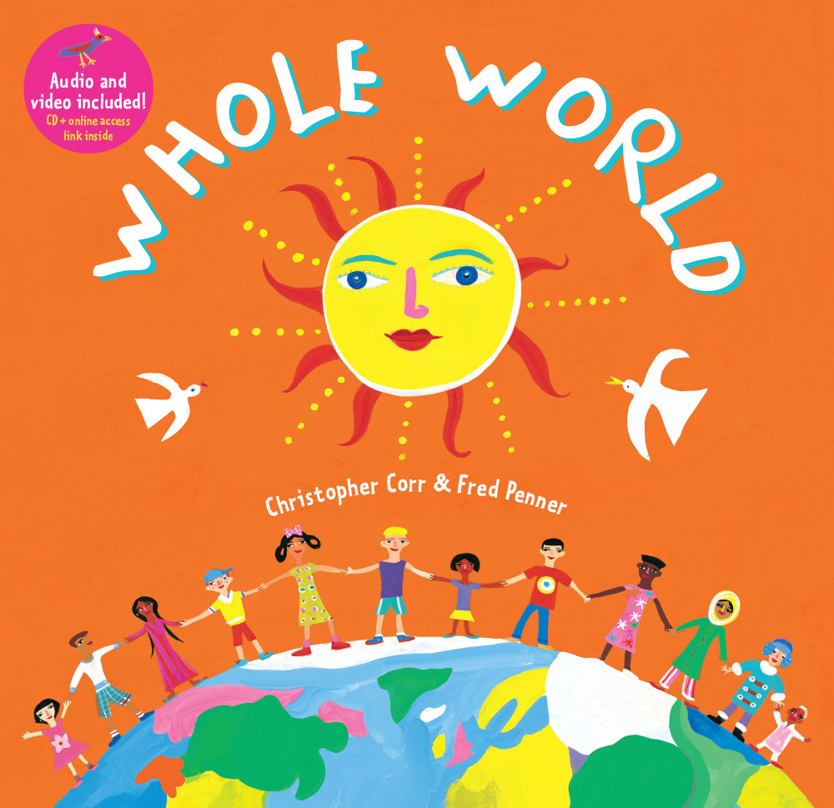 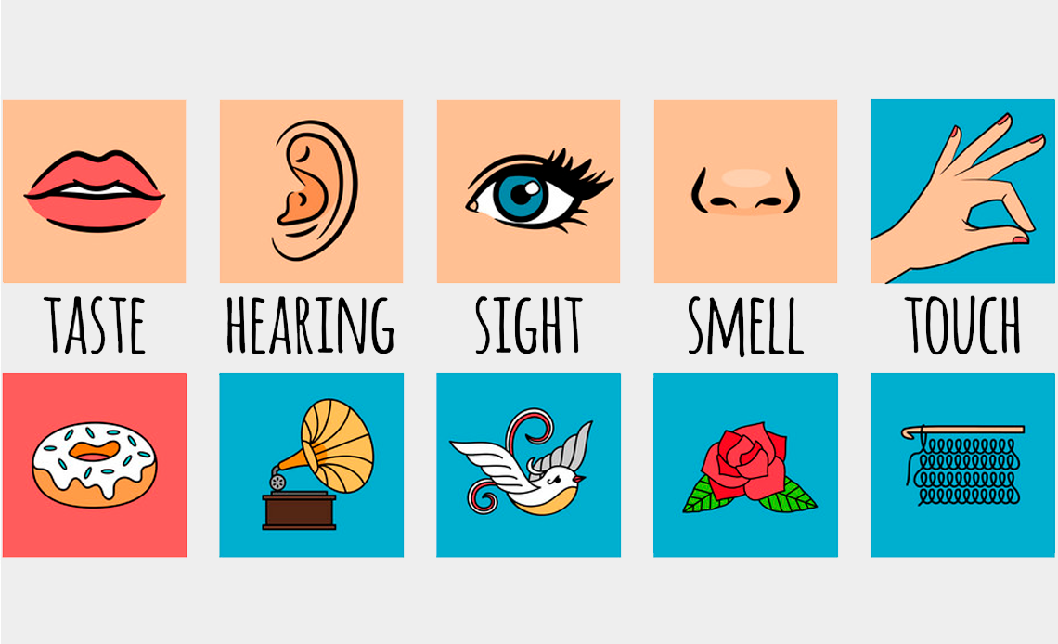 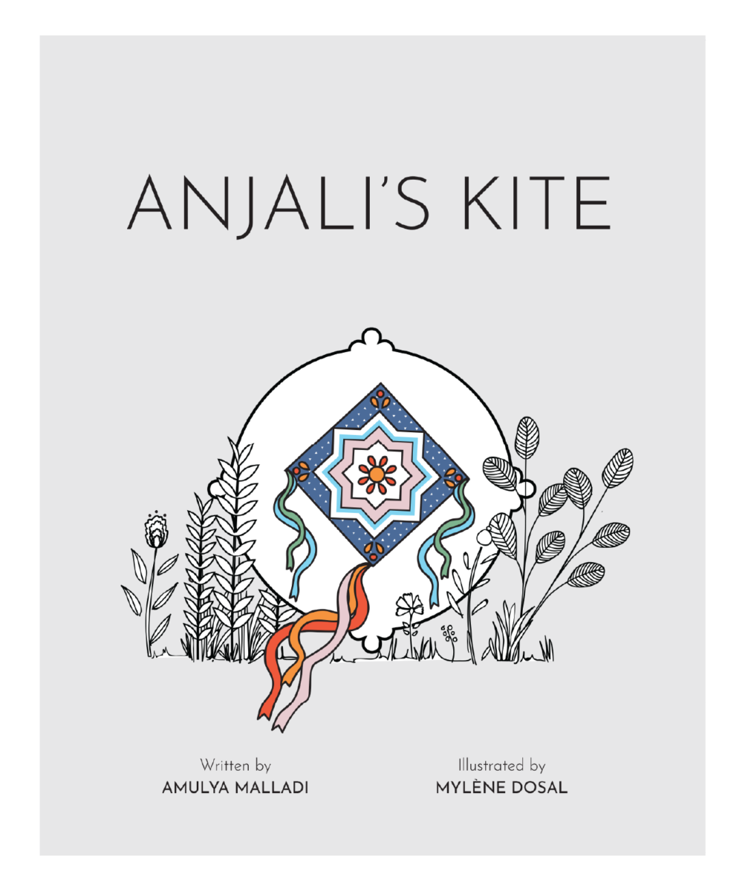

The Reception classes have been learning about the **Five Senses**. On each day they have focused on exploring a different sense. In phonics the children have been increasing their knowledge of vowel digraphs and trigraphs In mathematics they have been learning about **doubling**.

**Clothing, Water Bottles &   
Lost Property**

Please ensure your child’s changing bag is replenished and returned to school promptly. Your child needs a **spare set of clothes** (underwear, a top, leggings or jogging bottoms) in their changing bag in case they get wet or dirty. This should include spare **socks** and **shoes.**

**All personal property should be labelled clearly with your child’s name and class!**

Children should also continue to bring a **water bottle** into school every day, and if the weather is warm, they may also need a **(named) sun hat** and sunscreen applied before they arrive at school.

**Book Bags & Reading**

Your child needs to bring their book bag into school **every day**. Please   
check their book bag for important letters or information. We will be inviting your child to choose a book to take home and share with   
you every **Friday**.

Children in Reception are also issued with a **Bug Club** **login**. This is an **online reading resource** where class teachers allocate texts. Parents should log on **weekly** for children to practise reading an appropriate level of text using their developing phonic knowledge. When children are given this opportunity to read to and with parents at home it makes a real difference to their fluency and has a positive impact on their progress and attainment in reading.

**Parent Partnership**

We have two designated email addresses:

[Nurseryteachers@chisenhale.towerhamlets.sch.uk](mailto:Nurseryteachers@chisenhale.towerhamlets.sch.uk)

[Receptionteachers@chisenhale.towerhamlets.sch.uk](mailto:Receptionteachers@chisenhale.towerhamlets.sch.uk)

Please do not use these accounts to report your child absent, or for urgent queries as they are usually only checked once a day.

If children are going to be absent from school for an extended period of time (such as a trip or holiday) there is a form which needs to be completed in advance, and returned to the school office.

We have now completed our teacher assessments which includes the **Early Years Foundation Stage Profile** for children currently in Reception. We are now completing your child’s end of year report which will be shared with you before the end of the term.

**School Holiday Dates**

The end of the Summer term will be at

**2pm** on

**Friday 22nd July**.

School will reopen to children on

**Monday 5th September.**