Year 1 English Curriculum Overview 2023-24
This information is intended for parents/carers to see the learning journey for their child/children. These quality core books have been carefully chosen to inspire the English curriculum in each year group, selected from recommendations through the Centre of Literacy in Primary Education (CLPE).
As the teachers often reveal the texts gradually to hook the children into their new core text and encourage them to share predictions, please refrain from sharing these titles with your child. These will be enjoyed with their class - we can offer suggestions for suitable texts that would compliment these reads and hence could be shared at home. Thank you for your understanding.
YEAR 1 | Autumn 1 | Autumn 2 | Spring 1 | Spring 2 | Summer 1 | Summer 2
Topic | Being Brave | Blast Off! | Ahoy There! | Deep Discoveries | Creature Comforts | The Seaside
Core books  Related books are used within the teaching sequence to compliment the main core book and topic. These will cover a range of genres.  If you would like further information about these, please ask your child’s class teacher. | 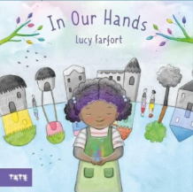  Whole school text - In Our Hands by Lucy Farfort  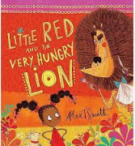  Little Red and the Very Hungry Lion by Alex T. Smith  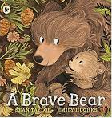  Brave Bear by Sean Taylor and Emily Hughes  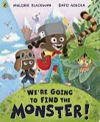  We’re Going to Find the Monster! by Malory Blackman and Dapo Adeola | 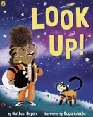  Look Up! by Nathan Byron  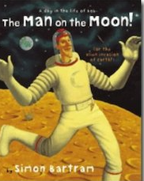  Man on the Moon by Simon Bartram | 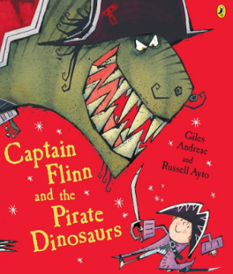  Captain Flinn and the Pirate Dinosaurs by Giles Andreae | 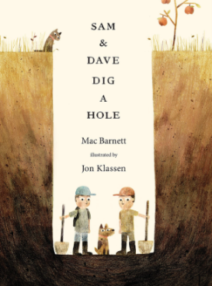  Sam and Dave Dig a Hole by Mac Barnett  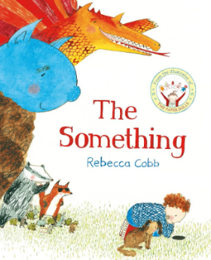  The Something by Rebecca Cobb  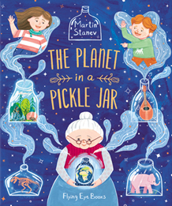  The Planet in a Pickle Jar by Martin Stanev | 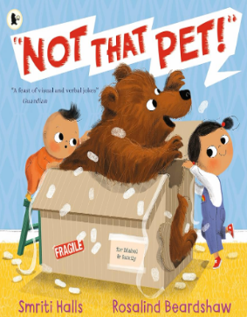  Not That Pet! by Smriti Halls  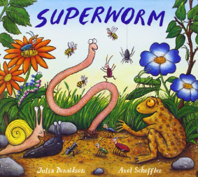  Superworm by Julia Donaldson | 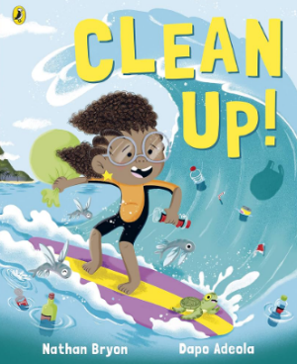Clean Up! by Nathan Byron  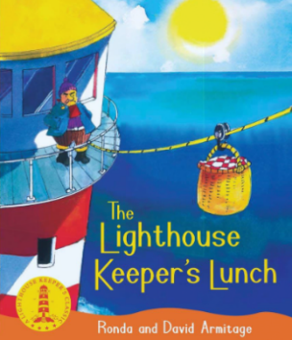  The Lighthouse Keeper’s Lunch by David and Ronda Artmitage
Writing:  Vocabulary, Grammar, Punctuation (and Spelling) | Spelling – Phonics teaching beginning with revisits of Phase 4 | - Phonics teaching – consolidate Phase 4; begin Phase 5  - Recognise and write capital letters from memory  - With adult prompting, separate words with spaces  - Begin to use a full stop to demarcate simple sentences  - Begin to identify question marks  - Use of suffix –s/-es, e.g. dog/dogs; wish/wishes | - Phonics teaching – Phase 5  - Use the conjunction ‘and’ to link clauses  - Separate words using spaces  - Use capital letters and full stops to demarcate simple sentences  - Use a capital letter for the pronoun I  - Begin to use capital letters for names of people, places and days of the week  - Begin to use question marks, where appropriate  - Begin to identify exclamation marks  - Use the suffix –ed/-ing on verbs (past and present tense) |  | - Phonics teaching – Phase 5  - Begins to use present and past tense with some accuracy  - Use some coordination to join clauses (e.g. and)  - Uses spaces between words that reflect the size of the letters  - Demarcates many sentences with capital letters and full stops  - Use a capital letter for the pronoun I  - Begin to use capital letters for names of people, places and days of the week  - Begin to use question marks, where appropriate  - Begin to identify exclamation marks, where appropriate  - Use the suffix –ed/-ing on verbs (past and present tense)  -Begin to use –er/-est (comparative/superlative)
Writing: Composition - audience and purpose | Children will be transitioning from Reception during autumn 1.  - Orally plan and sequence ideas  - Orally compose each sentence before writing (think it, say it, write it) using key vocabulary  - Write simple sentences containing an appropriate verb  - Begin to sequence sentences  - Read their writing, clearly and loudly, to an adult |  | - Orally compose each sentence before writing using key vocabulary, including the conjunction ‘and’ to link two clauses  - Re-read every sentence to check it makes sense  - Sequence sentences to produce short narratives and non-fiction; and recounts  - Discuss their writing with adults and peers, saying what they like about it  - Read their writing, clearly and loudly, to their peers |  | - Orally compose each sentence before writing using key vocabulary, including the conjunction ‘and’ to link two clauses  - Re-read every sentence to check it makes sense  - Write sequenced sentences to form short narratives about their own and others’ experiences (real or fictional) and about real events (own experiences)  -- Discuss their writing with adults and peers, saying what they like about it, beginning to refer back to the writing  Read their writing, clearly and loudly, to a group
Independent writing outcomes | Fiction Retell story  Non-fiction Captions and labelling  Poetry African traditional poem | Fiction Retell story from the aliens’ perspective  Setting description  Non-fiction Information about Mae Jefferson (cross-curricular)  Poetry Sound collector | Fiction Character description  Non-fiction Letter  Trip recount  Poetry Sea shanties | Fiction Narrative (Planet in a Pickle Jar)  Non-fiction Instructions  Poetry World Book Day themed | Fiction Retell with adaptation  Non-fiction  Missing poster  Fact files | Non-fiction Menus  Arguments  Poetry Chisenhale Poetry Slam

Teachers can reflect upon and change core books if new releases or better books related to the topics become available throughout the year. If a change is made, we will update families through the curriculum maps shared each half term. The English Leads continue to check coverage of books and the progression of genres and writing outcomes when changes are made.

