Year 2 English Curriculum Overview 2023-24
This information is intended for parents/carers to see the learning journey for their child/children. These quality core books have been carefully chosen to inspire the English curriculum in each year group, selected from recommendations through the Centre of Literacy in Primary Education (CLPE).
As the teachers often reveal the texts gradually to hook the children into their new core text and encourage them to share predictions, please refrain from sharing these titles with your child. These will be enjoyed with their class - we can offer suggestions for suitable texts that would compliment these reads and hence could be shared at home. Thank you for your understanding.
YEAR 2 | Autumn 1 | Autumn 2 | Spring 1 | Spring 2 | Summer 1 | Summer 2
Topics | Lively London | Fierce Fires | Magic Maps | Magnificent Medics | Vile Victorians | Harmonious Habitats
Core books  Related books are used within the teaching sequence to complement the main core book and topic. These will cover a range of genres.  If you would like further information about these, please ask your child’s class teacher. | 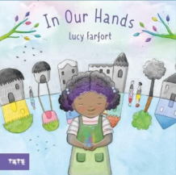  Whole school text - In Our Hands by Lucy Farfort  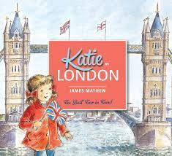  Katie in London by James Mayhew | 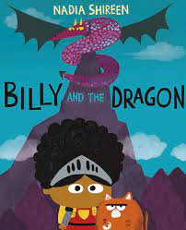  Billy and the Dragon by Nadia Shireen | 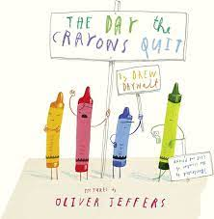  The Day the Crayons Quit by Drew Daywalt  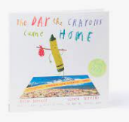 | 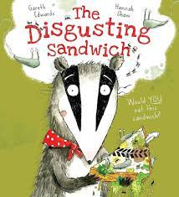  The Disgusting Sandwich by Gareth Edwards | 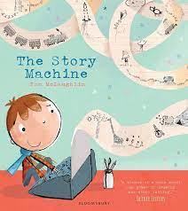  The Story Machine- Tom McLaughlin  The Night Gardener  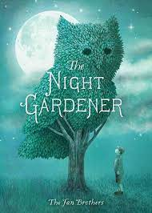 | 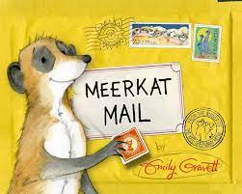  Meerkat Mail by Emily Gravett
Writing:  Vocabulary, Grammar and Punctuation | - Generate words/phrases for description (sight, smell, sound) using verbs, nouns and adjectives  - Write simple and compound sentences using coordinating conjunctions  - Begin to write sentences with different forms: statement, command, question and exclamation  - Begin to use subordination (e.g. because, when, if, that)  - Begin to use past tense mostly accurately for narratives, recounts and historical reports -  - Secure the use of capital letters and full stops  - Begin to use question marks and exclamation marks, where appropriate |  | - Generate, select, and effectively use verbs and nouns  - Write simple and compound sentences using coordinating conjunctions  - Use sentences with different forms: statement, command, question and exclamation, according to purpose  - Begin to use subordination (e.g. because, when, if, that)  - Begin to use past tense mostly accurately for narratives, recounts and historical reports  - Begin to explore the progressive verb form orally and in writing to mark actions in progress  - Use capital letters and full stops  - Begin to use question marks and exclamation marks, where appropriate |  | - Use affixes (e.g. un-, -ed, -ing, -er, -est)  - Use coordination (e.g. or, and, but) and some subordination (e.g. when, if, that, because) to join clauses  - Use present and past tense mostly correctly and consistently  - Demarcate most sentences in their writing with capital letters and full stops, and use question marks correctly when required
Writing: Spelling | Revisit Phase 5 GPCs as required by pupils  - Introduce Year 2 homophones when relevant (e.g. see/sea, be/bee, blue/blew, etc)  - The sound /dʒ/ spelt ‘-ge’ and ‘-dge’ at the end of words, and sometimes spelt as ‘g’ elsewhere in words before ‘e’, ‘i’ and ‘y’.  - /s/ sound spelt ‘c’ before ‘e’, ‘i’ and ‘y’  - /n/ sound spelt ‘kn’ and (less often) ‘gn’ at the beginning of words  - /aɪ/ sound spelt ‘i’ in common exception words: find, kind, mind, behind, child (children), wild, climb |  | - Revisit /l/ or /əl/ sound spelt ‘-le’ at the end of words  - Homophones and near homophones: e.g. quite/quiet, night/knight, new/knew, etc  - Possessive apostrophe (singular nouns)  - Apostrophe for contractions (e.g. can’t, didn’t, it’s)  - /aɪ/ sound spelt ‘y’ at the end of words  - /i:/ sound spelt ‘-ey’  - /r/ sound spelt ‘-wr’ at the beginning of words  - /ɒ/ sound spelt ‘a’ after ‘w’ and ‘qu’  - The sound /ʒ/ spelt ‘s’  - Adding endings ‘-ing-, ‘-ed’, ‘-er’, ‘-est’, ‘-y’ to  words ending in ‘e’ with a consonant before it  - Adding ‘-ing-, ‘-ed’, ‘-er’, ‘-est’ and ‘-y’ to words  of one syllable ending in a single consonant  letter after a single vowel letter  - Adding ‘-es’ to nouns and verbs ending in ‘y’  - The suffixes ‘-ful’ , ‘-less’ and ‘-ly’  - Words ending in ‘-tion’ |  | - Revisit possessive apostrophe (singular nouns)  - Possessive apostrophe (singular nouns)  - /l/ or /əl/ sound spelt ‘-el’ at the end of words  - /l/ or /əl/ sound spelt ‘-al’ at the end of words  - /l/ or /əl/ sound spelt ‘-il’ at the end of words (unusual spelling)  - The /ɔ:/ sound spelt ‘a’ before ‘l’ and ‘ll’  - The /ɔ:/ sound spelt ‘ar’ after ‘w’  - The /ʌ/ sound spelt ‘o’  - The /ɜ:/ sound spelt ‘or’ after ‘w’  - Common exception words  - Adding endings ‘-ing’, ‘-ed’, ‘-er’, and ‘-est’ to words ending in ‘y’  - The suffixes ‘-ment’, ‘-ness’
Writing: Composition - audience and purpose | - Orally rehearse each sentence prior to writing, including simple and compound sentences, using key vocabulary  - Identify audience and purpose for writing using appropriate language  - Begins to introduce character and describe the setting  - Edit and improve own writing with specific guidance from teacher  - Evaluate the writing with adults  - Read aloud their writing beginning to use intonation |  | - Orally rehearse each sentence prior to writing, including those that have been extended, using key vocabulary  - Identify audience and purpose for writing using the language needed, and discuss the structure needed  - Use a variety of sentences  - Begin to use first and third person pronouns, appropriate to genre  - Edit and improve own writing with some signposting from the teacher  - Proofread to check for errors in spelling, grammar and punctuation  - Read aloud their writing beginning to use intonation. |  | - Write simple, coherent narratives about personal experiences and those of others (real or fictional) (audience and purpose)  - Appropriately structured events follow simple chronology  - Sentence forms convey events, thoughts and actions  - Noun phrases used to describe and specify  - Write about real events, recording these simply and clearly (audience and purpose)  - Sentence forms used appropriately  - Personal comments and opinions provided  - Edit and improve own writing by strengthening the choice of vocabulary  - Discuss writing with a response partner  - Proofread to check for errors in spelling, grammar and punctuation  - Read aloud their writing beginning to use intonation, taking note of punctuation to make the meaning clear.
Independent writing outcomes | Fiction - Retell story  Non-fiction - Trip recount | Fiction - Adventure story  Poetry - Firework poems | Non-fiction - Letters  Non-chronological report | Fiction - Character description  Innovated narrative  Non-fiction - Instructions  Trip recount  Poetry - World Book Day themed poetry | Fiction - Setting description  Innovated narrative  Non-fiction - Diary entry (cross-curricular writing) | Fiction - Character description  Non-fiction - Non-chronological report  Poetry - Chisenhale Poetry Slam

Teachers can reflect upon and change core books if new releases or better books related to the topics become available throughout the year. If a change is made, we will update families through the curriculum maps shared each half term. The English Leads continue to check coverage of books and the progression of genres and writing outcomes when changes are made.

