Year 3 English Curriculum Overview 2023-24
This information is intended for parents/carers to see the learning journey for their child/children. These quality core books have been carefully chosen to inspire the English curriculum in each year group, selected from recommendations through the Centre of Literacy in Primary Education (CLPE).
As the teachers often reveal the texts gradually to hook the children into their new core text and encourage them to share predictions, please refrain from sharing these titles with your child. These will be enjoyed with their class - we can offer suggestions for suitable texts that would compliment these reads and hence could be shared at home. Thank you for your understanding.
YEAR 3 | Autumn 1 | Autumn 2 | Spring 1 | Spring 2 | Summer 1 | Summer 2
Topics | Exploring Environments | Extreme Earth | Rocking Romans | Amazing Anglo Saxons | Frozen Farlands | Magical Mediterranean
Core books  Related books are used within the teaching sequence to compliment the main core book and topic. These will cover a range of genres.  If you would like further information about these, please ask your child’s class teacher. | 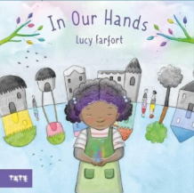  Whole school text - In Our Hands by Lucy Farfort  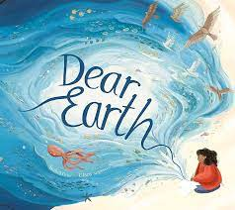  Dear Earth by Isabel Otter  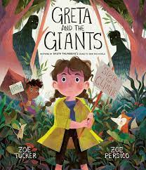  Greta and the Giants by Zoe Tucker | 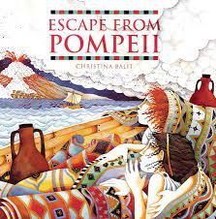  Escape from Pompeii by Christina Balit | 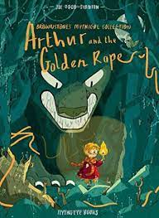  Arthur and The Golden Rope by Joe Todd-Stanton | 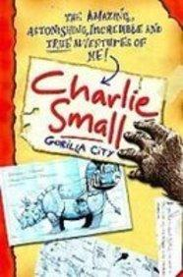Charlie Small by Charlie Small | 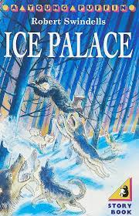  The Ice Palace by Robert Swindells  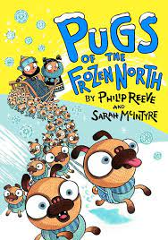  Pugs of the Frozen North by Philip Reeve  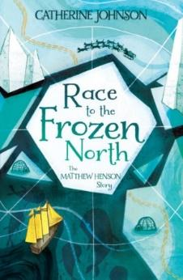  Race to the Frozen North: The Matthew Henson Story by Catherine Johnson | 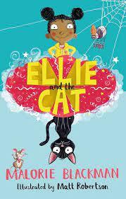  Ellie and the Cat by Malorie Blackman
Writing:  Vocabulary, Grammar and Punctuation | - Use the determiner ‘a’ or ‘an’ according to whether the next word begins with a consonant or vowel  - Consolidate KS1 affixes  - Use sentence of different forms as appropriate  - Identify clauses in sentences  - Use the punctuation taught in KS1 |  | - Use affixes to improve word choice precision  - Generate and select prepositions to provide clarity in writing  - Extend the use of adverbs to provide clarity for the reader  - Use sentence of different forms as appropriate  - Identify main and subordinate clauses in complex sentences and use coordinating and subordinating conjunctions  - Use tense appropriately and consistently  - Identify and use the progressive verb form  - Begin to use a comma to separate clauses in complex sentences, where the subordinate clause appears first  - Identify and begin to use inverted commas to punctuate direct speech |  | - Use a growing range of vocabulary (including noun phrases) for description (e.g. verbs, precise nouns)  - Use present and past tense mostly correctly and consistently  - Use a range of conjunctions, and begin to use some adverbs and prepositions  - Use sentence of different forms as appropriate  - Use the progressive verb form  - Begin to use the present perfect verb form  - Use pronouns mostly correctly  - Use taught punctuation with growing consistency (including previous years)  - Use inverted commas to punctuate direct speech
Writing: Spelling | - Revisit common exception words from Year 2  - Revise prefix ‘un’.  - Teach new prefixes: ‘pre-’, ‘dis-’, ‘mis-’, ‘re-’.  - Revise suffixes from Year 2: ‘-s’, ‘-es’, ‘-ed’, ‘-ing’, ‘-er’  - /eɪ/ sound spelt ‘ei’, ‘eigh’, or ‘ey’  - /ɪ/ sound spelt ‘y’  - Words ending with the /g/ sound spelt ‘gue’ and the /k/ sound spelt ‘-que’ (French in origin)  - Homophones: brake/break, grate/great, eight/ate, weight/wait, son/sun  - Revise contractions from Year 2 |  | - Revisit suffixes from Year 2 (‘-ness’ and ‘-ful’, with a consonant before)  - Prefixes: ‘sub-’, ‘tele-’, ‘super-’, ‘auto-’  - Suffixes ‘less’ and ‘ly’  - The /ʃ/ sound spelt ‘ch’ (mostly French in origin)  - The /k/ sound spelt ‘ch’ (Greek in origin)  - Homophones: here/hear, knot/not, meat/meet  - Revise contractions from Year 2 |  | - Revisit vowel digraphs from Years 1 and 2  - Suffix ‘-ly’ with root words ending in ‘le’ and ‘ic’  - Revisit Previously taught suffixes  - The /ɪ/ sound spelt ‘y’ other than at the end of  words (gym, myth)  - The /ʌ/ sound spelt ‘ou’ (young, touch)  - Homophones: heel/heal/he’ll, plain/plane, groan/grown, rain/rein/reign  - Revise contractions from Year 2
Writing: Composition - audience and purpose | - Create and develop characters for narrative (e.g. using descriptive devices to add detail)  - Using facts gathered through reading and discussion, group into paragraphs  - Discuss own writing with the teacher and make improvements in response to the discussion  - Proofread to check for errors in spelling, grammar and punctuation in own writing |  | - Identify audience and purpose for writing  - Improvise, create and write dialogue using inverted commas, and where appropriate begin to include an adverb  - Group related materials into paragraphs  - Respond to own and others writing  - Proofread to check for errors in spelling, grammar and punctuation in own writing  - Use appropriate intonation, tone and volume to present their writing to a group or class |  | - Identify audience and purpose for writing  - Write coherent narratives (fiction and non-fiction) for a range of purposes (including a short story)  - Organise some paragraphs around themes  - In narratives, create setting, character and plot  - Use simple organisational devices to aid presentation  - Proofread to check for errors in spelling, grammar and punctuation in own writing  - Use appropriate intonation, tone and volume to present their writing to a group or class (e.g. changing voice for different characters when reading dialogue)
Independent writing outcomes | Fiction - Story with a dilemma  Non-fiction - A letter to Bow  Poetry - Environment themed  Animal acrostic poetry | Fiction - Historical narrative  Non-fiction - Information report on volcanoes (cross-curricular)  Poetry - Kennings | Fiction - Adventure narrative  Diary  Non-fiction - Advert for a Roman soldier (cross-curricular) | Fiction – Narrative, a journey tale  Non-fiction – Non-chronological report  Poetry - World Book Day themed | Fiction - Narrative - story from other cultures  Setting description  Non-fiction - Explanation - How to survive the arctic | Fiction - Innovated narrative with a fantasy setting  Poetry Chisenhale Poetry Slam

Teachers can reflect upon and change core books if new releases or better books related to the topics become available throughout the year. If a change is made, we will update families through the curriculum maps shared each half term. The English Leads continue to check coverage of books and the progression of genres and writing outcomes when changes are made.

