Year 4 English Curriculum Overview 2023-24
This information is intended for parents/carers to see the learning journey for their child/children. These quality core books have been carefully chosen to inspire the English curriculum in each year group, selected from recommendations through the Centre of Literacy in Primary Education (CLPE).
As the teachers often reveal the texts gradually to hook the children into their new core text and encourage them to share predictions, please refrain from sharing these titles with your child. These will be enjoyed with their class - we can offer suggestions for suitable texts that would compliment these reads and hence could be shared at home. Thank you for your understanding.
YEAR 4 | Autumn 1 | Autumn 2 | Spring 1 | Spring 2 | Summer 1 | Summer 2
Topics | Kings, Queens and Castles | Kings, Queens and Castles | Groovy Greeks | Groovy Greeks | Exploring the World | Exploring the UK
Core books  Related books are used within the teaching sequence to compliment the main core book and topic. These will cover a range of genres.  If you would like further information about these, please ask your child’s class teacher. | 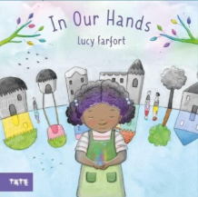  Whole school text - In Our Hands by Lucy Farfort  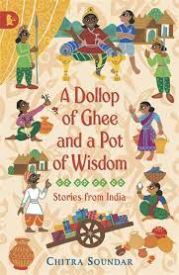  Dollop of Ghee and a Pot of Wisdom by Chitra Soundar | 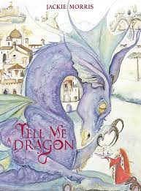  Tell me a Dragon by Jackie Morris  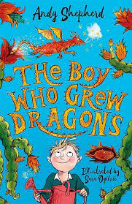  The Boy who Grew a Dragon by Andy Shepherd | 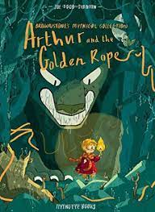  Marcy and the Riddle of the Sphinx by Joe Todd-Stanton | 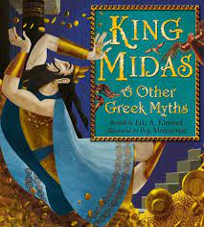King Midas & Other Greek Myths  by Eric A. Kimmel and Pep Montserrat | 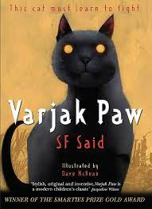  Varjak Paw by SF Said | 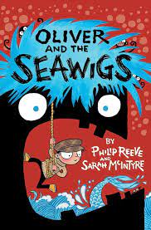Oliver and the Seawigs by Phillip Reeve and Sarah McIntyre
Writing:  Vocabulary, Grammar and Punctuation | - Identify, select and effectively use pronouns  - Use nouns for precision (descriptive vocabulary)  - Create sentences with fronted adverbials (how, when, where)  - Use different sentence forms, as appropriate, and use a greater variety of sentence starters  - Use taught punctuation with growing consistency (including previous years)  - Use inverted commas to punctuate direct speech |  | - Identify, select and effectively use pronouns  - Use nouns for precision (descriptive vocabulary) - Explore, identify and use Standard English verb inflections in writing  - Create sentences with fronted adverbials  - Use the perfect verb form, where appropriate, with growing consistency  - Use a growing range of conjunctions to extend sentences and/or expand detail in sentences  - Use comma after fronted adverbials  - Use inverted commas and other punctuation in indicate direct speech |  | - Use a rich and varied vocabulary (including well-chosen verbs and nouns, and noun phrases) for description  - Use a range of affixes for precision  - Use present and past tense mostly correctly and consistently  - Use a range of conjunctions (coordinating and subordinating), adverbs and prepositions  - Use inverted commas and other punctuation to indicate direct speech mostly correctly  - Use taught punctuation with accuracy
Writing: Spelling | - Revisit the /eɪ/ sound spelt ‘ei’, ‘eigh’, or ‘ey’  - Revisit the /ʃ/ sound spelt ‘ch’  - Revisit the /ʌ/ sound spelt ‘ou’  - Words ending /ure/ (treasure, measure)  - Prefixes ‘in-’, ‘il-’, ‘im-’ and ‘ir-’  - Adding suffixes beginning with vowel letters to words of more than one syllable (‘-ing’, ‘-en’, ‘-er’, ‘ed’)  - Homophones: peace/piece, main/mane, fair/fare  - Possessive apostrophe with singular proper  nouns (e.g. Cyprus’s population) |  | Revisit Year 3 rare GPCs  - The /g/ sound spelt ‘gu’  - Words ending /tʃə/ spelt ‘ture’ (creature,  furniture)  - Word endings that sound like /ʃən/, spelt ‘-tion’,  ‘-sion’, ‘-ssion’, ‘-cian’ (invention, comprehension, expression, magician)  - Prefixes ‘anti-’ and ‘inter-’  - Suffix ‘-ation’  - Homophones: scene/seen, male/mail, bawl/ball  - Revisit contractions from Year 2  - Possessive apostrophe with plurals |  | - Revisit prefixes from Year 3: ‘un-’, ‘dis-’, ‘in-’, ‘re-’,‘sub-’, ‘inter-’, ‘super-’, ‘anti-’, ‘auto-’.  - Words with the /s/ sound spelt ‘sc’ (Latin in  origin)  - Word endings that sound like /ʒən/ spelt ‘-sion’ (division, confusion)  - Suffix ‘-ly’. Teach the exceptions, for example  ‘y’ changed to ‘i’, ‘le’ ending changed to ‘ly’, ‘ic’ ending changed to ‘-ally’  - Suffix ‘-ous’ (poisonous, outrageous)  Homophones: whether/weather, who’s/whose, missed/mist, medal/meddle, team/teem  - Apostrophe for possession, including  singular and plural  - Revisit contractions from Year 2 and plural apostrophe rules
Writing: Composition - audience and purpose | - Begin to develop characterisation using action, dialogue and description  - Begin to link ideas across paragraphs in narratives (e.g. through the use of fronted adverbials)  - Respond to own and others writing  - Proofread to check for errors in spelling, grammar and punctuation in own writing  - Use appropriate intonation, tone and volume to present their writing to a group or class |  | - Develop characterisation using action, dialogue and description  - Improvise and compose dialogue between two characters  - Use paragraphs to organise writing in non-fiction texts  - Discuss own writing with the teacher and make improvements in response to the discussion  - Proofread to check for errors in spelling, grammar and punctuation in own writing  - Use appropriate intonation, tone and volume to present their writing to a group or class |  | - Write coherent narratives (fiction and non-fiction) for a range of purposes (including a short story)  - Organise paragraphs around themes across pieces of writing  - Use organisational devices to aid presentation  - Begin to create atmosphere in narrative writing  - Use a variety of sentences  - With a focus on audience and purpose, discuss and propose changes with partners and in small groups. Improve writing in response to the discussion.  - Use appropriate intonation, tone and volume to present their writing to a range of audiences  - Use their voice to respond to the use of Standard and non-Standard English in their own writing
Independent writing outcomes | Fiction - Write a speech as a villager  Non-fiction - Letter  Non-chronological report about Henry VIII’s wives (cross-curricular writing) | Fiction - Dragon description  Narrative, story in a fantasy setting  Non-fiction - Explanation about their castles (cross-curricular writing)  Poetry - Free verse dragon-themed poetry | Fiction -  Character description  Action paragraph  Narrative, a quest | Fiction - Character description  Narrative, myths/legends  Non-fiction - Diary entry - Daily life of an Ancient Greek child (cross-curricular writing)  Poetry - World Book Day themed  Minotaur free verse poem | Fiction -  Inner monologue/  dialogue between characters  Narrative, a story with a dilemma  Non-fiction - Letters  Persuasive writing - travel brochure (cross-curricular writing)  Poetry - Cat-themed Haiku and free verse poems | Fiction - Action paragraph  Non-fiction - Postcards  Explanation  Non chronological report  Poetry - Chisenhale Poetry Slam

Teachers can reflect upon and change core books if new releases or better books related to the topics become available throughout the year. If a change is made, we will update families through the curriculum maps shared each half term. The English Leads continue to check coverage of books and the progression of genres and writing outcomes when changes are made.

