Year 5 English Curriculum Overview 2023-24
This information is intended for parents/carers to see the learning journey for their child/children. These quality core books have been carefully chosen to inspire the English curriculum in each year group, selected from recommendations through the Centre of Literacy in Primary Education (CLPE).
As the teachers often reveal the texts gradually to hook the children into their new core text and encourage them to share predictions, please refrain from sharing these titles with your child. These will be enjoyed with their class - we can offer suggestions for suitable texts that would compliment these reads and hence could be shared at home. Thank you for your understanding.
YEAR 5 | Autumn 1 | Autumn 2 | Spring 1 | Spring 2 | Summer 1 | Summer 2
Topics | Water World | People and Places: Brazil | Ancient Egypt | The Vikings | People and Places: Local study | WWII
Core books  Related books are used within the teaching sequence to compliment the main core book and topic. These will cover a range of genres.  If you would like further information about these, please ask your child’s class teacher. | 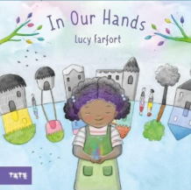  Whole school text - In Our Hands by Lucy Farfort  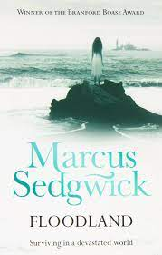  Floodland by Marcus Segwick | 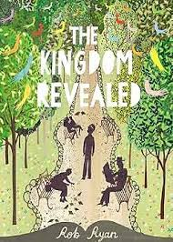  The Kingdom Revealed by Rob Ryan | 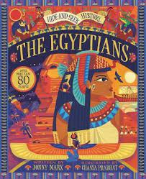The Egyptians by Jonny Marx  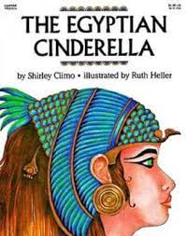  The Egyptian Cinderella by Shirley Cimo | 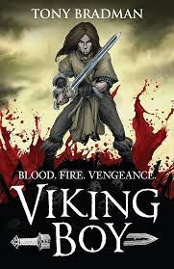Viking Boy by Tony Bradman | 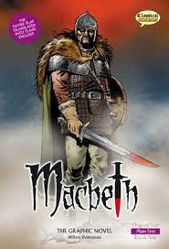Macbeth by William Shakespeare – Graphic novel by John McDonald  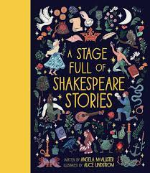  A Stage Full of Shakespeare Stories by Angela McAlllister | 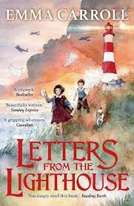Letters from the Lighthouse by Emma Carroll  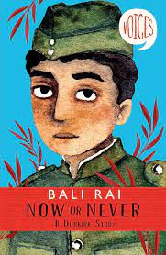  Now or Never by Bali Rai
Writing:  Vocabulary, Grammar and Punctuation | - Convert nouns or adjectives using suffixes e.g. -ate, -ise  - Begin to use multiclausal sentences, where appropriate - Explore, identify, collect and use expanded noun phrases with modification of the noun  - Use a range of verb forms  - Demarcate complex sentences using commas to clarify meaning  - Identify and use punctuation to indicate parenthesis  - Use inverted commas and other punctuation to indicate direct speech mostly correctly |  | - Use verb prefixes (e.g. dis-, de-, mis-, over-, re-)  - Use modal verbs  - Create complex sentences by adding a relative clause using a relative pronoun  - Begin to use multiclausal sentences, where appropriate  - Use devices to build cohesion within a paragraph  - Identify and use punctuation to indicate parenthesis  - Use inverted commas and other punctuation to indicate direct speech mostly correctly |  | - Use a rich and varied range of vocabulary with greater precision for description  - Begin to use a range of cohesive devices to link ideas within and across paragraphs  - Use present, past and future tense mostly correctly and consistently, as appropriate  - Use a growing range of conjunctions, adverbs, modal verbs and prepositions to provide clarity for the reader  - Use taught punctuation, including dialogue, with accuracy
Writing: Spelling | - Revisit plurals (adding ‘-s’, ‘-es’ and ‘-ies’)  - Revisit apostrophe for contraction and possession  - Words with ‘silent’ letters  - Morphology/ Etymology: Use spelling journals to record helpful etymological notes on curious or difficult words  - Words with the letter string ‘-ough’  - Words ending in ‘-able’ and ‘-ible’  - Homophones: isle/aisle, aloud/allowed, affect/effect, herd/ heard, past/passed  - Use of the hyphen (co-ordinate, co-operate)  - Use of a dictionary to support teaching of word roots, derivations and spelling patterns |  | - Revisit apostrophe for possession  - Teach words with rare GPCs from the Year  5 and 6 word list (bruise, guarantee, queue,  immediately, vehicle, yacht)  - Words with the /i:/ sound spelt ‘ei’ after ‘c’ (receive, ceiling)  - Morphology/ Etymology: Teach extension of base words using word matrices.  - Words ending in ‘-ably’ and ‘-ibly’  - Revisit words ending in ‘-able’ and ‘-ible’  - Homophones: altar/alter, led/lead, steal/steel  - Use a dictionary to create collections of words  with common roots |  | - Homophones: cereal/serial, father/farther, guessed/guest, morning/mourning, who’s/whose  - Problem suffixes  - Teach use of dictionary to check words, refer-  ring to the first three or four letters  - Morphology/ Etymology: Teach morphemic and etymological strategies to be used when learning  specific words
Writing: Composition - audience and purpose | - Show characterisation through using description and dialogue, drawing on reading to deepen understanding  - Beginning to connect ideas within and across paragraphs  - Consider how they wanted the reader to feel and reflect upon whether this was achieved  - Proofread to ensure:  Consistent and correct use of tense throughout  Consistent subject and verb agreement  Spelling and punctuation errors are addressed  - Use appropriate intonation, tone and volume to present their writing to a range of audiences |  | - Show characterisation through using description and dialogue, drawing on reading to deepen understanding  - Creates atmosphere in narrative writing  - Connect ideas within and across paragraphs  - With a focus on audience and purpose, discuss and propose changes with partners and in small groups, improving writing in response to the discussion  - Proofread and suggest changes to grammar, vocabulary and punctuation to enhance effects and clarify meaning  - Use appropriate intonation, tone and volume to present their writing to a range of audiences  - Use their voice to respond to the use of Standard and non-Standard English in their own writing |  | - Discuss the structure, vocabulary and grammar needed drawing on how authors develop characters, settings and atmosphere or own reading/research (authentic texts)  - Write effectively and coherently for a range of purposes and audiences (including a short story)  - In narratives, describe settings, characters and atmosphere, integrating dialogue to advance the action  - Use organisational and presentational devices to structure texts and to guide the reader  - Use a variety of sentences  - Assess the effectiveness of own and others’ writing in relation to audience and purpose, suggesting changes  - Use appropriate intonation, tone and volume to present their writing to a range of audiences, ensuring the meaning clear (using punctuation present)
Independent writing outcomes | Fiction Setting description  Non-fiction Diary entries  Poetry Poem on a theme (the sea) | Fiction Narrative, stories with dilemmas  Non-fiction Cafe review | Non-fiction Non-Chronological report (cross-curricular writing)  Persuasive leaflet (cross-curricular writing) | Fiction Narrative, stories with historical settings - action sequence  Poetry World Book Day themed | Non-fiction Letters  Diary entries  Instructions  Poetry The Witches spell | Fiction Postcards  Non-fiction  Instructions  Non-Chronological report  Poetry Chisenhale Poetry Slam

Teachers can reflect upon and change core books if new releases or better books related to the topics become available throughout the year. If a change is made, we will update families through the curriculum maps shared each half term. The English Leads continue to check coverage of books and the progression of genres and writing outcomes when changes are made.

