Year 6 English Curriculum Overview 2023-24
This information is intended for parents/carers to see the learning journey for their child/children. These quality core books have been carefully chosen to inspire the English curriculum in each year group, selected from recommendations through the Centre of Literacy in Primary Education (CLPE).
As the teachers often reveal the texts gradually to hook the children into their new core text and encourage them to share predictions, please refrain from sharing these titles with your child. These will be enjoyed with their class - we can offer suggestions for suitable texts that would compliment these reads and hence could be shared at home. Thank you for your understanding.
YEAR 6 | Autumn 1 | Autumn 2 | Spring 1 | Spring 2 | Summer 1 | Summer 2
Topics | If you can’t do the time, don’t do the crime (Crime and Punishment) | ‘Here and There’  (A Comparison of a region in the UK, Europe and North America) | People Planet | Maya take you back in time | Never eat shredded wheat (Map Skills) | Transition
Core books  Related books are used within the teaching sequence to compliment the main core book and topic. These will cover a range of genres.  If you would like further information about these, please ask your child’s class teacher. | 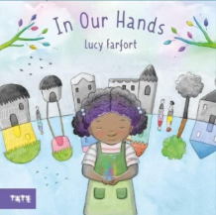  Whole school text - In Our Hands by Lucy Farfort  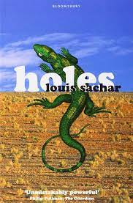  Holes by Louis Sachar | 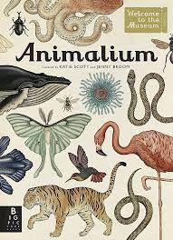  Animalium by Jenny Broom | 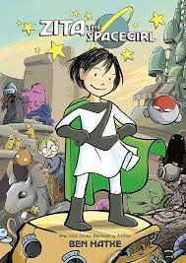Zita the Spacegirl by Ben Hatke  (Graphic novel)  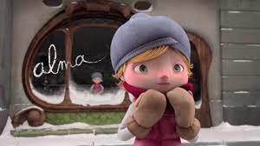  Alma (Literacy Shed animation) | 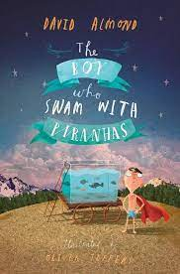The Boy Who Swam with Piranhas by David Almond  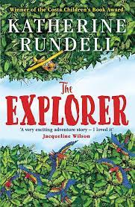  The Explorer by Katherine Rundell | 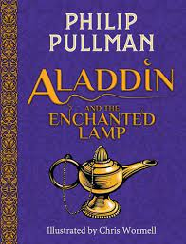Aladdin and the Enchanted Lamp by Phillip Pullman. | 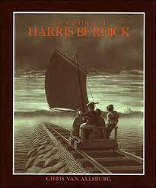The Mysteries of Harris Burdick by Chris Van Allsburg
Writing:  Vocabulary, Grammar and Punctuation | - Use subjunctive forms in formal speech and writing, focusing on wish and if… clauses  - Use devices to build cohesion between paragraphs in narratives  - Identify in texts semi-colons which are used to mark the boundary between independent clauses  - Identify the subject and object of a sentence  - Explore and collect examples of the past perfect form of verbs to mark relationships of time and cause  - Identify and use colons to introduce a list, punctuation bullet points correctly |  | - Explore the difference between vocabulary of informal and formal speech  - Use devices to build cohesion between paragraphs in a range of narratives  - Identify in texts semi-colons which are used to mark the boundary between independent clauses  - Explore and collect active and passive  - Explore, collect and use subjunctive forms within formal speech writing Punctuation  - Identify and use colons and semi-colons |  | - Selecting vocabulary and grammatical structures that reflect what the writing requires, doing this mostly appropriately (e.g. using contracted forms in dialogue in narrative; using passive verbs to affect how the information is presented; using modal verbs to suggest degrees of possibility)  - Use a range of devices to build cohesion (e.g. conjunctions, adverbials of time and place, pronouns, synonyms) within and across paragraphs  - Use verb tenses consistently and correctly throughout their writing  - Use the range of punctuation taught at key stage 2 mostly correctly (e.g. inverted commas and other punctuation to indicate direct speech)  - Explore how hyphens can be used to avoid ambiguity
Writing: Spelling | - Revisit words ending ‘-able/ably’, ‘-ible/ibly’  - Revisit words with the /i:/ sound spelt ‘ei’ after ‘c’.  - Adding suffixes beginning with vowel letters to words ending in ‘-fer’.  - Word endings that sound like /ous/ spelt ‘-cious’ or  ‘-tious’ (precious, ambitious)  - Homophones: advice/advise, device/devise, licence/license, practice/practise, prophecy/prophesy |  | - Revisit words containing the letter string ‘-ough’  - Generating words from prefixes and suffixes  - The /ʃəl/ sound, words ending ‘tial’ and ‘cial’  (official, special, artificial, partial, confidential,  essential)  - Homophones: compliment/complement, desert/dessert, principal/principle, profit/prophet, stationery/stationary  - All homophones from KS2 |  | - Revisit words with rare GPCs from the Years  5 and 6 word list (bruise, guarantee, queue,  immediately, vehicle, yacht)  - Words ending in ‘-ant’, ‘-ance’/‘-ancy’, ‘-ent’,  ‘-ence’/‘-ency’  - Homophones and near homophones: draft/draught, dissent/descent, precede/pro-  ceed, wary/weary
Writing: Composition - audience and purpose | - Identify the audience and purpose for a piece of writing and consider this carefully when selecting the text form, type and language for writing  - Examine and compare how authors develop text discussing techniques used (authentic texts)  - Blend action and dialogue within sentences and paragraphs to convey character and advance the action  - Revise the use of different sentence forms and structures  - Use synonyms and pronouns to build cohesion within and across paragraphs  - Proofread to ensure:  Consistent and correct use of tense throughout  Consistent subject and verb agreement  Spelling and punctuation errors are addressed  - Use appropriate intonation, tone and volume to present their writing to a range of audiences, ensuring the meaning clear (using punctuation present) |  | - Identify the audience and purpose for a piece of writing and consider this carefully when selecting the text form, type and language for writing  - Compare two similar texts (authentic texts) and draw on these to create own plan  - Select appropriate vocabulary and language effects, appropriate to task, audience and purpose, for precision and impact  - Stage directions in speech (speech + verb + action)  - Revise the use of different sentence forms and structures and discuss how these sentences could be understood by the reader  - Use a variety of sentences: (see previous years)  - Assess the effectiveness of own and others’ writing in relation to audience and purpose, suggesting changes  - Proofread and suggest changes to grammar, vocabulary and punctuation to enhance effects and clarify meaning  - Use their voice to respond to the use of Standard and non-Standard English in their own writing |  | - Identify the audience and purpose for a piece of writing and consider this carefully when selecting the text form, type and language for writing  - Write effectively for a range of purposes and audiences, selecting language that shows good awareness of the reader (e.g. the use of the first person in a diary; direct address in instructions and persuasive writing (audience and purpose)  - In narratives, describe settings, characters and atmosphere  - Integrate dialogue in narratives to convey character and advance the action  - Proofread and suggest changes to grammar, vocabulary and punctuation to enhance effects and clarify meaning
Independent writing outcomes | Fiction Flashback story  Non-fiction Non-chronological reports (cross-curricular writing) | Non-fiction Non-chronological reports  Instructions  Poetry The Highway Man | Fiction Ghost story  Non-fiction Persuasive piece linked to Fairtrade debate (cross-curricular writing)  Poetry Haikus | Fiction Circus legend story  Non-fiction Diary entries  Poetry World Book Day themed poetry | Fiction Adventure story  Non-fiction Letters | Fiction Monster tale  Poetry Chisenhale Poetry Slam

Teachers can reflect upon and change core books if new releases or better books related to the topics become available throughout the year. If a change is made, we will update families through the curriculum maps shared each half term. The English Leads continue to check coverage of books and the progression of genres and writing outcomes when changes are made.

