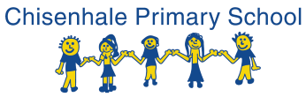
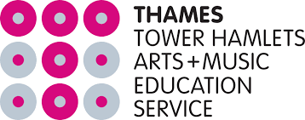

Hello!
We are really lucky to be involved with the Tower Hamlets Arts and Music Education Service. We have had extra curriculum music lessons after school for some time now. This year will be slightly different as we are offering these THAMES music lessons to take place on Fridays as part of an enrichment afternoon.
Lessons will be given by trained musicians in small groups of no more than 5, and instruments are provided by THAMEs on loan. The lessons will be from 1.15-3.00 in 30min slots.
I have included some videos of pieces of music played on the instruments available to learn. The options of instruments available to learn are as follows:
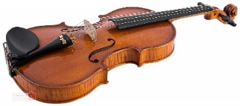
Violin
Grace, the violin teacher, has already worked at Chisenhale for a year.
Violin - https://www.youtube.com/watch?v=T7k2pmKUXxI
Brass
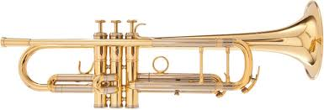
Alys, the brass teacher, is able to teach trumpet, trombone and baritone.
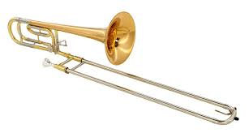
Trumpet – https://youtu.be/smoEelV6FUk
Trombone – https://youtu.be/kYV-JxDfdYM

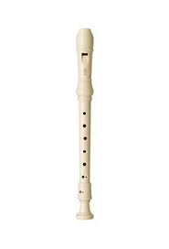
Woodwind
Natalie, the woodwind teacher, is able to teacher recorder, flute and clarinet.
Recorder – https://youtu.be/oKy8x5EyDQk

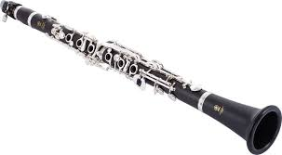
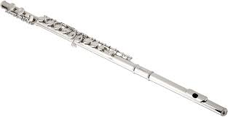
Flute – https://youtu.be/be1jJCH32OU

Clarinet - https://youtu.be/nuEMqMc1Fh4

Lessons are free for children entitled to Pupil Premium (please ask if you are not sure), and £100 per term for those who are not entitled.
Please email by Friday 2nd October, teachers@chisenhale.towerhamlets.sch.uk with your child’s name, class and which instrument they would be interest in learning. We need to fill the slots, to make it cost effective.

