Thursday 12th September 2024

**Reading at Chisenhale – Year 4**

Dear Parents and Carers,

Being able to read is a priority at Chisenhale. It is an essential skill which has wider benefits, such as improved language and attention skills, supports developing empathy and children’s wellbeing, among many more academic benefits. Children at Chisenhale have a love of reading and we do everything we can to promote this in school and at home. Many studies have shown that children who read more are also better readers, and we see great progress from children who read a lot at home!

As it is the start of a new academic year, we wanted to remind you about the home-school reading system at Chisenhale - *Accelerated Reader*. This supports children in choosing appropriate books for their independent home-school reading and it is the same system that they used last year.

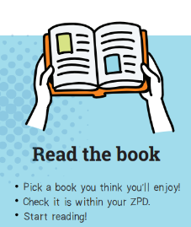 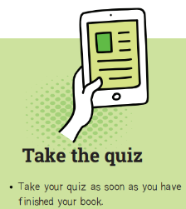

The books suggested are based on a calculation made using the children’s most recent reading assessment (a STAR reading assessment), providing each child with a range of books that will be of an appropriate interest and reading challenge called their ZPD (Zone of Proximal Development). This correlates with a colour-coded system on the Accelerated Reader books in classrooms and in the school library as well, indicating the books that would be best for them to read.

**In Year 4, we would like children to read for at least 15 minutes each day at home.** They will also read in school between 8.45-9.10am each morning to ensure that they have enough time to practise their reading skills and make progress with these. To enable the reading system to work, children must bring their reading books back to school every day – initially please prompt them to do this, putting their book back into their school bag after reading at home.

Once the children finish reading their home-school reading book, they take an online quiz. This checks their understanding of what they have read and provides information about their comprehension for their class teacher. The quizzes are around 10 questions long and should take about 5 minutes. These will be taken in school during the whole school reading time at the start of each day and they are not something that we want the children to worry about – if they have read the entire book and take the quiz soon after finishing this, they will be able to access the questions, and there will always be an adult available if the children need support.

In line with promoting a culture of reading for pleasure at Chisenhale, all the Accelerated Reader books are ‘real’ quality books, those which the children would choose to read through their own choice, written by exciting and interesting authors. If a child wants to read a non-Accelerated Reader book (one without a colour-banded sticker in school or out of school), this is absolutely fine and encouraged. We want the children to enjoy reading, to enjoy choosing books - a book not being part of the Accelerated Reader catalogue is not a good reason to not read it. What we encourage is that the children read a variety of books, including some that are part of Accelerated Reader and hence some which they can complete the associated quiz in school.

A few frequently asked questions are below:

| *Can I still read a book from home or one that I have borrowed from a library outside of school?* |
| --- |
| Yes. The teachers will be monitoring what books children are taking home and ask the children to take some Accelerated Reader books over the term for them to complete the associated comprehension quizzes. However, as stated above, we want the children to read any book that sparks their interest! The Accelerated Reader catalogue contains thousands of books which are regularly updated with new releases. If they read a book outside of school, the children will be able to see if their chosen book has a related quiz when they login at school. If you would like to check this yourself, please go to this website [www.arbookfind.co.uk](http://www.arbookfind.co.uk) and search for the book title. |
| *Do I still need to record the book title in my yellow reading record and get a signature from my parent/carer?* |
| Previously the children had a yellow reading record (all year groups) or a sentence book (in Years 5 and 6) that they were asked to complete alongside their home-school reading. They no longer need to complete these as this is replaced by the comprehension quiz. |
| *Does this replace the Chisenhale Core Book Challenge?* |
| In addition to home-school reading books, the children are encouraged to participate in the Chisenhale Core Book Challenge which runs alongside this. We will launch this later this term. The Core Book Challenge books are “must reads” for each year group and they can be enjoyed either independently or read with family members. |

Thank you for your ongoing support,

Charlotte Fallows and Sarah Nyes

English Leads