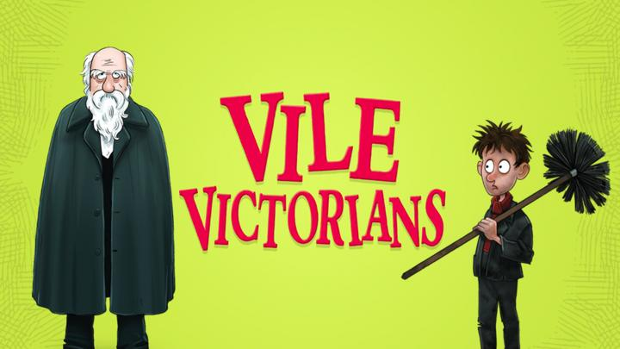
v
Literacy:
- The Story Machine by Tom McLaughlin
- Setting Description
- Recount of trip to Ragged School museum

PSHE
- Jigsaw- Changing Me Unit

Music:
- Singing with sign language
Maths:
- Time
- Statistics
RE
- What do religions teach us about caring for others and the world?
DT:
- Design and create a ferris wheel
PE:
- Teacher led 1- Net and Wall
- Teacher led 2- Teambuilding
Science: Materials
- Identify materials
- Compare suitability
- Comparing qualities of materials
- Using materials to solve a problem

Computing:
- Coding Busy things
- J2Code

Topic: History
- Experience Victorian school life at the Ragged School Museum
- Learning about chronology- past and present
- Reflection on why did people in the past act as they did?
- Performing research and retelling key events from Victorian Britain

