**OFFICE 365 - Go to** [**www.office.com**](http://www.office.com)

**Type in your login:** Student Login

**This will bring you to this screen**



**Now just login again with your student login and your password: Password**

**Now just login again with your student login and your password: Password**

Go to the student video by clicking on the CHS distance learning tab on the main page, CHS Distance learning key information and then Using Microsoft 365.

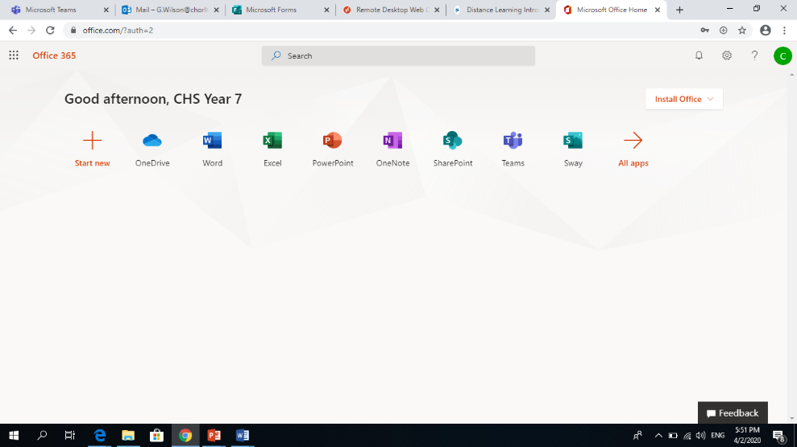**TEAMS - This will bring you to Office 365. Here you need to You are one step away from your learning!**

**Click on TEAMS.**

**TEAMS - All of your subjects have TEAMS. The teams that are working for next week are CHS Science Year 7, CHS English Year 7 and CHS Maths Year 7.**

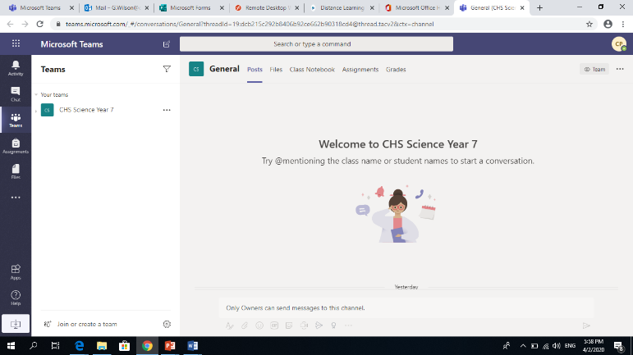

**Click on each TEAM to access your lessons for that subject.**

**Along the top is your menu. In POSTS, your teacher will give you messages about your lesson.**

**FILES – is where you will find all of your lessons for that subject. Go into the relevant folders and access WEEK 1. Make sure you follow the right COLOUR pathway for Maths, English and Science. Your colours are below:**

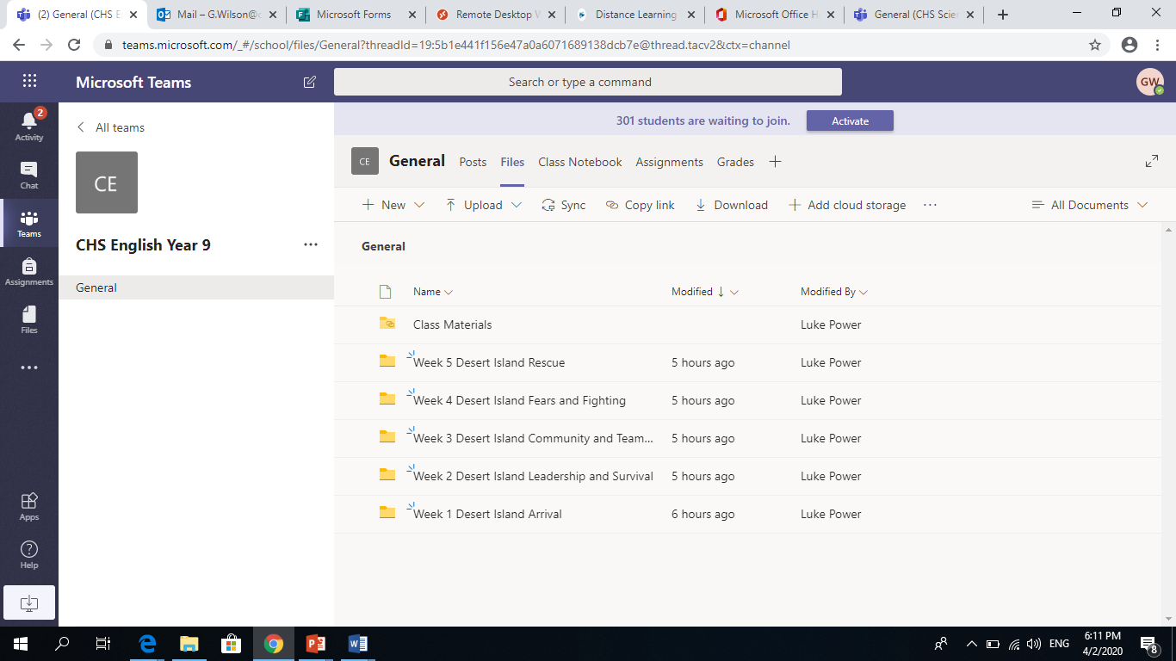

English Pathway: English Pathway

Maths Pathway: Maths Pathway

Science Pathway: Science Pathway

**CLASS NOTEBOOK – this is your Digital Exercise Book – you can complete your learning tasks here**

**ASSIGNMENTS – this is where your teacher might set you some assignments/quizzes**

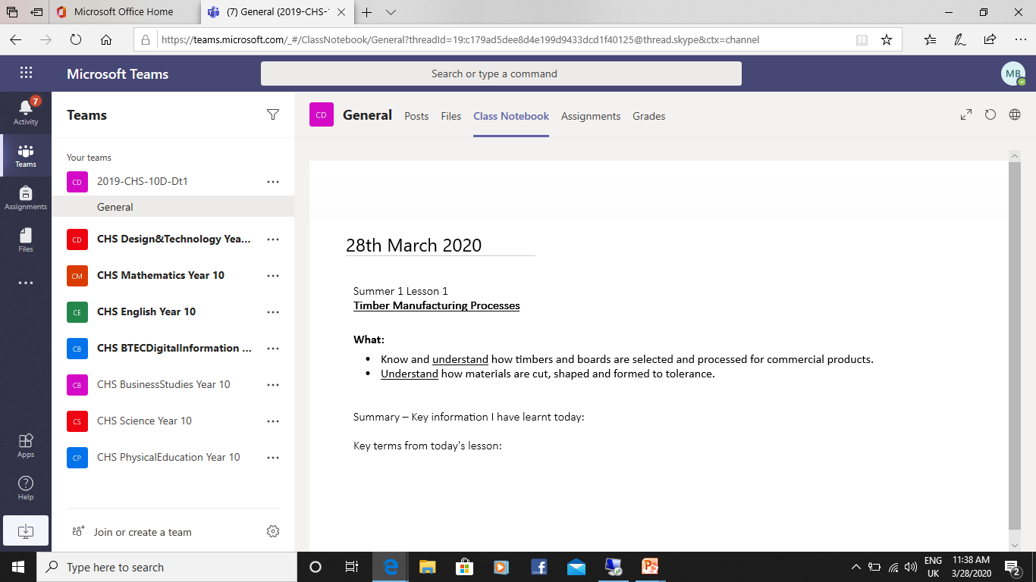

**HELP**

If you have any problems logging in or accessing your work on TEAMS. Please email

[MicrosoftHelp@chorltonhigh.manchester.sch.uk](mailto:MicrosoftHelp@chorltonhigh.manchester.sch.uk)

If you need subject specific help with English, Maths and Science

[Englishhelp@chorltonhigh.manchester.sch.uk](mailto:Englishhelp@chorltonhigh.manchester.sch.uk)

[Mathshelp@chorltonhigh.manchester.sch.uk](mailto:Mathshelp@chorltonhigh.manchester.sch.uk)

[Sciencehelp@chorltonhigh.manchester.sch.uk](mailto:Sciencehelp@chorltonhigh.manchester.sch.uk).