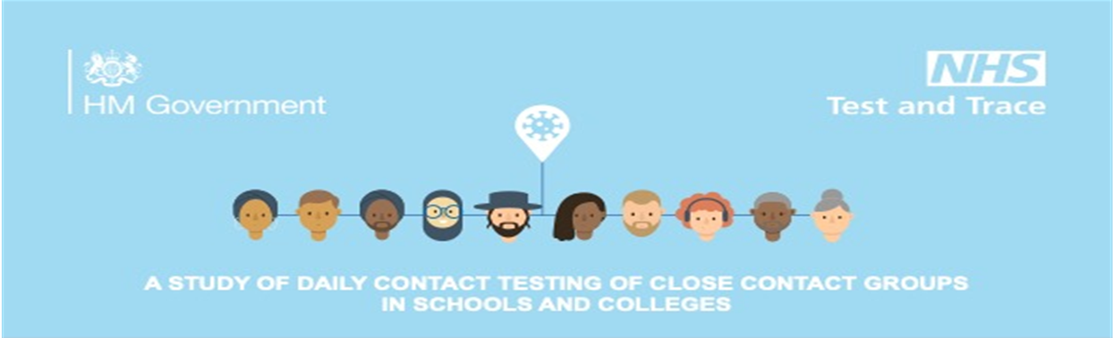
Dear Parent/Carer
Currently students and staff are testing at home twice a week using the lateral Flow (LFT) test kits; this will continue until further notice. As we move forward our school has been chosen to take part in a new study called “Daily Contact Testing” which is being led by the Department for Health and Social Care through NHS Test and Trace.

Why is this study important?
Currently, when we identify a person has COVID-19, those that have been in close contact with that person have to go home and self-isolate for 10 days to stop the virus spreading. This can mean loss of learning, but it is important to do this to protect the other people in school and at home.
This new study will allow schools to keep close contacts in school. Instead of being sent home to isolate for 10 days they will undertake daily Orient Gene rapid testing in the Green Room Test Centre for 7 consecutive days following identification. Results take 20 minutes so students will wait there. If a student does not have a positive test result, they will be able to go into school as normal. However, students will still need to self-isolate at home in the evenings, weekends and holidays for the 10 days.
Is taking part voluntary?
Participation in the study is completely voluntary. If students do not wish to take part they will have to self-isolate if identified as a close contact. If a student chooses to take part in the study, they can change their mind at any time.

What does the study involve?
If we have a positive case students and staff identified as a close contact and who have consented to take part in the study will be asked to perform LFT COVID-19 tests on school days for 7 consecutive days, this will involve:
• A Orient Gene rapid test at school every day for 7 days – this will involve coming directly to the Green Room Test Centre an undertaking supervised self-swabbing as before - students will rub a soft cotton bud inside the nostrils to test for the virus. If the result is not positive students will be allowed into school, if they are positive, they will be sent home to start a period of self-isolation. LFT results will be shared with parents as before.
• A Polymerase Chain Reaction (PCR) test at home on day 2 and 7 – two home PCR testing kits for the study will be provided. These are similar to the tests performed at NHS Test and Trace sites. A swab is taken at home from the nose and throat to be processed in a laboratory at the end of the study (there will be instructions on how to return the swab). Results of these tests will therefore not be available until after the 7-day testing period.
Unless the rapid test is positive, students and staff will be able to take part in school activities although they will need to continue self-isolating when not at school.
Students and staff will be asked to complete a brief survey on day 7 and may be invited to speak to a researcher.

What happens on non-school days?
On non-school days students and staff will not receive a rapid test and will be required to self-isolate. If the last day of daily testing falls on a Saturday or Sunday, a final rapid test will be completed on the Monday.

What if a rapid test is positive during the study?
A positive result with the LFT means the individual must follow the national guidance and self-isolate for 10 days.
If someone who is taking the daily tests comes into contact with someone who tests positive for COVID-19 again, the tests on school days for 7 consecutive days will restart. If they do not want to do the tests again they can self-isolate as per national guidance. If a student receives a positive test at any point during the study they will be asked to take an additional special home PCR testing kit for the study.

What happens if the rapid test is NOT positive during the study?
This means students can continue with normal school activities until the next test is due. Students will need to continue self-isolating when not at school. Sometimes, a student could still have COVID-19, even if they don’t test positive. This means everyone should continue to wash hands, cover their face and maintain social distancing.
What are the benefits and risks of taking part?
As this is a new study and has not been done in school before we cannot know exactly what the impact will be. Sometimes a person may still have the virus, even if they do not have a positive test result. However, it is thought they are less likely to spread COVID-19, as they either do not have the virus or have a very low level of virus. It is very important that the national guidance to stop the virus spreading (including social distancing, hand washing, using face coverings) is followed at all times.
Consideration should be given to how taking part in the study may affect the other people in your house or people you see regularly. For example, if you live with another person who has health problems you may decide you would prefer to self-isolate rather than continue attending school/college.

What will you do with my information? - PRIVACY NOTICE
This is a summary of the School’s Privacy Notice for Daily Contact Testing Trial, a full copy is attached.
We will collect personal information, including name, date of birth, contact details and names of contacts at school for you and the people you have been in contact with. This information, together with COVID-19 test results will be provided to the Department of Health and Social Care (DHSC) so they know when someone tests positive to help stop the spread of the virus. DHSC will use it to assess how effective the trial is. DHSC are the ‘controller’ for this use of personal data and will be responsible for it. The school use this information to manage the response in school.
The use of personal data by the school and by DHSC is made lawful as it is being used for the protection of public health. We will keep all the information securely in accordance with the UK General Data Protection Regulation (UKGDPR) and Data Protection Act 2018. DHSC: data_protection@dhsc.gov.uk
Are household contacts or other people able to participate?
This study is only open to students and staff at schools/colleges who have been identified as a close contact of a student or staff member whilst at school.

What should a student do if they develop symptoms?
If students develop symptoms at any time during the study, they must immediately self-isolate and book a test at https://www.gov.uk/get-coronavirus-test or by calling 119. The school should be informed if the test result is positive. If you have any questions about this, please contact the school.
To give consent please use this link https://forms.office.com/r/HG86fRALcw The closing date is Wednesday 28th April 10am.
Yours sincerely,
Chorlton High School

