We cannot believe that we are halfway through the academic year already! The children are all working so hard and we are extremely proud of them all. This half term the children will be studying many new and exciting topics, whilst also revisiting some of the key concepts they have already learnt. This will enable them to consolidate and broaden their knowledge and understanding in all areas of the curriculum.
If your child has anything special that they would like to share with the class i.e. swimming certificates or other out of school achievements, we would love to see/hear about them in class
Thank you for your continued support
Mrs Morgan, Mrs Beeson and Mrs Favager
Easter Craft Workshop  Our Easter Craft Workshop is on Monday 18th March. The gates will open at 1.45pm.  We are not able to accommodate younger siblings. | PE Days  Year 1 PE days are on Wednesday and Thursday.  Please make sure children come to school in their PE kit.
Phonics
We teach phonics daily in Year 1 and the scheme that we follow is ‘Little Wandle Letters and Sounds Revised’.
The children are taught 3-4 new grapheme phoneme correspondences (GPCs) per week, plus a review lesson on a Friday. Knowing a GPC means being able to match a phoneme (sound) to a grapheme (written representation) and vice versa.
The children will also learn a series of ‘tricky words’. Tricky words are those words which cannot be sounded out using their phonemes.
We assess the children every six weeks to check progress and identify any gaps. Any child who needs extra support will have keep-up sessions planned for them. Here is an outline of the sounds and tricky words the children will learn this half term.
If you go on to the Little Wandle website there is a section for parents which you may find useful. There is a selection of videos to watch explaining the scheme as well as lots of useful resources.
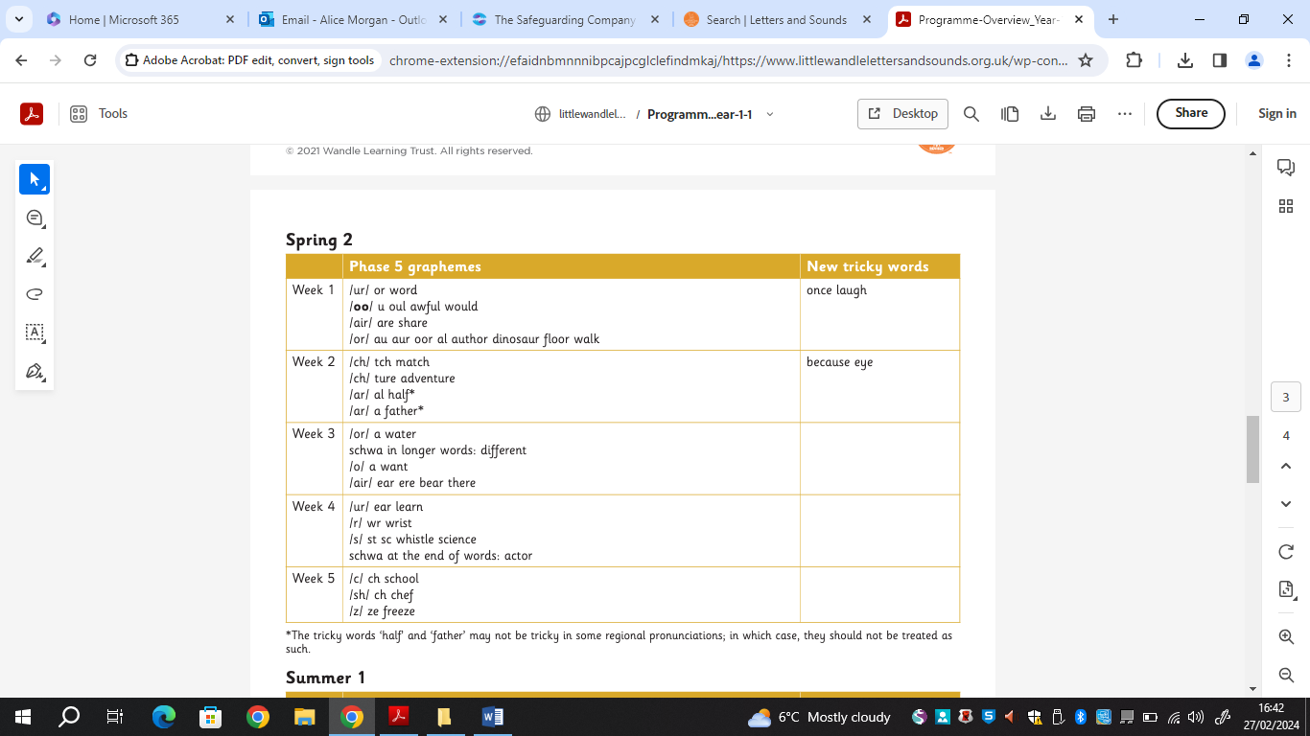

Reading
The children also take part in reading practice sessions, where they read the same book three times per week.
The first time we work on decoding (sounding out) the words, the second time we work on prosody, which is reading with expression - making the book sound more interesting, and the third time we look at comprehension. We read the book three times in school because we want to develop fluency. The more children see words, the more they begin to read them automatically without having to sound them out.

Supporting your child with reading at home

Although your child will be taught to read at school, you can have a huge impact on their reading journey by continuing their practice at home.

Reading Practice Books
These decodable books have been carefully matched to your child’s current reading level. When listening to your children read their book please remember to give them lots of praise – celebrate their success and where necessary their perseverance!
If they can’t read a word, allow them time to use their sounds to build it up. Where necessary, help them to build the word or read it to them.
Re-read sentences to develop rhythm and intonation.
After they have finished, talk about the book together.

Sharing a Story
In order to encourage your child to become a lifelong reader, it is important that they learn to read for pleasure. All children will bring home a book chosen from our class library to share at home, these will be changed weekly.
Please remember that you shouldn’t expect your child to read this alone. Read it to or with them. Discuss the pictures, enjoy the story, predict what might happen next, use different voices for the characters, explore the facts in a nonfiction book. The main thing is that you have fun!

Reading Diary
We will continue to use the Reading Diaries to note your child’s assigned reading practice book. It is important to us that the record is easy for families to complete, so please leave a short comment in the diary to let us know your child has read the book and how they got on! We look forward to catching up with you about your child’s reading progress in our upcoming parents evening.

Please do not hesitate to talk to us if you have any questions about your child’s reading in the meantime.

